Purpose:want forward remark
Step:1 add forward remark while forward the data
Caption: forward remark
Value:input type
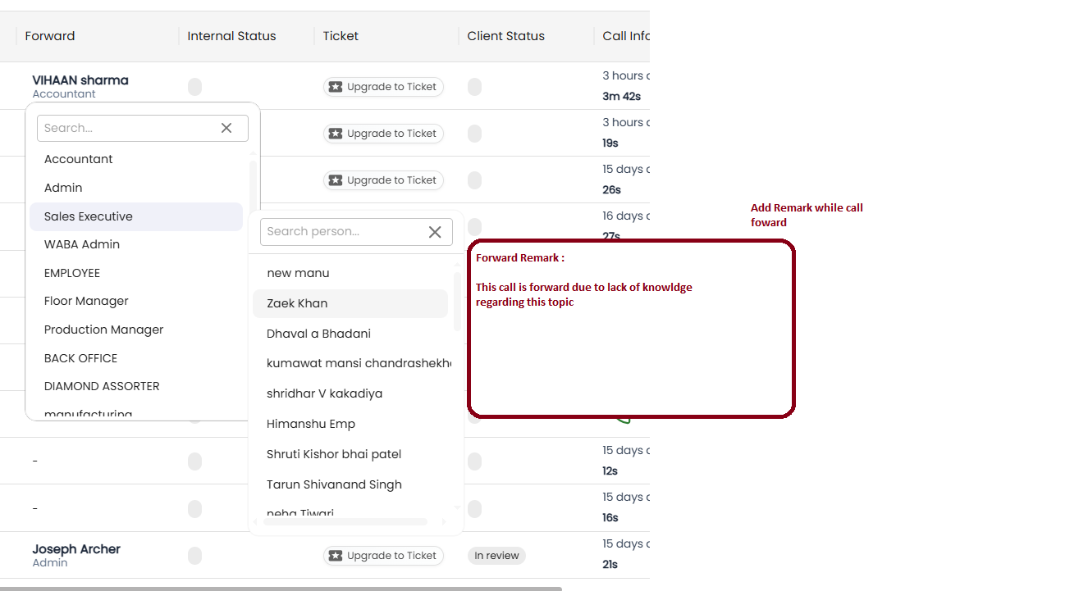

Step:2 show forward remark onhover on forward person name

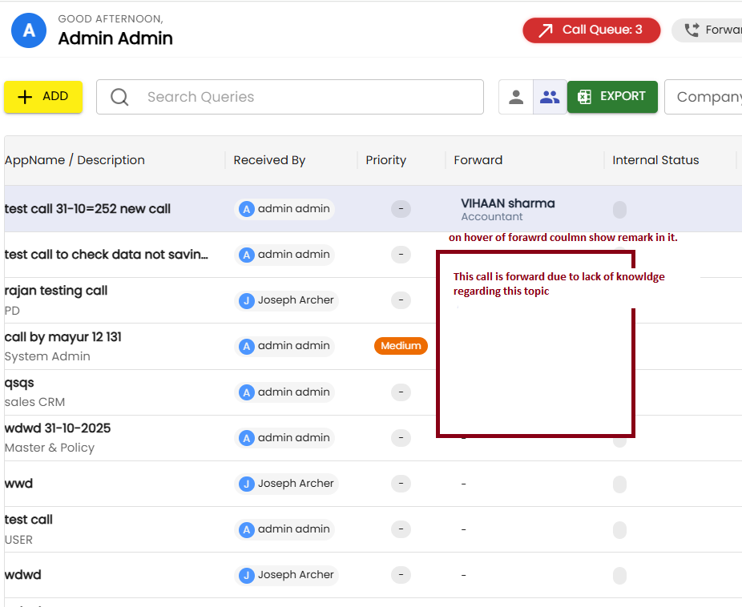

Step:3 show this remark in call details forward remark as shown in image

