Homepage Block Sequence:
- Hero Banner for Ad
- Jewellery showcase (Category wise)
- Album
- Collection block
- Trending
- New Arrivals Block
- Bestseller
- Physical Store
- Social Media
- About Us

Name for every block - Make sure all elements must be centered. The title line should look like below & sub title is not bold but use same font.
Block 2. Category - Essence of Style
Block 3. Collection - Iconic Collection
Block 4. Trending - Trending Masterpieces
Block 5. New arrivals - New In (Every debut tells a story of artistry, of elegance, of you)
Block 6. Bestseller - Bestseller
Block 7. Physical Store - Physical Store
Block 8. social Media - Curated moments(from our atelier to your screen).

In this New Arrival block : Price details should look like this :
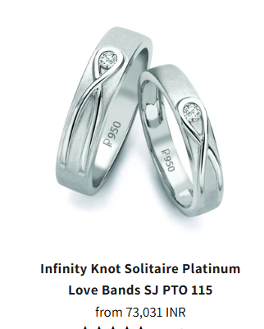
Design title line
design subtitle
Price
Nwt: |Dwt:

30-Pointer Classic 6 Prong Solitaire
Ring made in Platinum SKU 0012
from 76,00,000 INR
Nwt : 10.00 | Dwt: 0.5

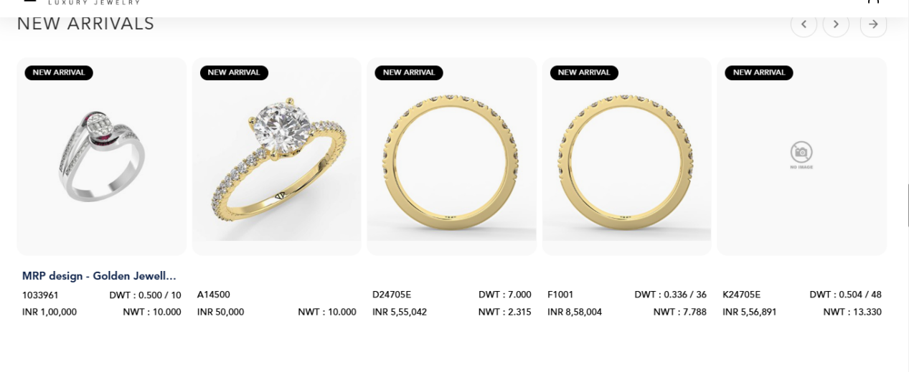
Physical store look like this:
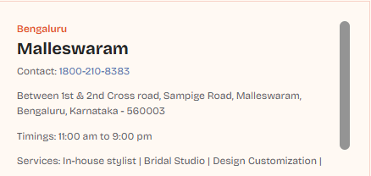
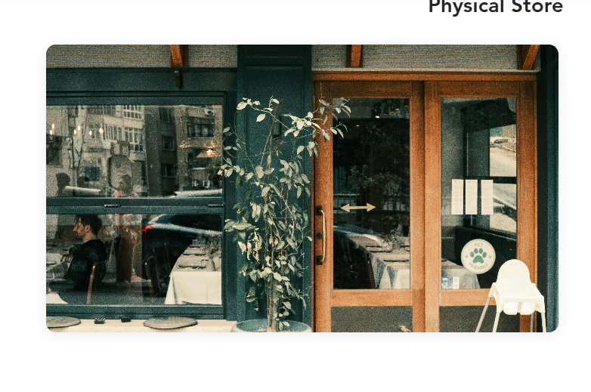
Make like Ui like this
State name
Exact store Area name
Contact
Exact store location
Timing : 11:00 am to 9:00pm
Service : In - house stylist | Bridal studio | Design Customization

In this social media block: Change the links, right now we use elvee so change it with these-
Instagram : https://www.instagram.com/
Pinterst : https://in.pinterest.com/
Facebook : https://www.facebook.com/
Linkdin : https://in.linkedin.com/
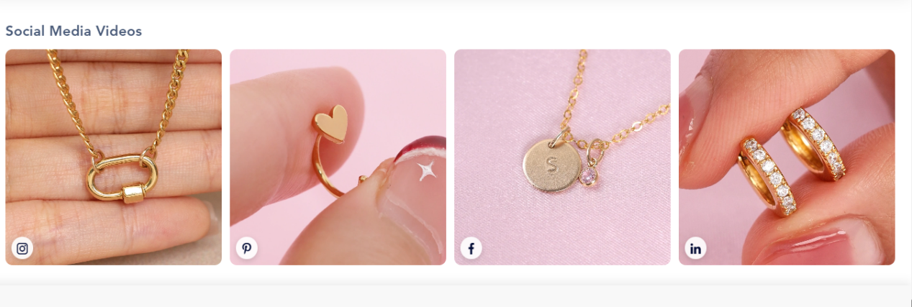
All buttons are looks same as this below image:
Background - white
Font color - Black
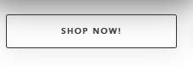
Change this collection button
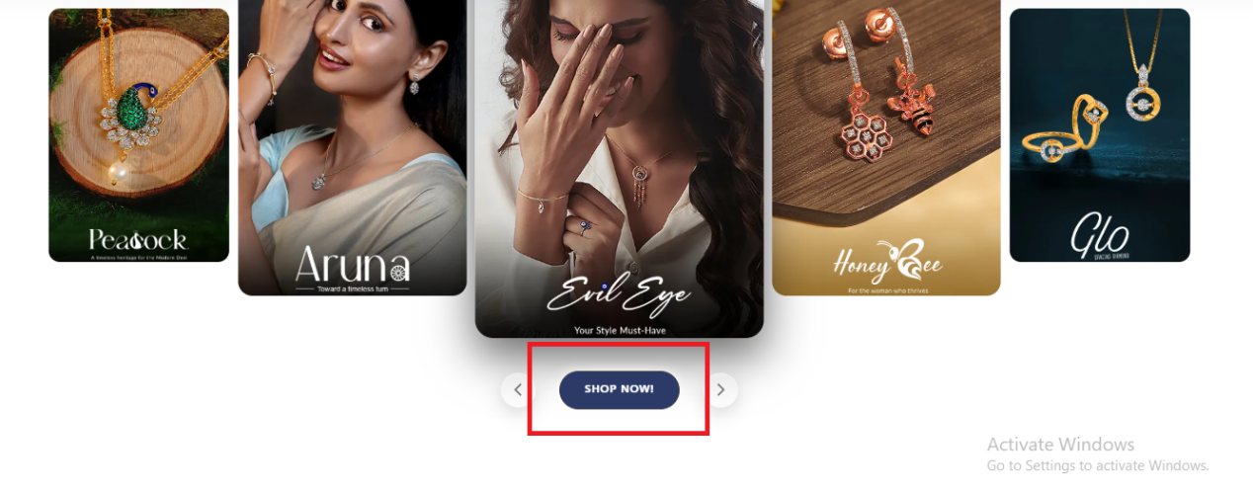

Put these Navigation arrows on the right side
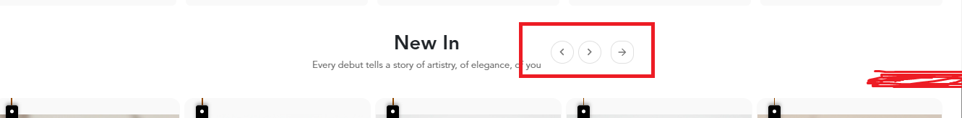

Static images:
Hero Banner :
\\evo\Project\WebSite\customer data\vedica\website_theme\Homepage\Hero banner
Essence of style :
\\evo\Project\WebSite\customer data\vedica\website_theme\Homepage\Essence of style
Iconic Collection :
\\evo\Project\WebSite\customer data\vedica\website_theme\Homepage\Iconic collection
Physical store:
\\evo\Project\WebSite\customer data\vedica\website_theme\Homepage\store block

Binding
1.
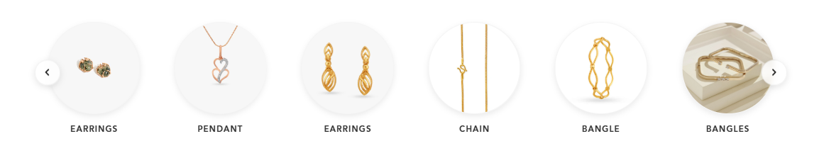
In this block Bind “Category”
Ring
Men's chain
Pendants
Bracelet
Bangles
Mangalsutra
EARING
Men's Bracele
NACKLACE

2.
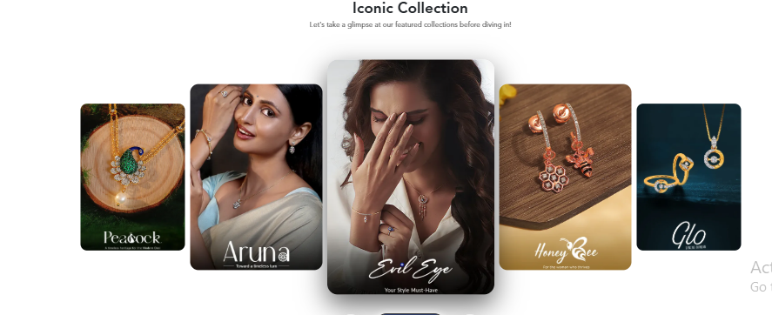
In this block Bind “Collection”
Everyday Wear -every2211
Gen-z drops - gen2212
Wedding Collection - wed2213
Night Out Glam - night2214
Shopping All - all collection

