Task : Fg stock Summary Bulk Purchase Issue in saving weight in it
Team
- Documentation: Trupti
- Stakeholder: Kuldeep
- Developer: Mahesh
- Tester: Vidhi
- Support: Kuldeep
Purpose and Goal:
Purpose
Customer checks daily stock in it date wise but in the case of bulk items if I do tagging in current date and check stock of bulk in previous date , the weight gets updated in previous date.
Goal
To provide error free report to customer to view daily stock date wise .

Current Flow and Storyline:
Currently in this report it shows all the items as currently exisiting in stock book date wise . It shows bulk job entries too.

Step1 : Scan the job which are in stock book and in autosplit and make autosplit on
Books keeping>sales book >autosplit
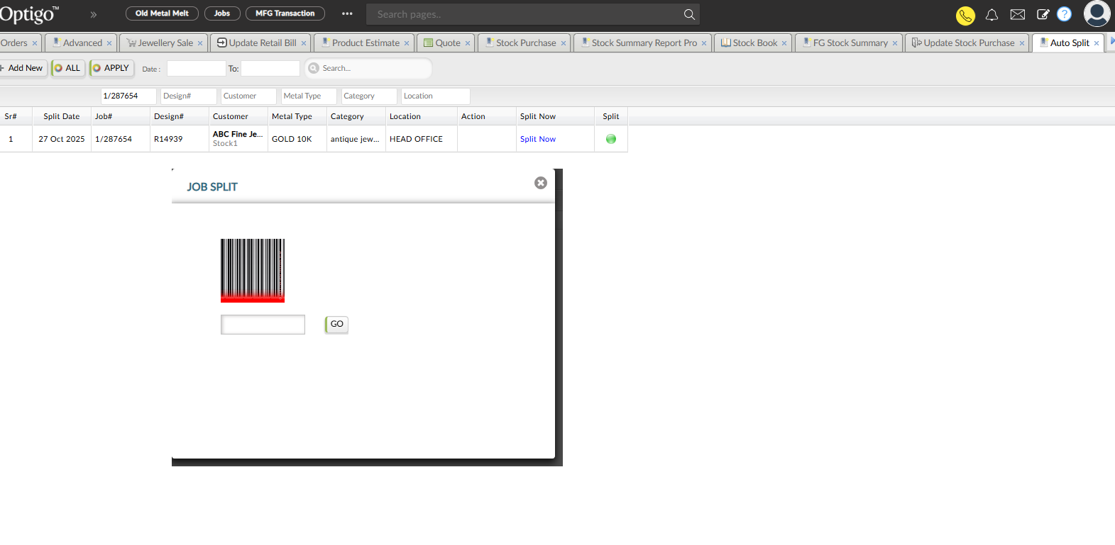
Step3 : Do tagging it in through quick tagging ( Books keeping>purchase book > quick tagging) in date 28-oct-2025

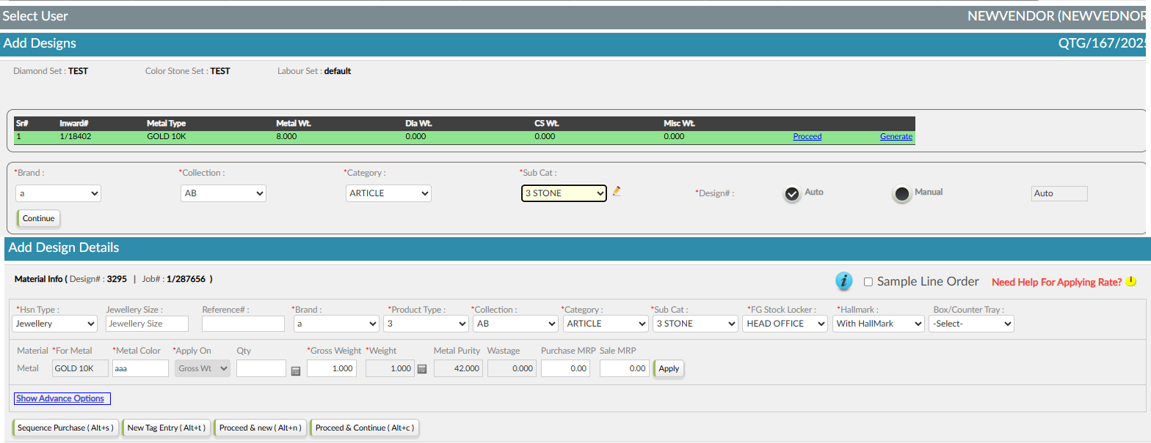

Now check fg stock summary with date search 26-oct-25
Output weight get changed in it .

Live Sample entry to Solve this bug
01- Sep-25
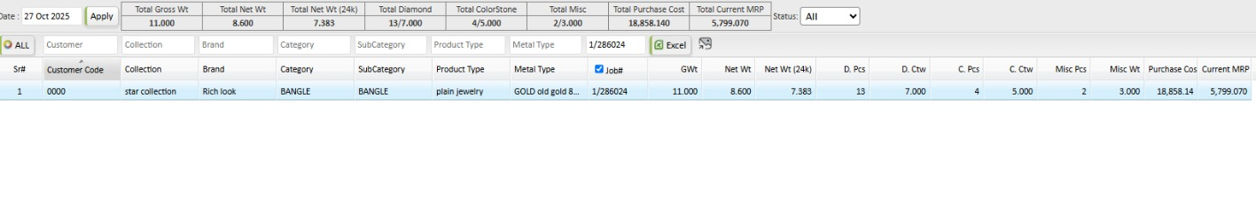

Tagging done as on 27-oct-25 - 1/287653 5.000 GROSS wt
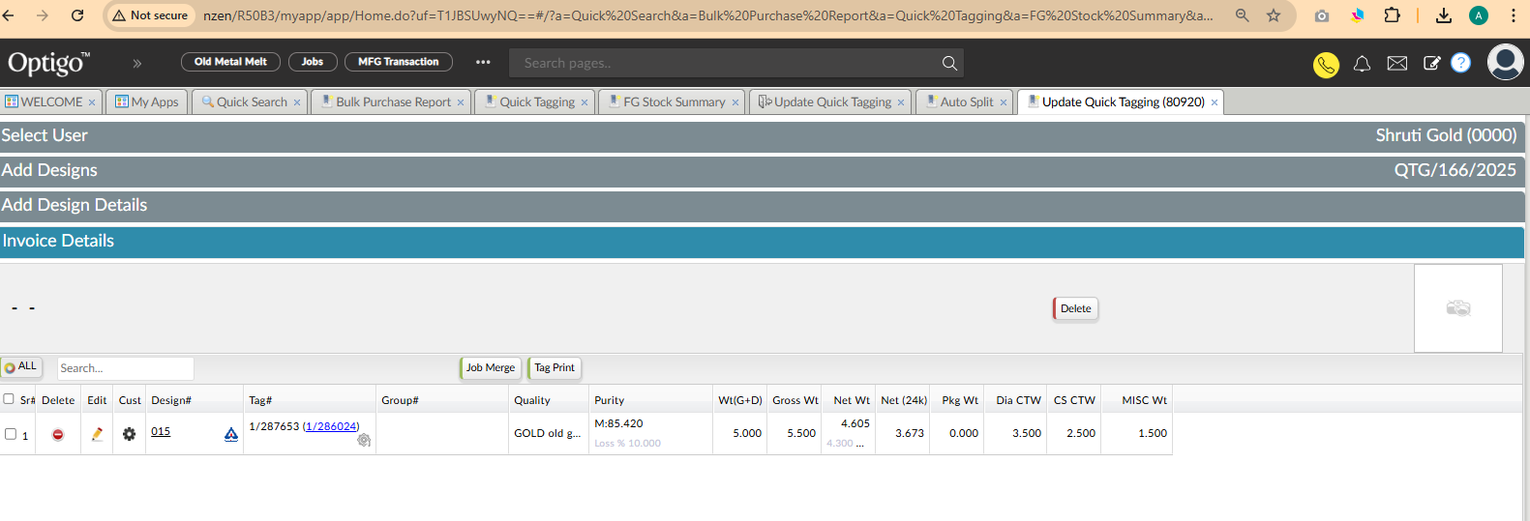
Effects in FG stock Summary after tagging as shown below
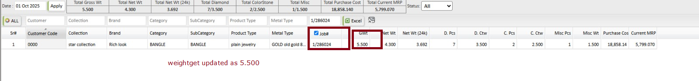
Currently weight comes as 5.500 need to update it as 11.000

1.2 Workflow Confirmation

- Check all flows from which this entry comes.
Autsplit job gets scanned for
- Merged job ( Click on two jobs in stock book and in action button select merged job in it )
- Stock purchase ( Books keeping> Purchase book > Purchase Bill option)
- Stock Purchase Import
- Factory floor
- Quick tagging
- Sales Return (old tag)

