Task : Design Wise MRP
Team
- Documentation: Trupti
- Stakeholder: -
- Developer: Mahesh plus Maitri
- Tester: Vidhi /Sneha
- Support: Kuldeep
Purpose and Goal:
Currently if need to set MRP in Quotation design wise , there is no option to set in it
We can set design wise labour but not MRP
Current Flow and Storyline:
No Current flow for setting design wise MRP however you can use article wise MRP but customer will not use some designs as Article entry for setting mrp in it. So need design wise mrp in it
New Requirement :
Step1 : Add one flag in Webconfig as IsDesignWiseMRP by default off
You can this in setup login in Config Flag (Orail Admin> WebConfig> Config Flag)
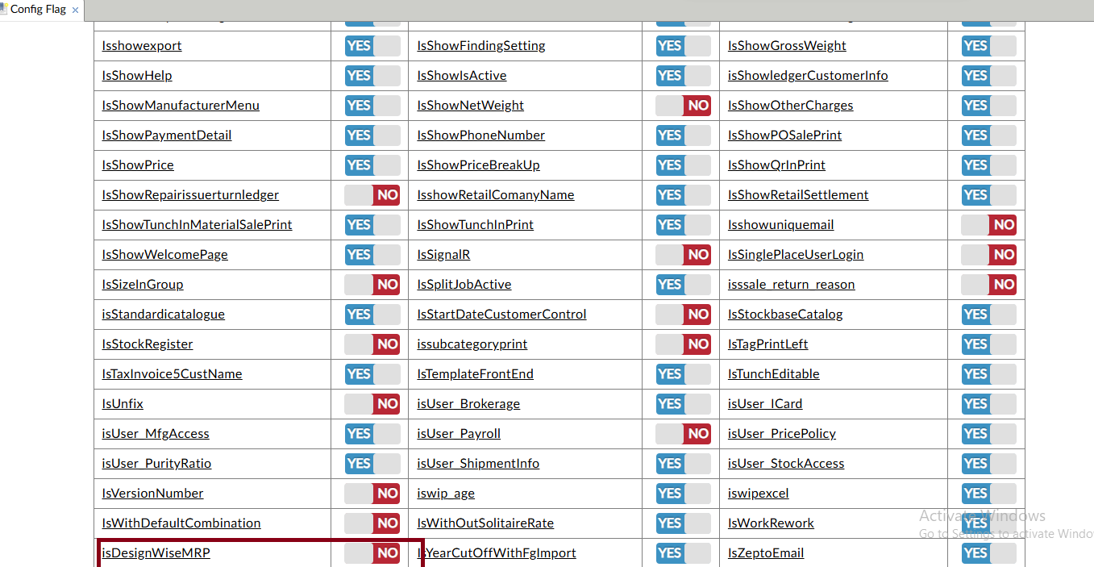

Step2 : Add flag on then add mrp column in design master as shown below
(PD > Designs> Design Master )
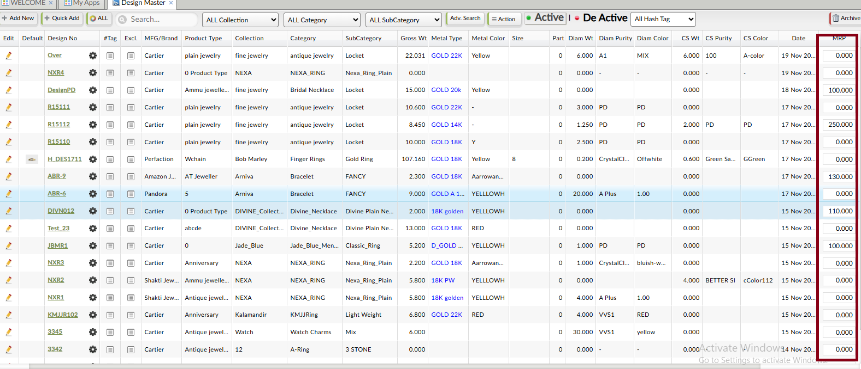

In employee login , give this field according to access permission
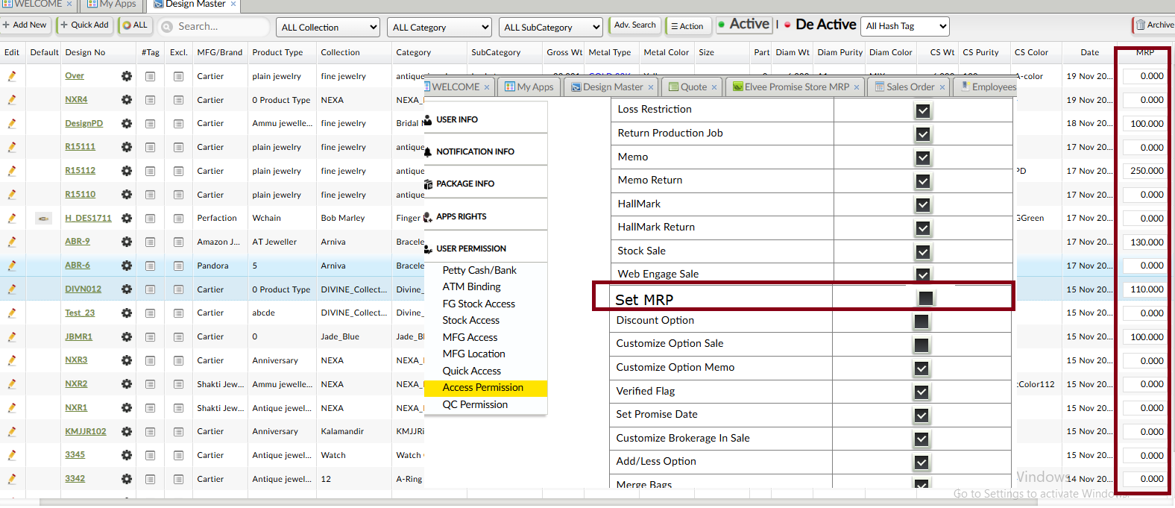

In employee login, if update rights not given then do not give MRP add/update facility in it
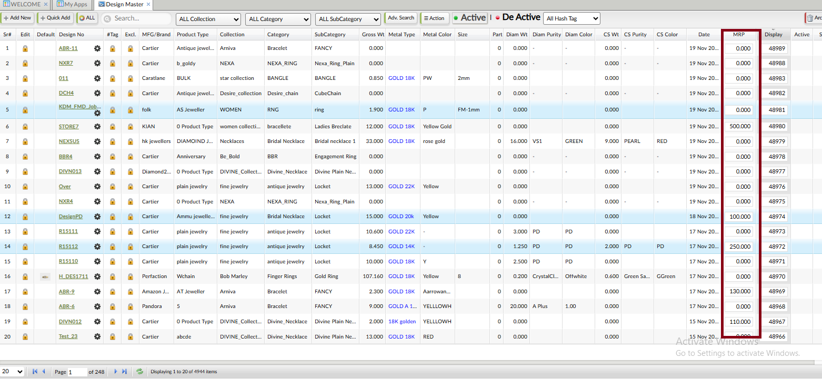
Sample entry :
Useerid : test@eg.com
Pwd : 1234

Step3 : If such designs MRP added then while making quotation it will always fetch MRP as shown below
SalesCRM>Sales > Quote, Order
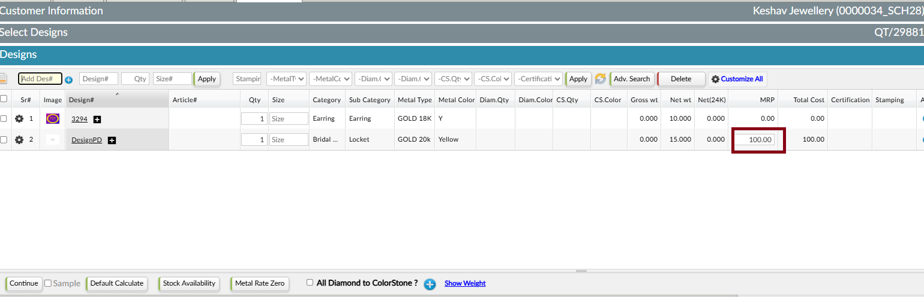
Sample entry
DesignPD design master fetched mrp as 100 .
Mrp will fetch here auto and updatable too

Step4 : Once flag on its effect in memo , sale etc will run as mrp . Such jobs entry will auto fetch in Set MRP page

