Task Name: Apply Messaging Update Across All Events: Replace 'Send SMS' with 'Send WhatsApp', Remove Default Send SMS Checkbox Selection.
Team
- Documentation: Shaifali
- Stakeholder: Trupti, Shreya
- Developer: Team
- Tester:
- Support:

Purpose and goal:
This task is to update event-based messaging system to align with current communication preferences and improve user experience. As WhatsApp has become a more widely used and preferred communication channel over SMS, the system needs to reflect this shift. This will,
- Replace the 'Send SMS' label with 'Send WhatsApp' across all event-related messaging interfaces.
- Ensure that in many of events the checkbox is not selected by default, to prevent unintentional message sending.

Current Flow and Storyline:
- Currently in our messaging events in some of events Send SMS checkbox is coming ON by default .
Example :
Account > Transactions > Bank Payment
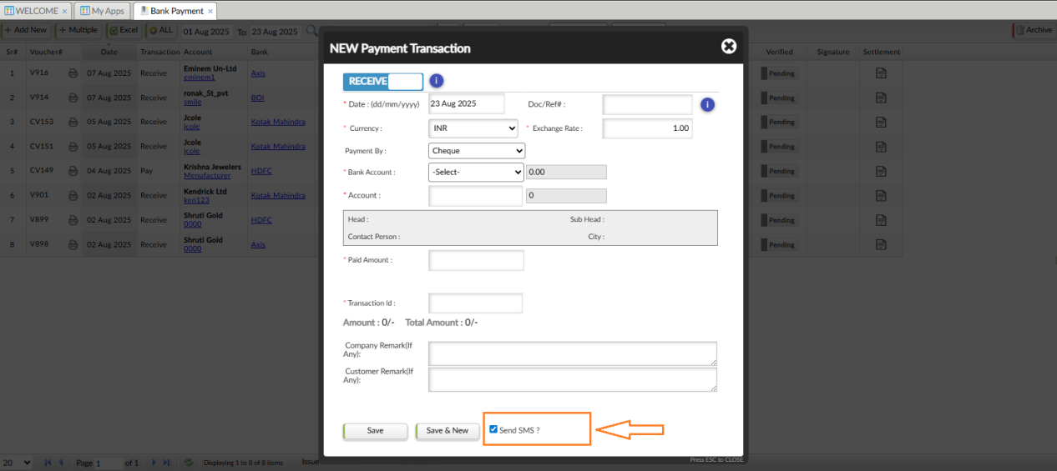
- As per image in bank payment page when user add new transaction the Send SMS check box is ON by default.
- In our all messaging event there is ‘Send SMS’ label so we need to change it and make ‘Send WhatsApp’ As WhatsApp has become a more widely used for communication.

New change Requirement (Sample):
- Change labels from Send SMS to Send WhatsApp. Events are as follows,
- In Customer Controls :-
E-Commerce Back office >> AD HOC >> Customer Controls
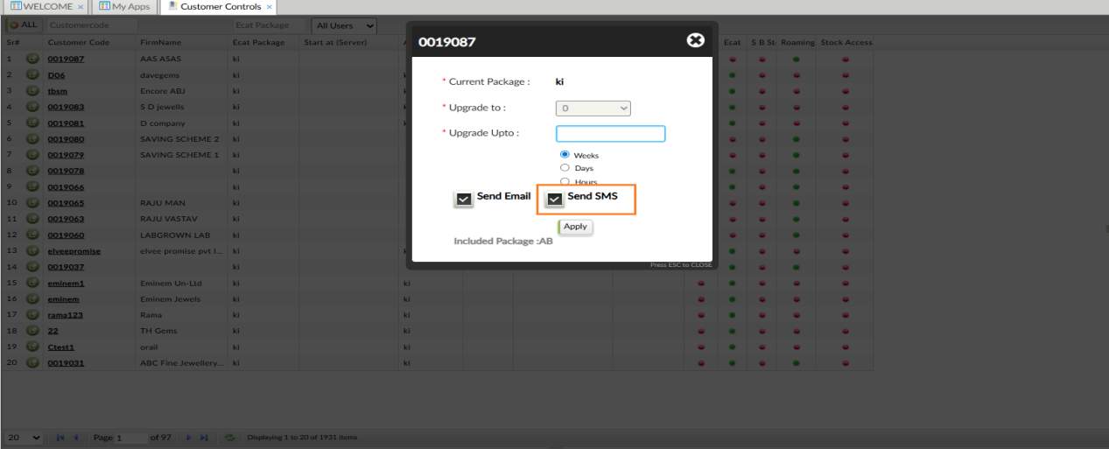
- In Shipment :-
Books Keeping >> Sales Book >> Shipment
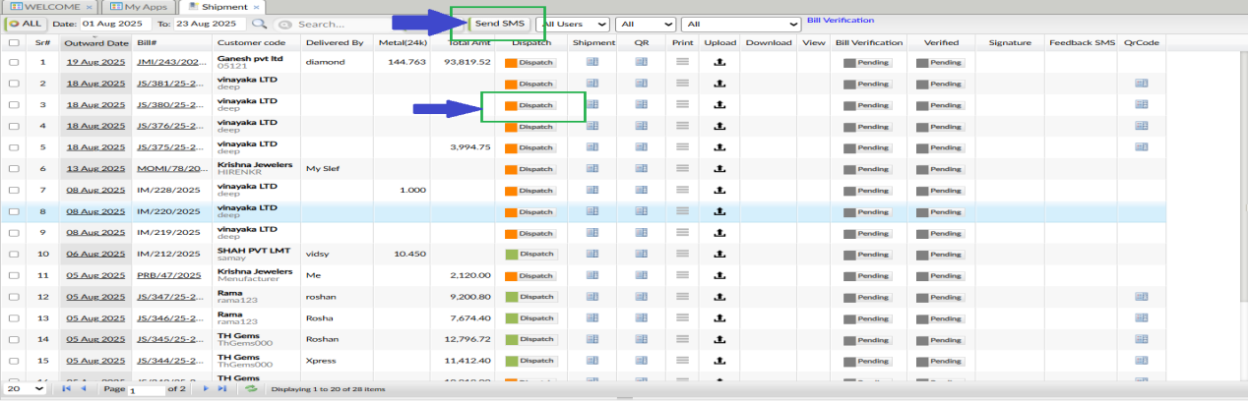
On Shipment page there is Send SMS button on top. Change it to Send WhatsApp.

when user click on Dispatch button also can send Whatsapp.
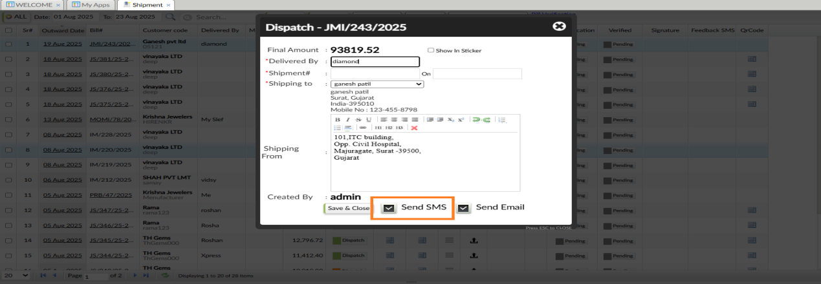

- Stock Availability :-
Sales CRM >> Sales >> Design Collection >> Add to Cart >> Check Out >> Stock Availability
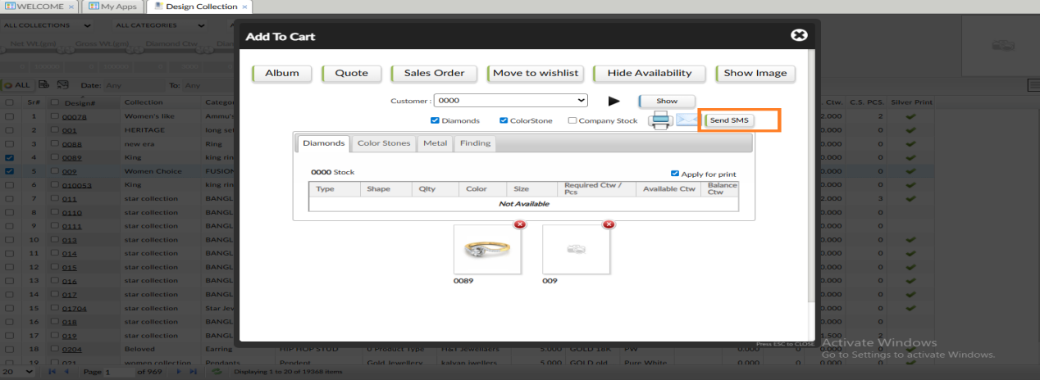

- Material Purchase Return:-
Books Keeping >> Return Goods >> Material Purchase Return >> Send SMS (In Grid)
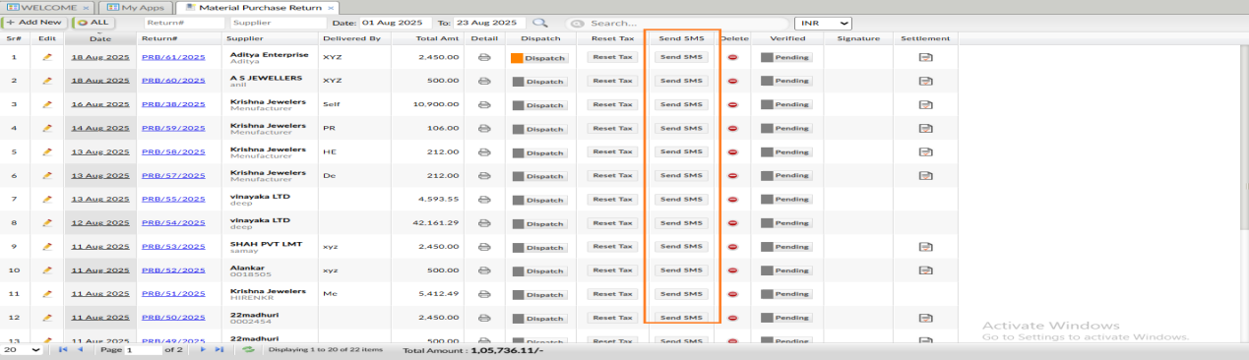
- Material Settlement :-
Account >> Rate Cut >> Material Settlement >> Metal Settlement >> Send SMS (Grid)
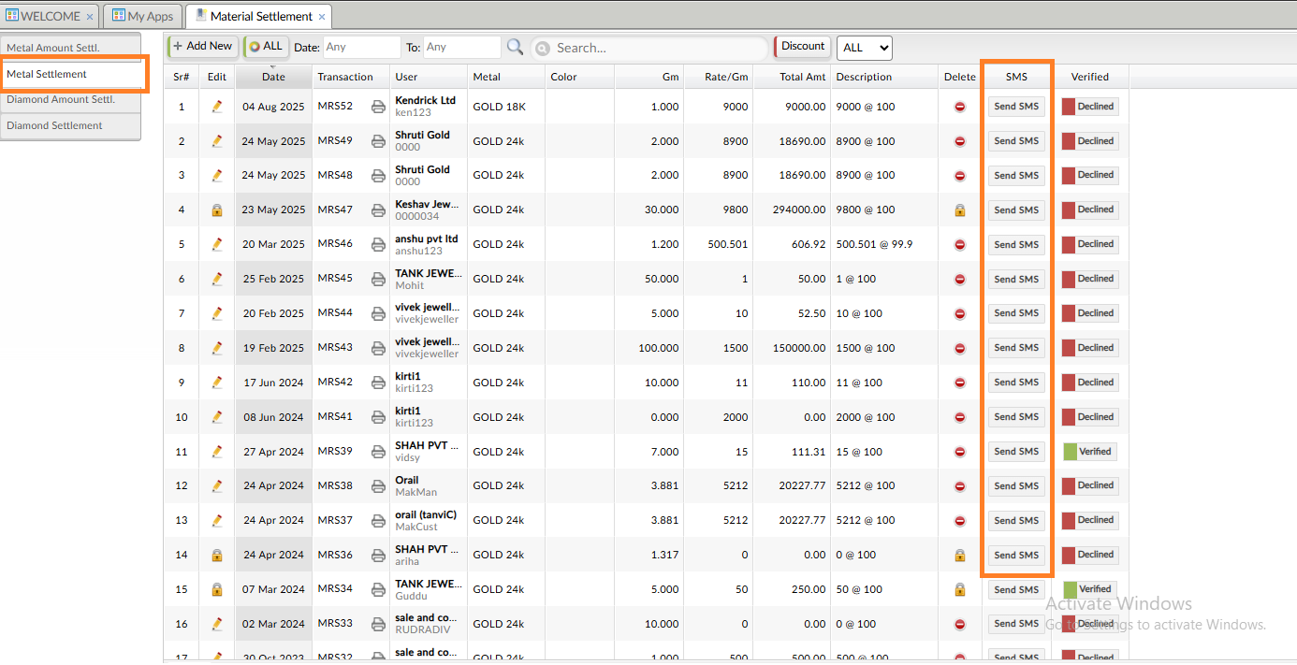
Account >> Rate Cut >> Material Settlement >> Diamond Settlement >> Send SMS (Grid)
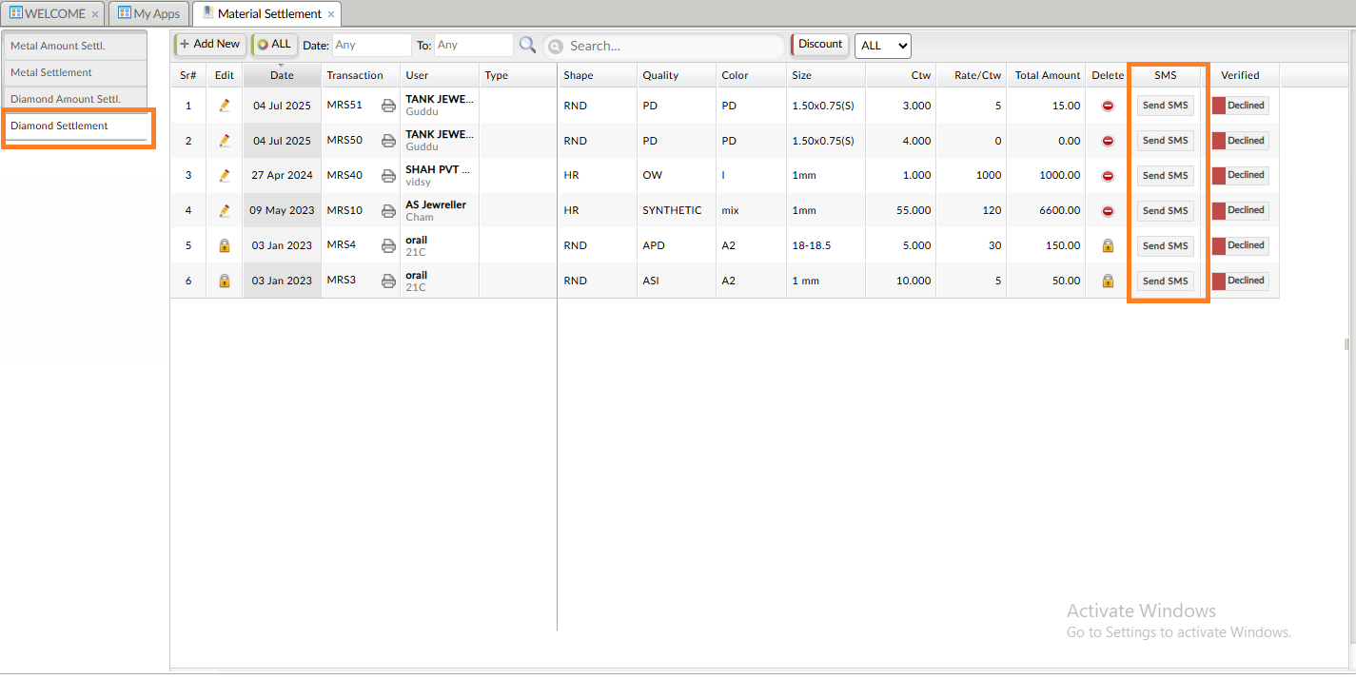

- Amount Settlement :-
Account >> Rate Cut >> Amount Settlement >> Metal Amount Settlement >> Send SMS (Grid)
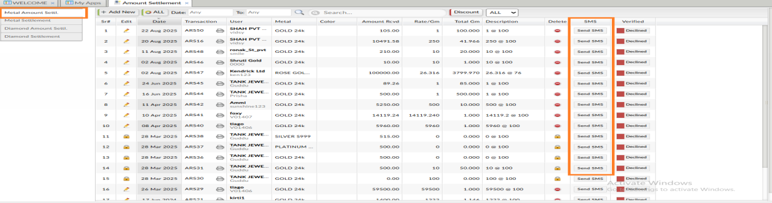
Account >> Rate Cut >> Amount Settlement >> Diamond Amount Settlement >> Send SMS (Grid)
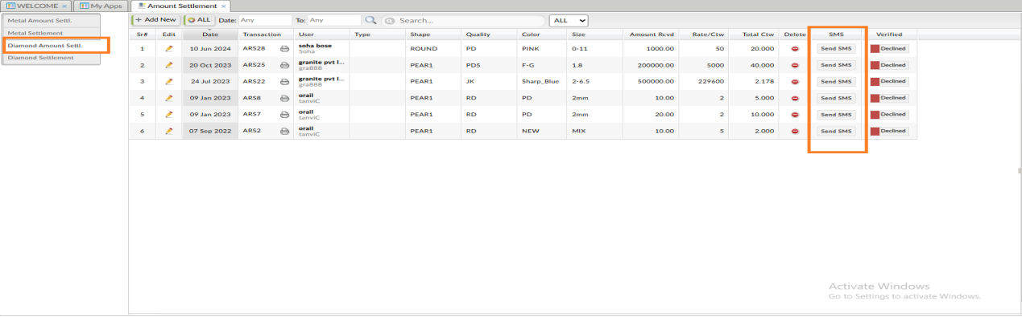

- Stock Purchase :-
Books Keeping >> Purchase book >> Stock Purchase >> Send SMS (grid)
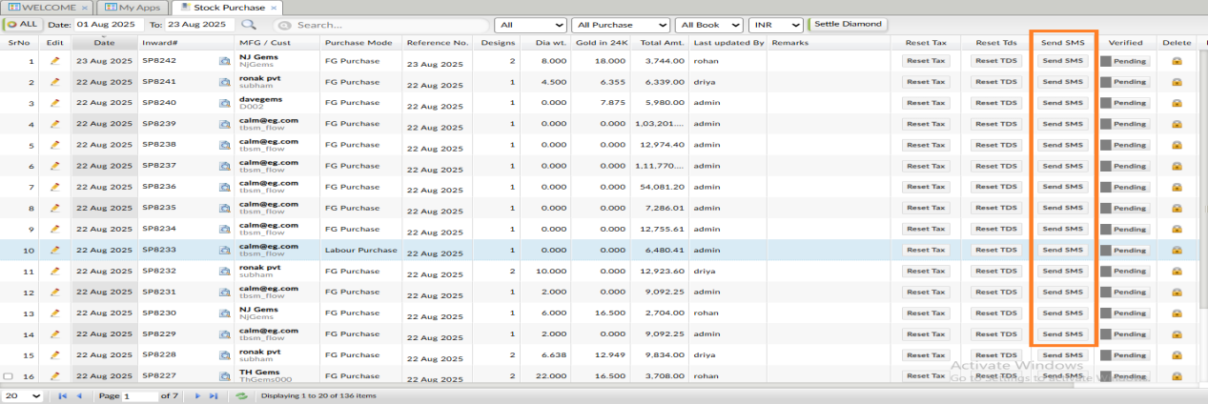

- Material Sale :-
Books Keeping >> Sales Book >> Material Sale >> Send SMS (Grid)
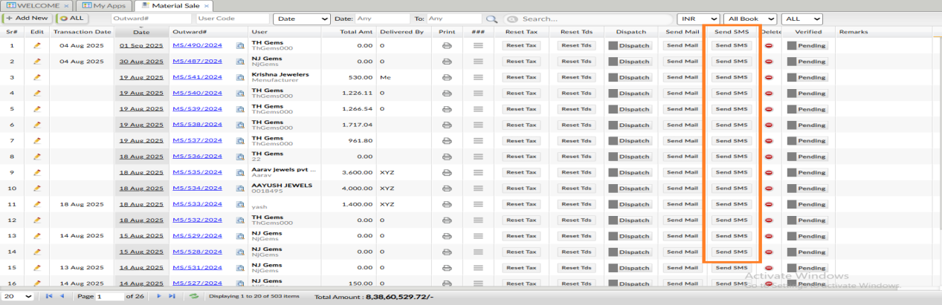
- Customer Return :-
Books Keeping >> Return goods >> Customer Return >> Send SMS (Grid and at edit time checkbox)
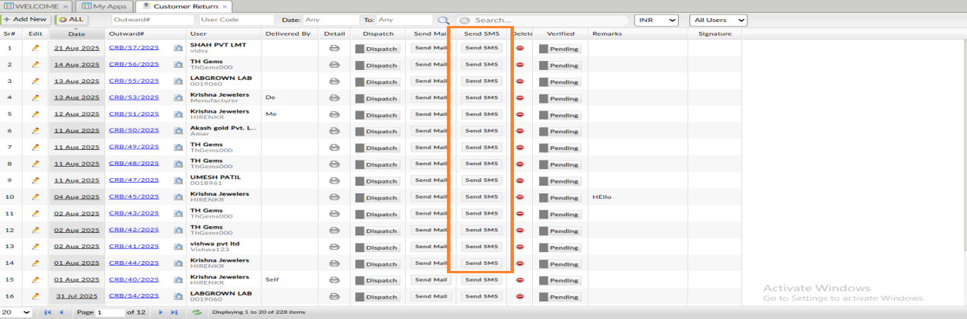
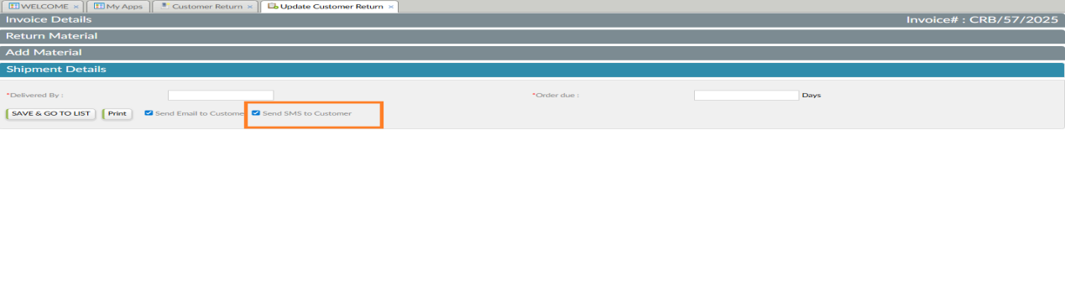

- Quotation :-
Sales CRM >> Sales >> Quote >> Send SMS and RM SMS (From grid)
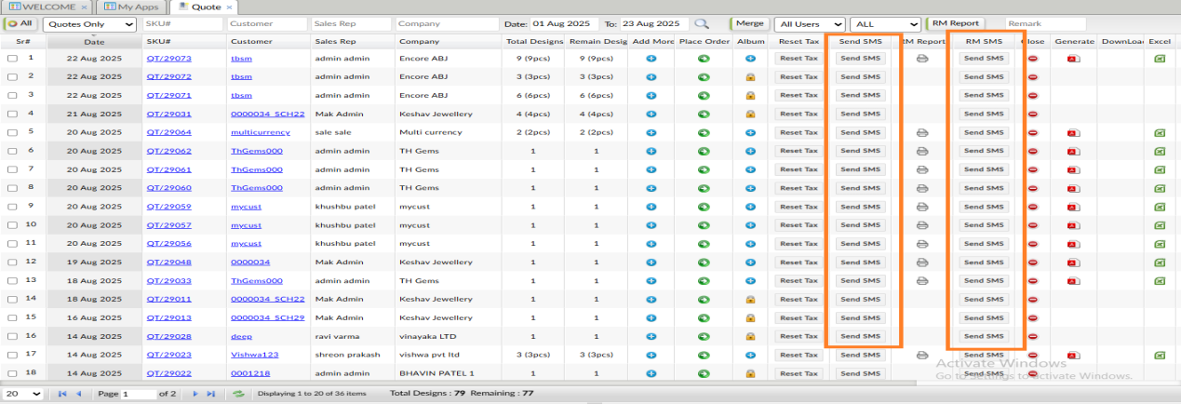

- MIS Summary :-
MIS >> MIS >> MIS Summary
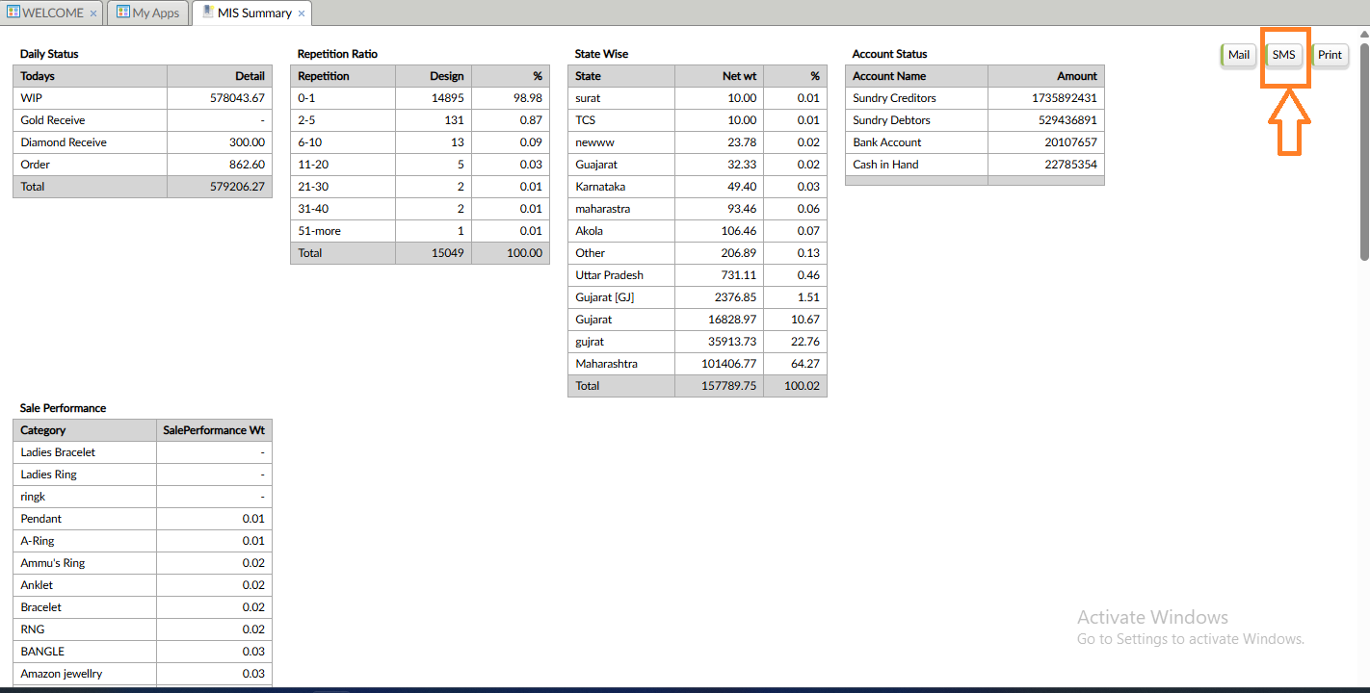
- Monthly MIS :-
MIS >> MIS >> Monthly MIS
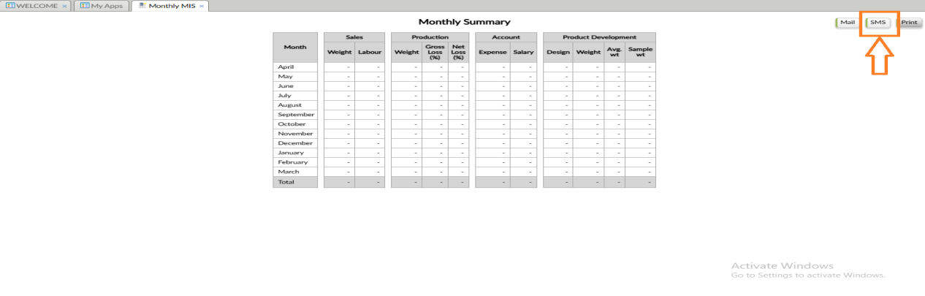
- Sales :-
Books keeping >> Sales Book >> Sales >> Jewellery Sale
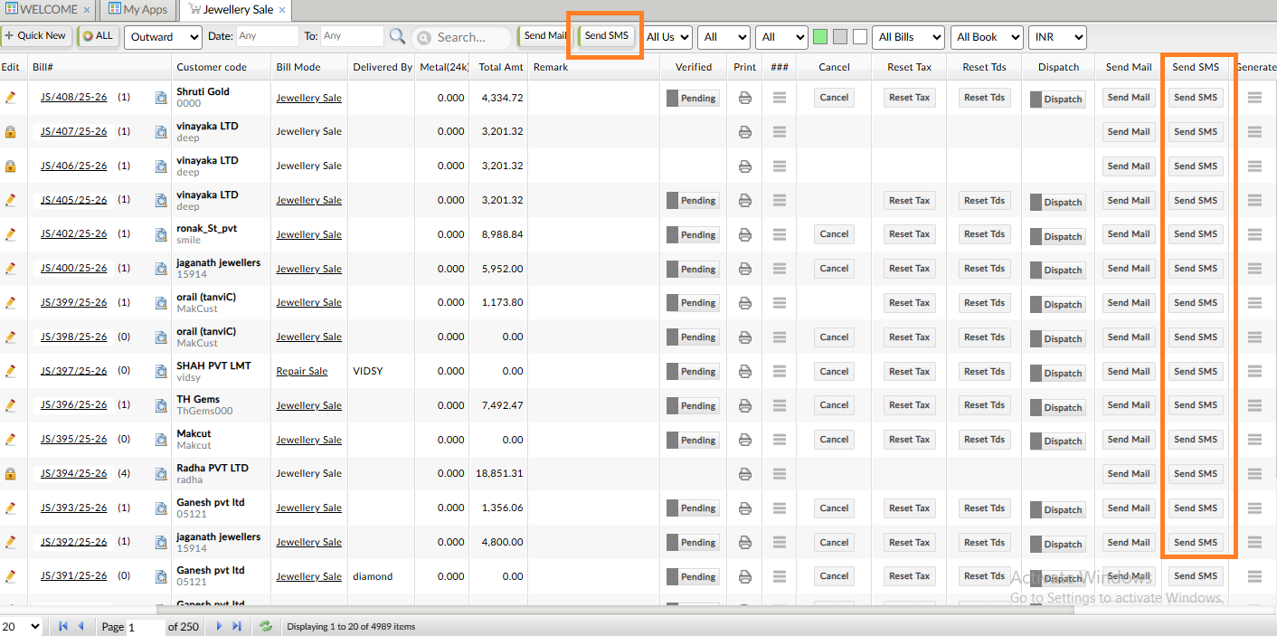

- Cash Payment :-
Account << Transections << Cash Payment << Add New << Receive/Pay
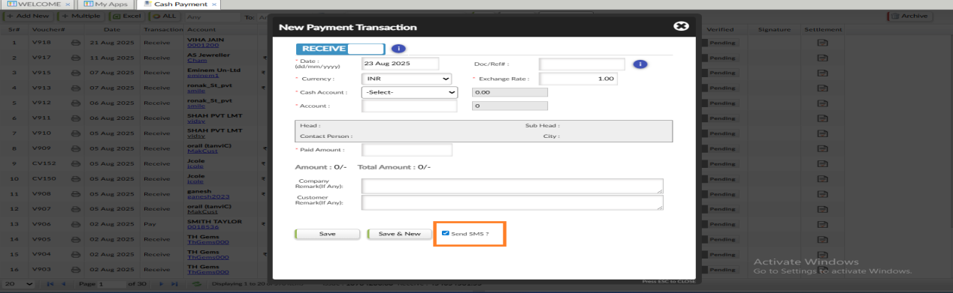
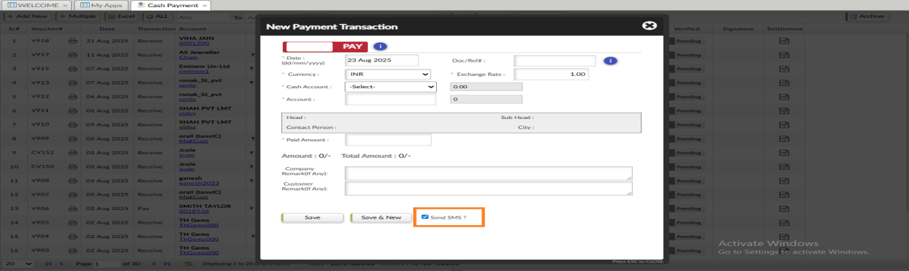
- Bank Payment :-
Account << Transections << Bank Payment << Add New << Receive/Pay
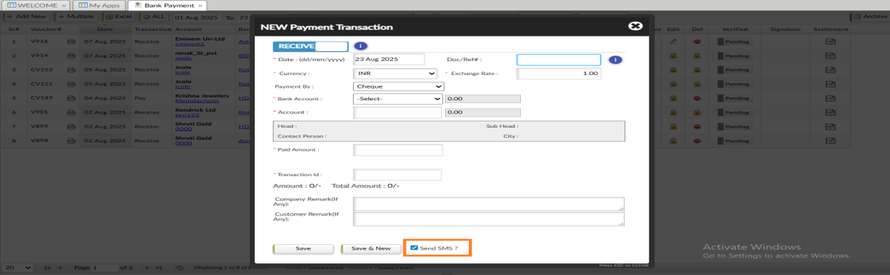
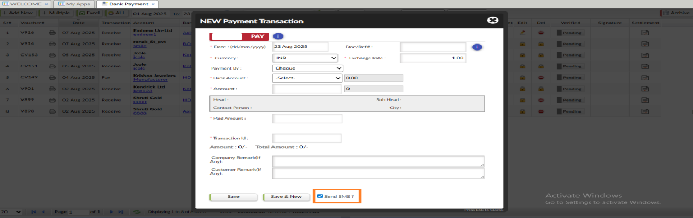
- Account Freeze :-
Account >> Account >> Yearly Account Freeze >> Click on Apply Date >> Send SMS
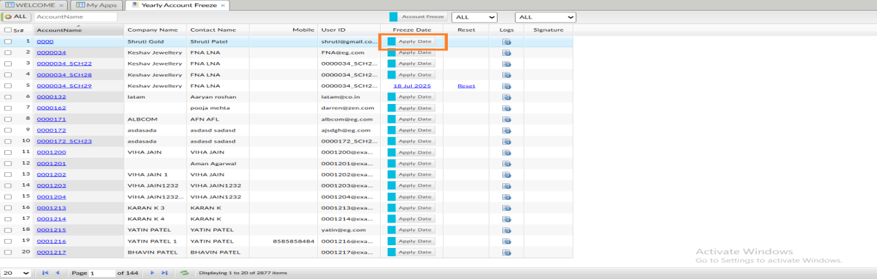
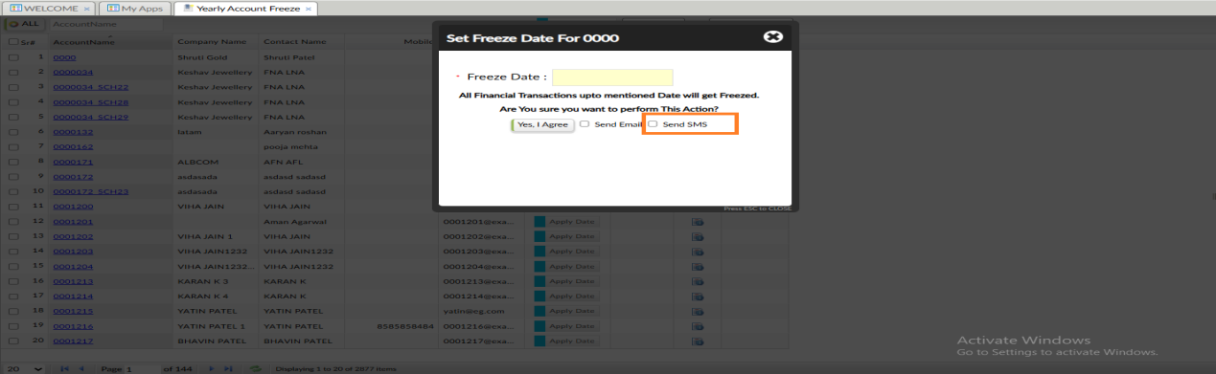

- Saving Scheme :-
Sales CRM >> Saving Scheme >> click on split installment hyperlink >> Generate Scheme >> Installment History >> Send SMS
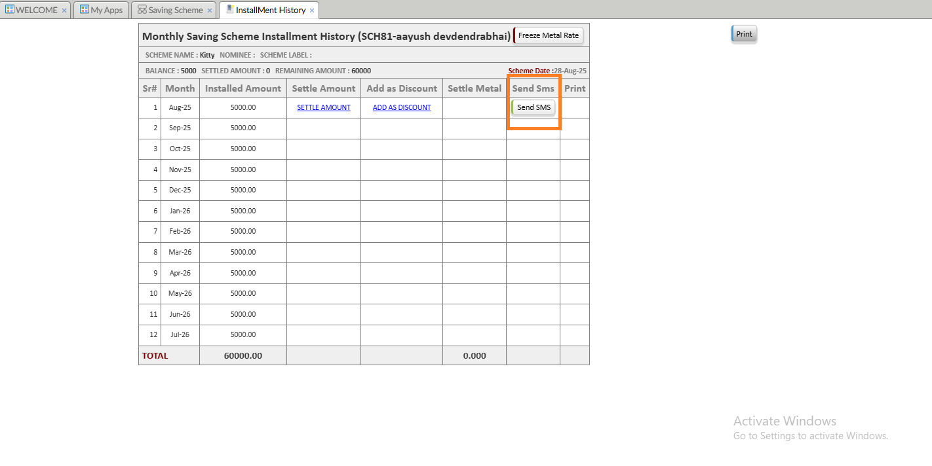
- Message box :-
Message box >> inbox >> Compose
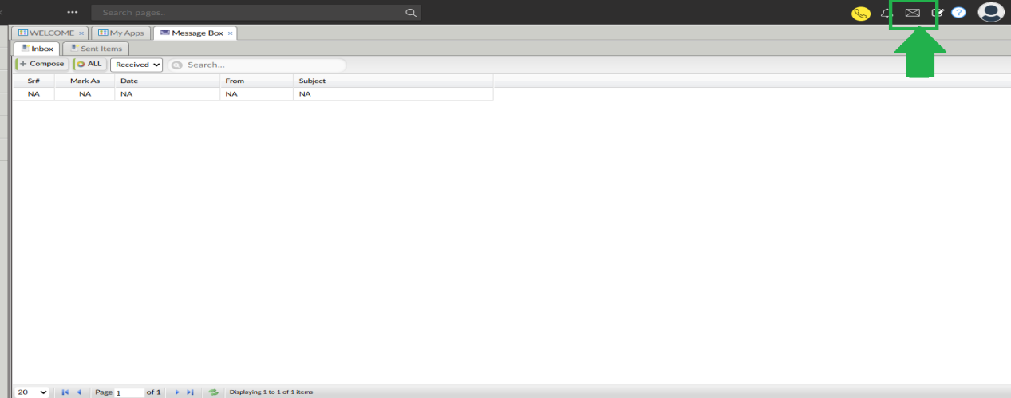
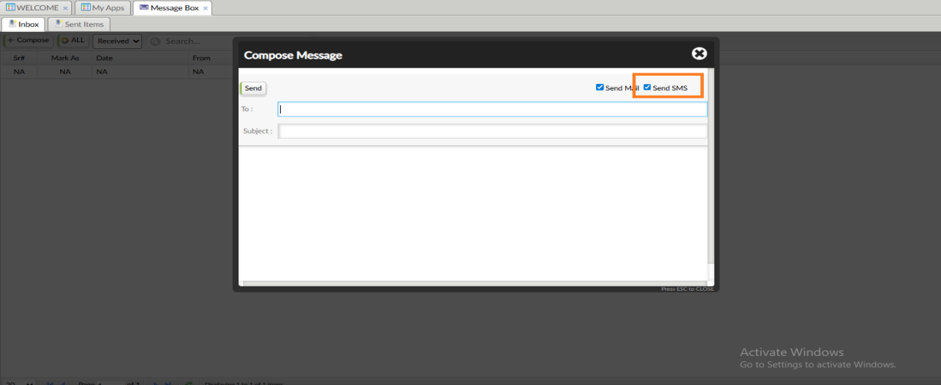

- Product Estimate :-
books keeping >> sales book >> product estimate-- Send SMS from grid and Send SMS button on top
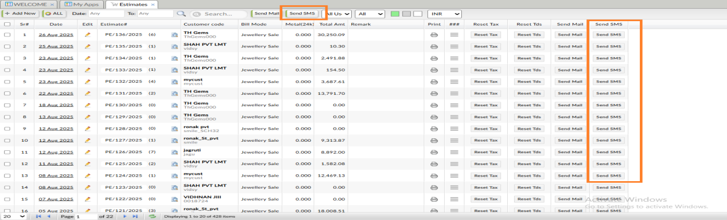

- For Send WhatsApp Checkbox :-
- Customers with flag isSendWhatsAppMessage=1 value then they only have get Send WhatApp checkbox ON (with tick) default.
- If the flag isSendWhatsAppMessage=0 value then all check boxes should be OFF (without tick).
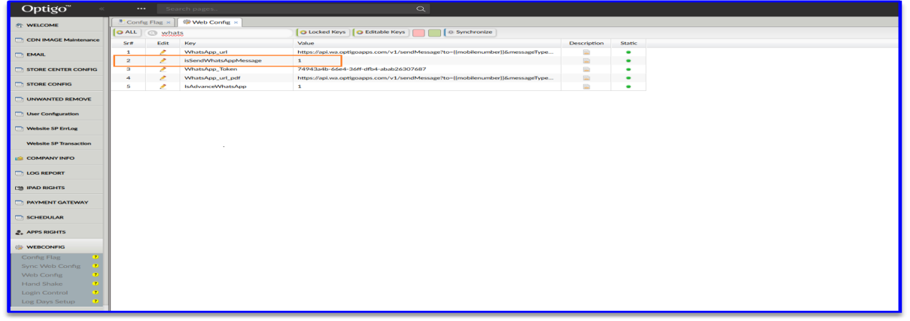
Flag : isSendWhatsAppMessage=1 ; New service will activate

- Check box facility available on events are as follows,
- Customer Controls :- E-Commerce Back office >> AD HOC >> Customer Controls
- Shipment :- Books Keeping >> Sales Book >> Shipment
- Cash Payment :- Account << Transections << Cash Payment << Add New << Receive/Pay
- Bank Payment :- Account << Transections << Bank Payment << Add New << Receive/Pay
- Account Freeze :- Account >> Account >> Yearly Account Freeze >> Click on Apply Date >> Send SMS
- Message Box :- Message box >> inbox >> Compose

Software Documentation Checklist for Developer

1. Project Overview
- ☐ Purpose of the software
- ☐ Target users/audience
- ☐ Key problems being solved
- ☐ Brief description of functionalities

2. Functional Requirements
- ☐ Feature-wise breakdown
- ☐ User actions and system responses
- ☐ Roles & permissions (Admin, User, etc.)
- ☐ Workflows / User journeys
- ☐ Business logic rules

3. Non-Functional Requirements
- ☐ Performance expectations (speed, load time)
- ☐ Scalability needs
- ☐ Security requirements (encryption, login, etc.)
- ☐ Compliance (e.g., GDPR, ISO)
- ☐ Availability / Uptime expectations

4. UI/UX Guidelines
- ☐ Screen-wise wireframes/prototypes
- ☐ Mobile responsiveness
- ☐ Branding guidelines (colors, fonts, logos)
- ☐ Navigation flow

5. Integrations
- ☐ Third-party APIs to be used (payment, SMS, etc.)
- ☐ ERP/CRM integration details (if any)
- ☐ File formats or data exchange standards (e.g., JSON, XML, CSV)

6. Technical Specifications
- ☐ Preferred tech stack (frontend, backend, DB)
- ☐ Hosting/deployment expectations (cloud, on-premise)
- ☐ Browser/device compatibility
- ☐ Database structure or sample data schema

7. Reports & Outputs
- ☐ Required reports (PDF, Excel, etc.)
- ☐ Filters/sorting options in reports
- ☐ Export options

8. User Roles & Permissions
- ☐ Defined roles (e.g., Admin, Staff, Viewer)
- ☐ Access rights per module/page/feature

9. Master Data
- ☐ What pre-defined data needs to be entered (e.g., product categories, cities, tax slabs)
- ☐ Source for master data (manual/import/API?)

10. Notifications
- ☐ Email, SMS, push notification rules
- ☐ Templates for alerts/reminders/messages
- ☐ Events that trigger notifications

11. Import / Export Modules
- ☐ File formats allowed (CSV, Excel, etc.)
- ☐ Sample input/output files
- ☐ Error handling for import

12. Validations & Error Handling
- ☐ Field-wise input validation
- ☐ Mandatory vs optional fields
- ☐ System messages for common errors

13. User Acceptance Criteria
- ☐ Test scenarios
- ☐ Acceptance benchmarks
- ☐ Go-live checklist

14. Maintenance & Support
- ☐ Backup policy
- ☐ Logging & audit trails
- ☐ Support contact and escalation flow

15. Timeline & Milestones
- ☐ Modules phase-wise delivery
- ☐ Key milestone dates
- ☐ Demo/review schedule

