Add call type field in add call with following static master data
- Short training
- Long training
- Technical Optigoside
- Technical Clientside
- Queary
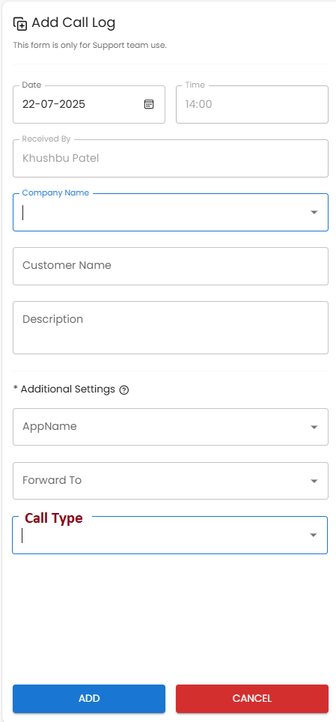

Step:2 show call type in calllog grid

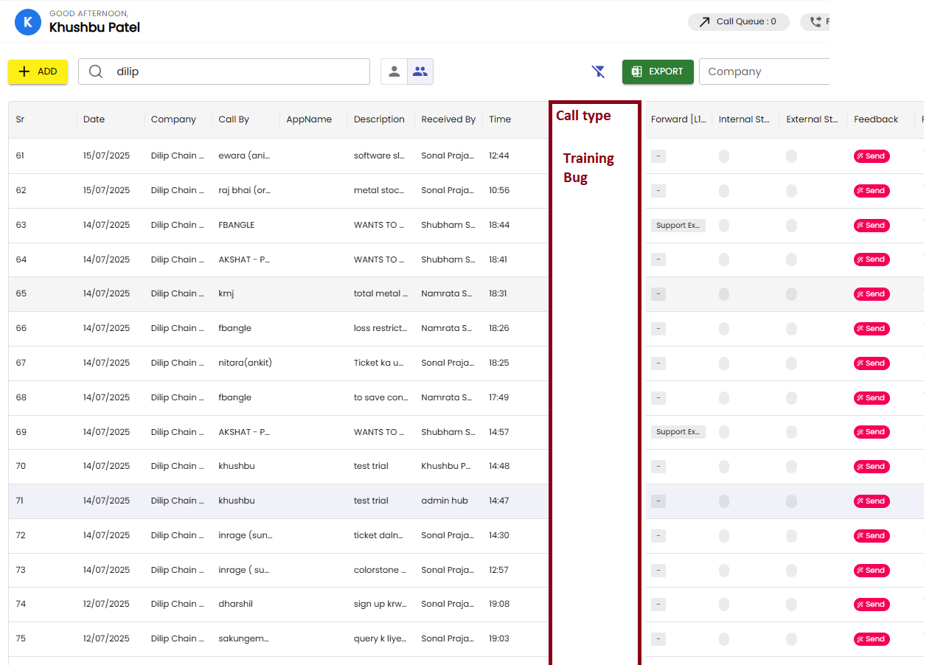

Example
- Company code:test74

Desctiption
Training reagrding STock purchase imporrt and in balance sheet customer name not showing

Call type
Short training Training

2)Company code:test73

Description
you can refer invoice wise sale / sale tally excel no any other option

Call type
Long training

3)Company code:test72

Description
you can refer invoice wise sale / sale tally excel no any other option

Call type
Long training

