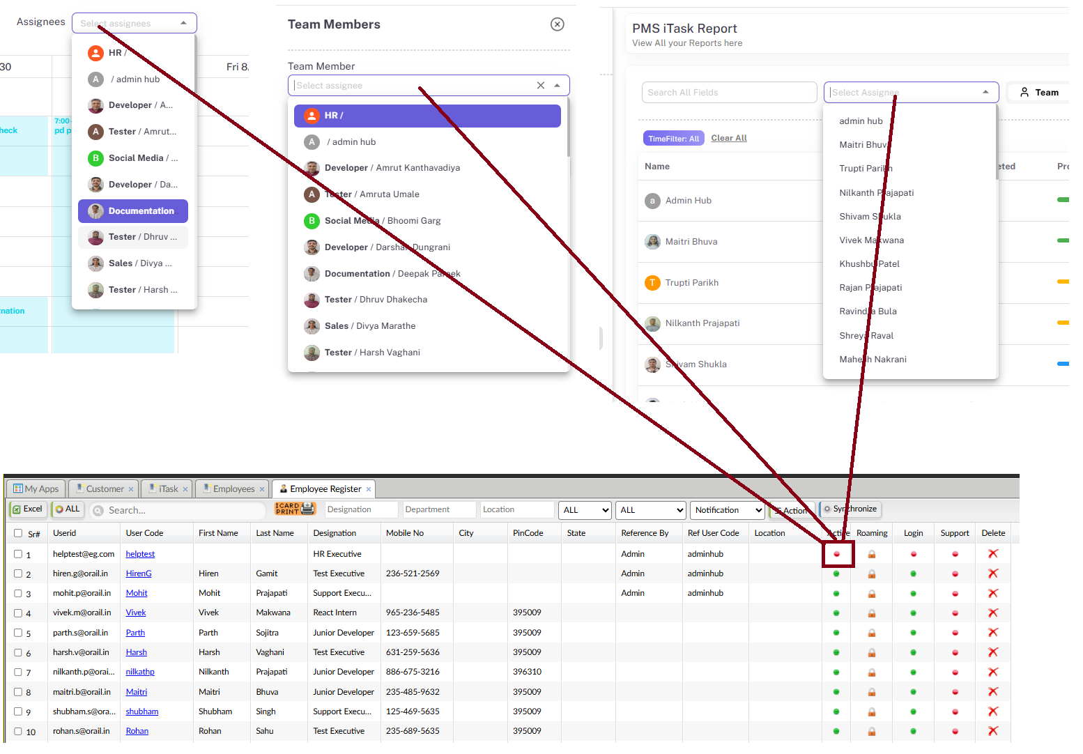

Hide unactive user in itask in following
- while add project module
- In assignee in calender module
- On task page

