Phase:2 Itask mobile app
Team : khushbu
API:parth(amrut)
UI:jenish
Tester:

Add two pages in admin app
- quick add
- Task list

As from now convert admin app in next js stucture

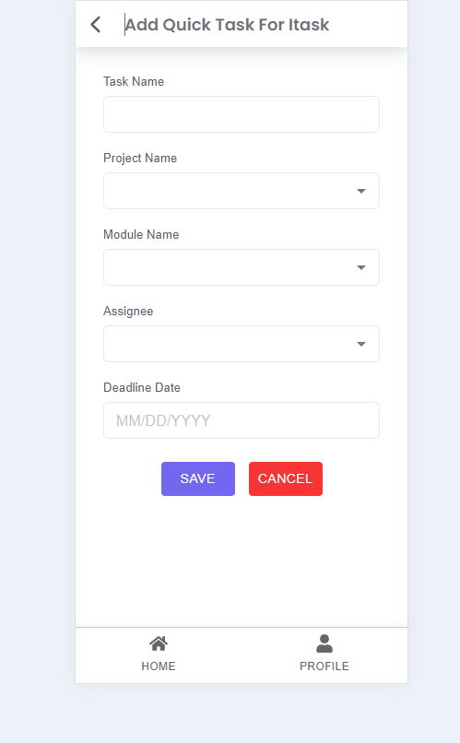

Purpose: we can add quick task in mobile and assignee to other
This screen allows users to create and assign a new task quickly within the iTask system.

The Add Quick Task form enables users to input essential details of a task, including task name, project, module, assignee, and deadline. Once submitted, the task is saved into the system database and made available in the task list.

2. Functional Requirements
# | Requirement ID | Requirement Description | Type
1 | FR-01 | System shall allow user to enter a Task Name (text input). | Functional
2 | FR-02 | System shall allow user to select a Project Name from a dropdown list fetched from the API. | Functional
3 | FR-03 | System shall allow user to select a Module Name associated with the selected project. | Functional
4 | FR-04 | System shall allow user to select an Assignee from a dropdown list of available users. | Functional
5 | FR-05 | System shall allow user to select a Deadline Date using a date picker component. | Functional
6 | FR-06 | When the Save button is clicked, all mandatory fields shall be validated before submission. | Functional
7 | FR-07 | If validation passes, task details shall be submitted to the API endpoint using POST method. | Functional
8 | FR-08 | On successful save, a confirmation message should be shown and user redirected to task list. | Functional
9 | FR-09 | If the user clicks Cancel, the system shall clear entered data and navigate back to previous screen. | Functional

3. Validation Rules
Field | Validation Rule | Error Message
Task Name | Required, 3–100 characters | “Task name is required.”
Project Name | Required (must select from dropdown) | “Please select a project.”
Module Name | Required (dependent on project) | “Please select a module.”
Assignee | Required (must select valid user) | “Please select an assignee.”
Deadline Date | Required, must be a valid future date | “Please select a valid deadline date.”

4. UI / UX Specifications
UI Element | Type | Behavior / Description
Task Name | TextField | Plain input for task title.
Project Name | Dropdown(typo) | Populated from project API.
Module Name | Dropdown+typo | Populated dynamically after project selection.
Assignee | Dropdown+typo | Populated with active users.
Deadline Date | Date Picker | Opens calendar popup using MUI date picker.
Save Button | Button (Primary) | Calls API to save task. Color: Purple (#685dd8).
Cancel Button | Button (Secondary) | Resets and navigates back. Color: Red (#ff3b30).
Navigation Bar | Header | Displays title “Add Quick Task For iTask” and back arrow.
Footer Menu | Navigation | Two icons — Home and Profile.

6. Non-Functional Requirements
# | Description
NFR-01 | Form must load within 2 seconds on a 4G network.
NFR-02 | API requests must be asynchronous with proper error handling.
NFR-03 | UI must be responsive and mobile-friendly.
NFR-04 | Validation must occur client-side before API call.

7. Error Handling
Scenario | Expected Behavior
API fails | Show alert: “Unable to save task. Please try again later.”
Network timeout | Show toast: “Connection timeout. Check your internet connection.”
Validation error | Highlight invalid fields and show respective error message.

8. Success Flow
User fills all fields.
User clicks Save.
Frontend validates input.
If valid → call POST /api/task/add.
API responds success → Show toast “Task created successfully”.
Redirect to Task List or Dashboard.
