Step 1: make the duplicate page of itask with the name of “team cal view ”
Step:2 show side bar,in this department and assignee dropdown can come
Step:3 added assignee show in in below

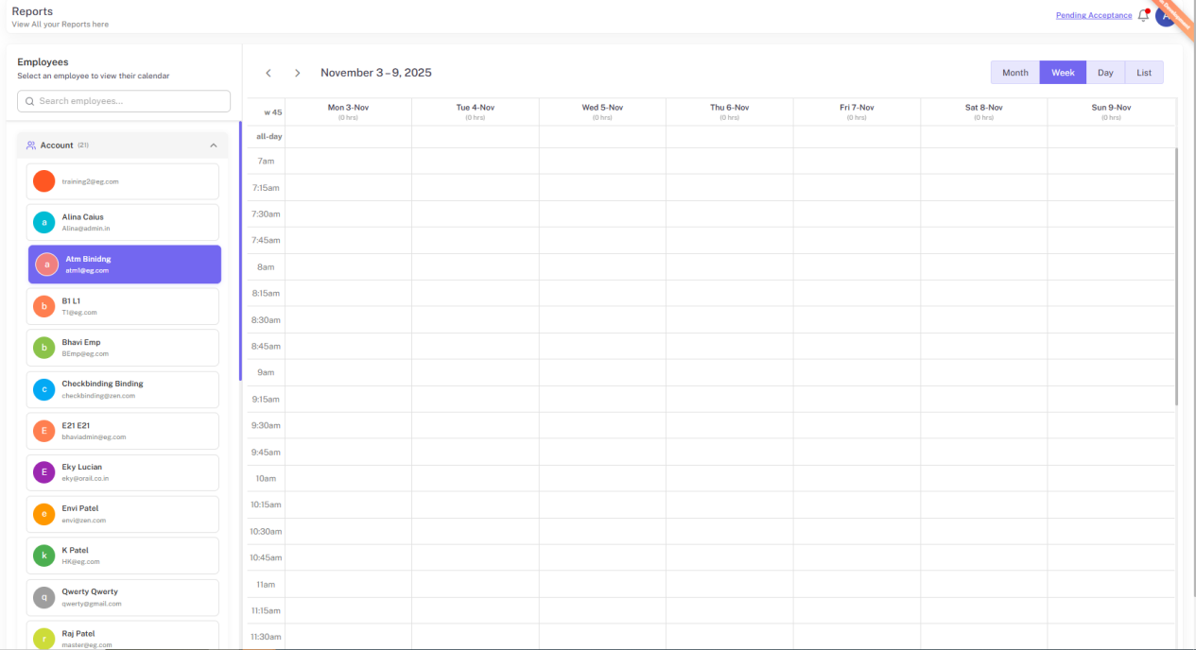

Only added employee's calender can show in it

Step:4 make this page on rights based

