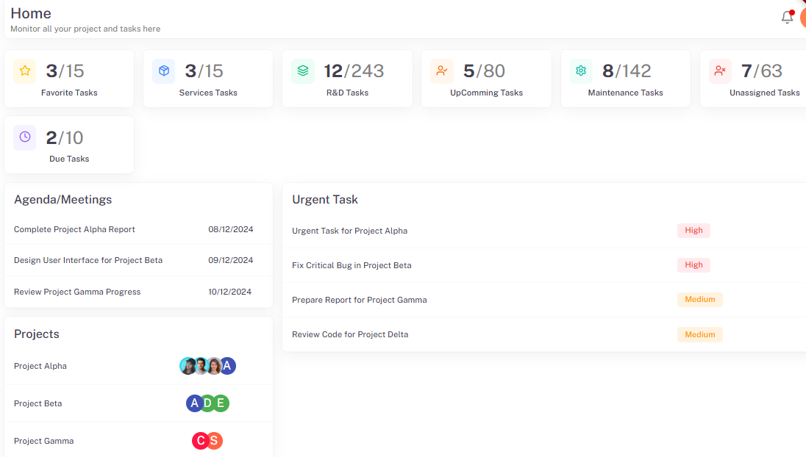

- Favorite task
Number of Favourite task/total task

- R & D task
Today date task /total RND task

- upcoming task
Today date task/total upcoming task

- maintenance task(category)
Today date task /total maintenance task

- unassigned task
Today date task /total number of assassine task (currently onhold)

- due task
Today date task /total number of due task

