1.1 Purpose
This document defines the functional and non-functional requirements for implementing a Recurring Task feature in the Task Management System. The purpose of this feature is to allow users to create tasks that repeat at specified intervals (daily, weekly, monthly, etc.) to reduce repetitive manual input.
Step:1 Add repeat button when click and calender scheduled task
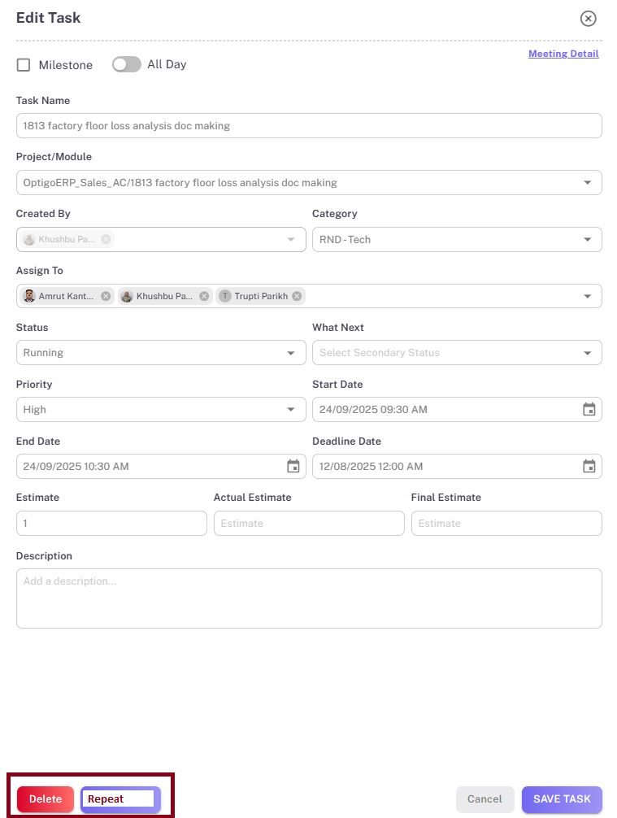
Notes:
- task details are same as clicked task
- Start date will auto update by current date and time

Step:2 on repeat button click save same task name with new separate task

Technical special note : for developer
Currently meeting and task table are different so when when create repeat task ith will go in meeting table then going in task table

