Project name:1930 login page in csystem.optiogoapps.com
Step:1
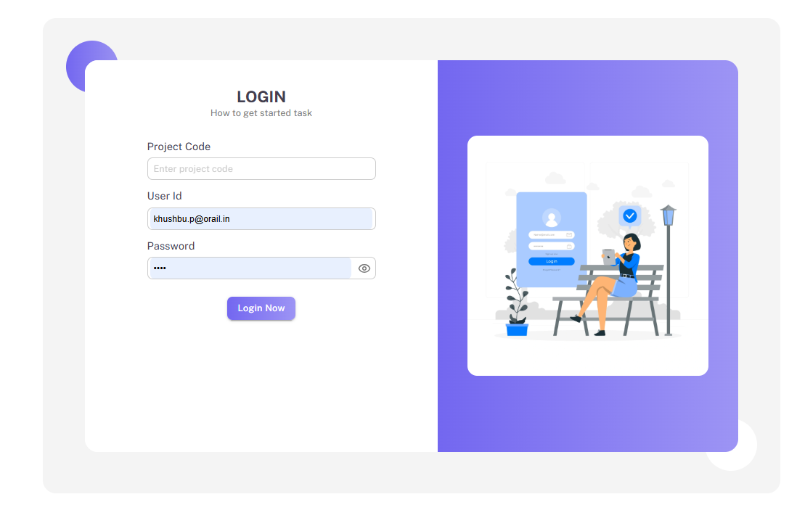

Software Requirements Document (SRD)
System Overview:
The system in the image is a login page used for authentication. It requires a project code, user ID, and password for the user to gain access. The design appears to be web-based with an intuitive user interface that allows for easy login.

1. Functional Requirements:
Login Form
The user is prompted to enter a Project Code, User ID, and Password in the login form.
The user should be able to see the placeholder text "Enter project code," "Enter username," and "Enter password" when no input is given in each respective field.
Password field should have a toggle (eye icon) to show/hide password input for ease of visibility.
Password Management:
The login form should display a dropdown or suggestion list of saved passwords when the user interacts with the password input field.
The saved password list should include previously used credentials for the specific username or domain.
Project Code Field:
The user needs to input the Project Code before accessing the platform.
If the code is incorrect, the system must return an error message (not shown in the image but implied for error handling).
Login Button:
There should be a clearly visible Login button to submit the form once all fields are filled.
The login button should be disabled until all required fields (Project Code, User ID, Password) are properly filled.
Visual Design:
The design should have a clean and modern look, with a minimalistic aesthetic. The use of purple and blue gradients in the background emphasizes a soothing user experience.
The image on the right (of a woman sitting on a bench) provides a friendly and welcoming vibe.
Responsive Design:
The system should be responsive, meaning that it adjusts seamlessly across devices (mobile, tablet, desktop).
The layout should adapt to different screen sizes without losing functionality.

2. Non-Functional Requirements:
Performance:
The page must load within 2 seconds to provide a smooth experience for users.
Security:
Passwords should be encrypted and not stored in plain text.
Ensure two-factor authentication (2FA) options are available for added security (this can be an additional feature to consider, but not shown in the image).
Usability:
The login form should be easy to navigate, with clear input labels.
Accessibility:
The system should support screen readers for visually impaired users.
High contrast between text and background should be maintained for readability.

3. System Architecture:
The system should be built using HTML, CSS, and react js for the front-end implementation.
Backend technology (Node.js, .) should securely handle user authentication.
Database to store user credentials securely, such as using hashed passwords and ensuring compliance with relevant security standards (e.g., GDPR, CCPA).

4. Error Handling:
If the user enters incorrect login credentials (either Project Code, User ID, or Password), the system should return an error message.
The error message should be clear and instructive, such as “Invalid credentials, please try again.”

5. Assumptions and Constraints:
The system assumes that the user has access to the internet and is able to interact with a web browser.
The login system will not support auto-creation of user credentials from this form but will require re-registered accounts.

Step:2 Show application as per Rights access
- Callog
- Order delivery(admin)
- Ticket admin
- Add training

