Software Requirements Specification (SRS)

Introduction
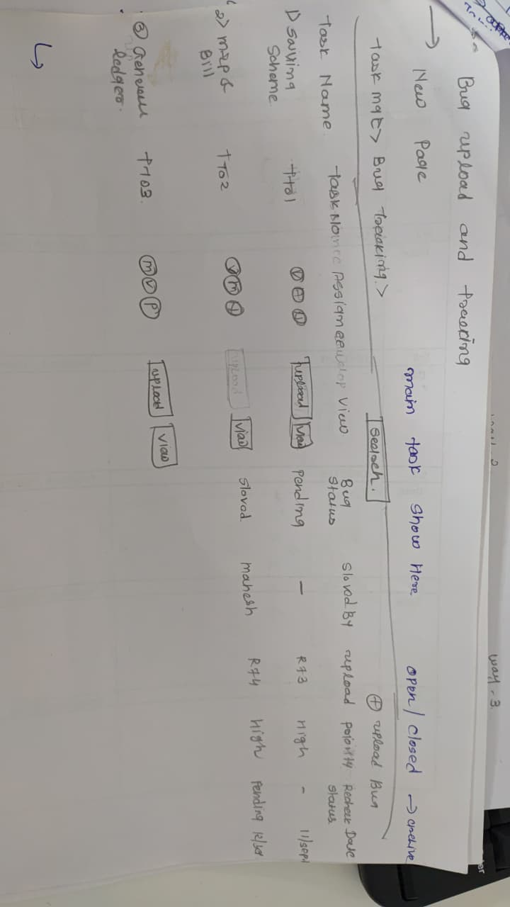

1.1 Purpose
The purpose of this system is to provide a Bug Upload and Tracking module that allows users to create, view, assign, prioritize, and track bugs efficiently. The system also supports task management and status updates to ensure timely resolution.

1.2 Scope
This system will manage tasks related to bugs in a project. Key functionalities include:
Uploading new bugs
Viewing existing bugs
Assigning tasks to team members
Setting priorities
Tracking bug status (open/closed/pending)
Searching and filtering bugs
The system will ensure accountability by tracking who uploaded and resolved each bug.

1.3 Definitions, Acronyms, and Abbreviations
Term | Description
Bug | A defect or error in software
Task | A unit of work associated with a bug
Status | The current state of a bug: Open, Closed, Pending
Priority | Importance level of a bug: High, Medium, Low
Assign | Assigning the bug/task to a team member
Upload | Action to create a new bug report

2. Functional Requirements

2.1 Task Management
Task Name: Each bug is associated with a task name.
Task Assignment: Tasks can be assigned to team members.
Task Priority: Priority can be set (e.g., High, Medium, Low).
Task Status: Tasks can be tracked as Open, Closed, or Pending.
Task Actions: Users can upload new bugs, view details, and update status.

2.2 Bug Management
Upload Bug: Users can create a new bug entry and provide details such as task name, description, and priority.
View Bug: Users can see a list of uploaded bugs along with relevant details.
Search Bug: Search functionality to find bugs by task name, assigned person, or status.
Status Update: Users can mark bugs as Open, Closed, or Pending.
Priority Update: Users can change the priority of a bug as needed.

2.3 User Assignment
Each task can be assigned to multiple team members.
Assignment details include:
Assigned By
Assigned To
Task Status
Upload Date

2.4 Reporting
Status Report: Track the current status of all bugs.
Priority Report: View all bugs filtered by priority.
Assignment Report: Identify who is responsible for each bug.

3. Non-Functional Requirements
Performance: System should handle multiple simultaneous users without delays.
Usability: Intuitive UI to upload, view, and search bugs.
Security: Role-based access to prevent unauthorized edits.
Reliability: Accurate status and assignment updates.

4. Data Model
From the image, table fields can be structured as follows:
Field Name | Description
Task Name | Name of the task or bug
Task Assigned To | Person responsible for the task
Task Assigned By | Person assigning the task
Status | Open / Closed / Pending
Priority | High / Medium / Low
Upload Date | Date the bug was uploaded
Action Buttons | Upload / View / Update

5. User Interface Mockup
Main Page: List of tasks/bugs with columns: Task Name, Assigned To, Status, Priority.
Upload Button: Opens a form to add new bugs.
View Button: Opens bug details and allows status updates.
Search Bar: Filters tasks by keywords.
Status Toggle: Open / Closed / Pending for each task.
Priority Selector: High / Medium / Low.

Image editor

1. Introduction
This document describes the requirements for an Image Upload and Editing System. The system allows users to upload images, preview them, and apply basic image editing features such as text insertion, image adjustments, and color modifications.

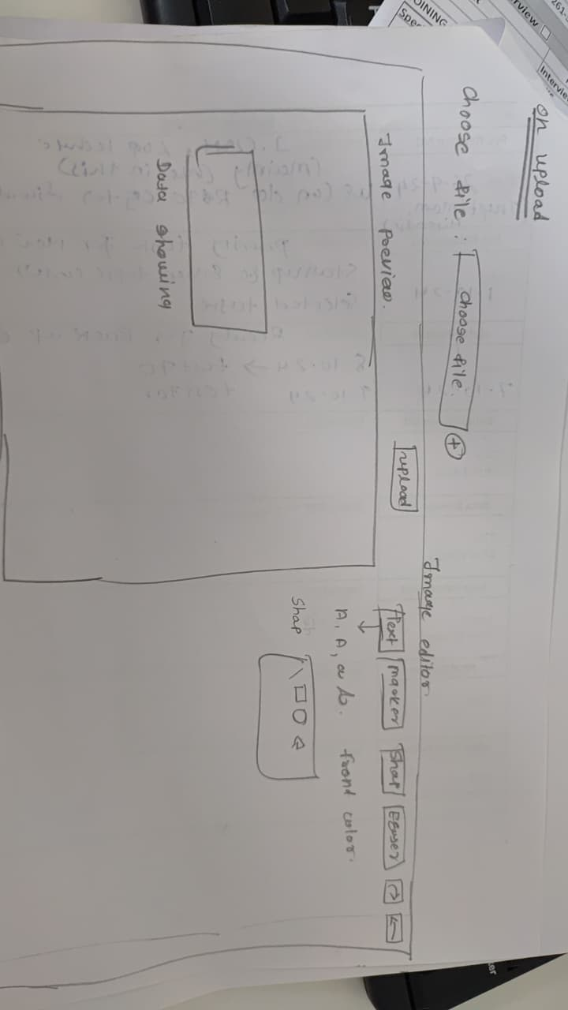

2. System Overview
The system consists of the following main functionalities:
Image Upload: Users can select and upload image files.
Snap Photo Will automatic update in it
Image Preview: Users can preview the uploaded image.
Text Editor: Users can add and format text on the image.
Drawing Tools: Users can draw shapes on the image, with the ability to select colors and styles.
Image Editor Toolbar: Provides controls for image editing such as resizing, rotating, and adjusting colors.

3. Functional Requirements

3.1 Image Upload
The system allows the user to choose an image file from their local device.
A file input button ("Choose File") will allow the user to browse their computer.
The system supports multiple image formats (e.g., PNG, JPG, JPEG).
Once uploaded, the image will be displayed in a preview area.

3.2 Image Preview
The uploaded image is displayed in a designated preview area.
Users can click on the image to view it in full size or zoom in/out.

3.3 Text Editor

Users can add text to the uploaded image.
The text editor will have basic text formatting options:
Font size: Users can choose from predefined font sizes (small, medium, large).
Font style: The system will allow text to be styled (e.g., bold, italic).
Font color: Users can choose the text color from a color palette.
Text position: Users can drag and place the text anywhere on the image.

3.4 Drawing Tools
The system will allow users to draw shapes on the image, such as rectangles, circles, or freehand lines.
Users can select the following options for drawing:
Shape type: Rectangle, Circle, Freehand
Color selection: Users can pick colors from a color palette for their shapes.
Shape fill: Options to fill the shape with color or leave it transparent.
Line thickness and style: Users can choose different line thickness and dashed/solid styles.

3.5 Image Editing Toolbar
A toolbar will be displayed below the preview area with the following options:
Zoom: Users can zoom in or out of the image.
Rotate: A button to rotate the image clockwise or counterclockwise.
Undo/Redo: Allows users to undo or redo the most recent actions (e.g., text insertion, drawing).
Clear/Reset: Clears all edits and resets the image to the original state.
Save: Users can save the edited image in their preferred format (PNG, JPG, etc.).

4. Non-Functional Requirements

4.1 Usability
The interface should be intuitive, with a clear layout of buttons and tools.
Tooltips or help texts should be available for explaining the functions of each button and tool.

4.2 Performance
The system should support quick file uploads for images under 5MB.
The system should provide real-time preview updates when editing the image.

4.3 Compatibility
The system should work on all modern browsers (Chrome, Firefox, Edge, Safari).
The system should be responsive, supporting different screen sizes and devices (desktop, tablet, mobile).

5. System Design

5.1 User Interface
The interface consists of the following components:
A file input area for image upload.
A preview area displaying the uploaded image.
An image editor toolbar with options to edit, save, or clear the image.
A color palette for text and shape color selection.
A text editor area for adding and formatting text.

5.2 Back-End
The system will store the uploaded images temporarily on the server for editing.
Image modifications (such as added text or shapes) will be applied dynamically on the client side.

6. Constraints
File size limit for image uploads is set to 5MB.
The system supports only image file formats (e.g., PNG, JPG, JPEG).

7. User Stories
User Story 1: As a user, I want to upload an image so that I can start editing it.
User Story 2: As a user, I want to add text to my image and change its font and color.
User Story 3: As a user, I want to draw shapes on my image and change their color and size.
User Story 4: As a user, I want to save my edited image for later use.

