Purpose:need training title to describe the training information
Storyline:
Step 1: add training title to while add training
Caption: Training Title
Value :input type
Character Lenth:100 word

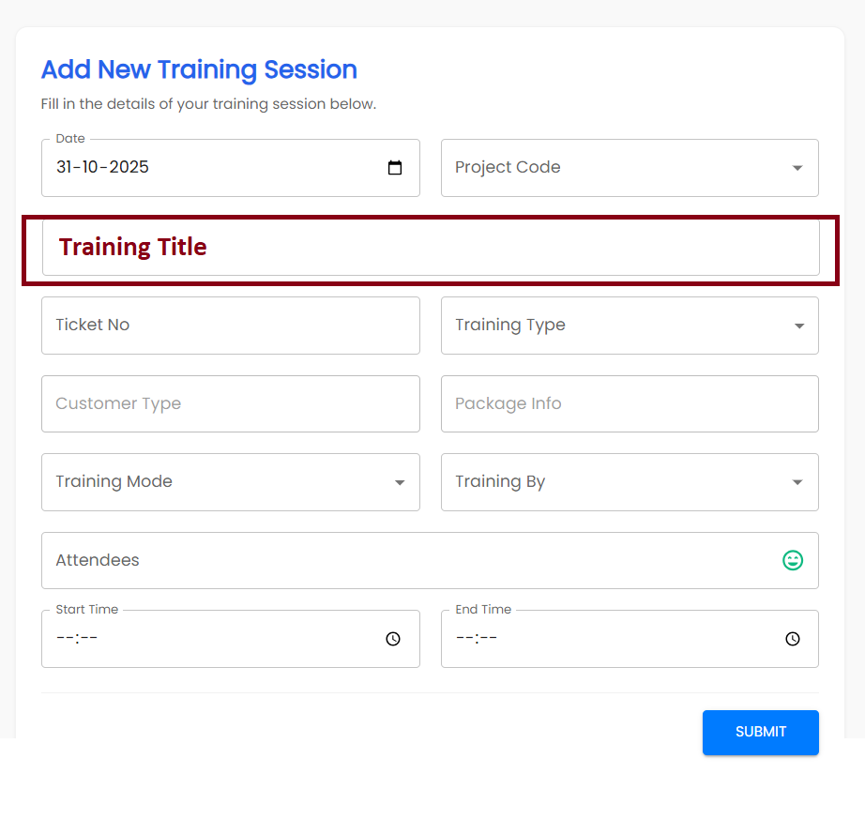
Step:2 show this title in training dashboard grid optigo side

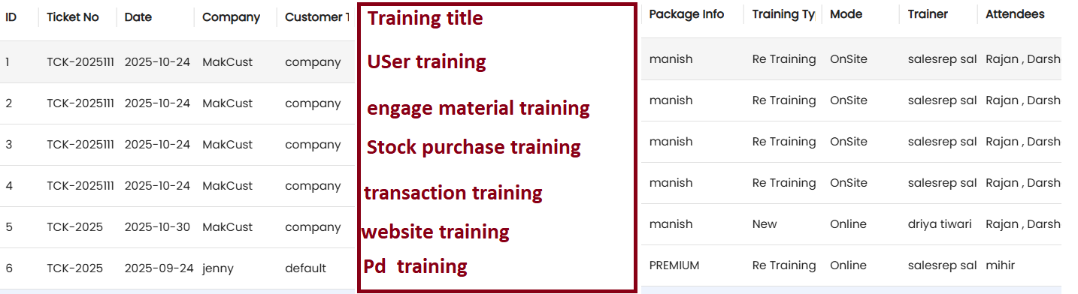

Step:3 Step:2 show this title in training dashboard grid customer side

Example
- user training
- Enagae material training
- Stock purchase training
- Mfg transaction training
- Website training
- Pd training

