Project: Website customization- bespoke jewellery form required Add on fields - new form
*react js build website*
Old form remain as it is .
need to add new form to get data on email
Team :
doc: shreya (not available : khusbu)
Developer: mahesh
Ui developer : rajan (react)
tester: no tester for website yet (check by own doc and developer)
reference form (old)https://sonasons.optigoapps.com/bespoke-jewelry
Need customize form for particular customer : Eliorjewel
https://b2b.eliorjewel.com/ (SR theme-sonasons)
Existing bespoke jewellery form :
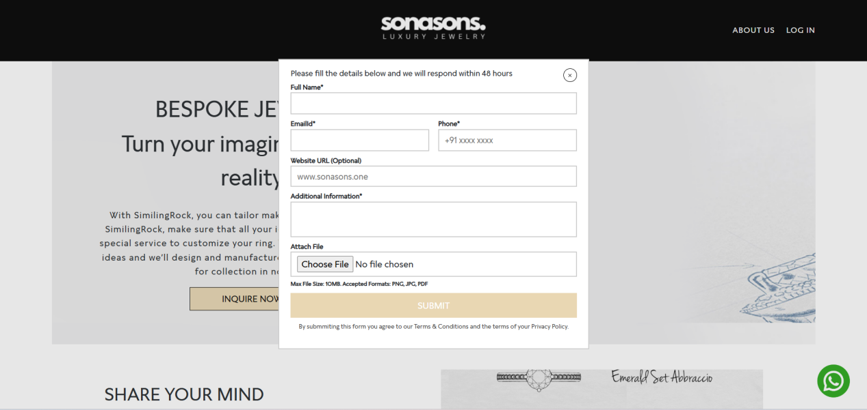
Add new form Custom jewellery order form
Required new form:
https://whatsform.com/gipubh
form details required
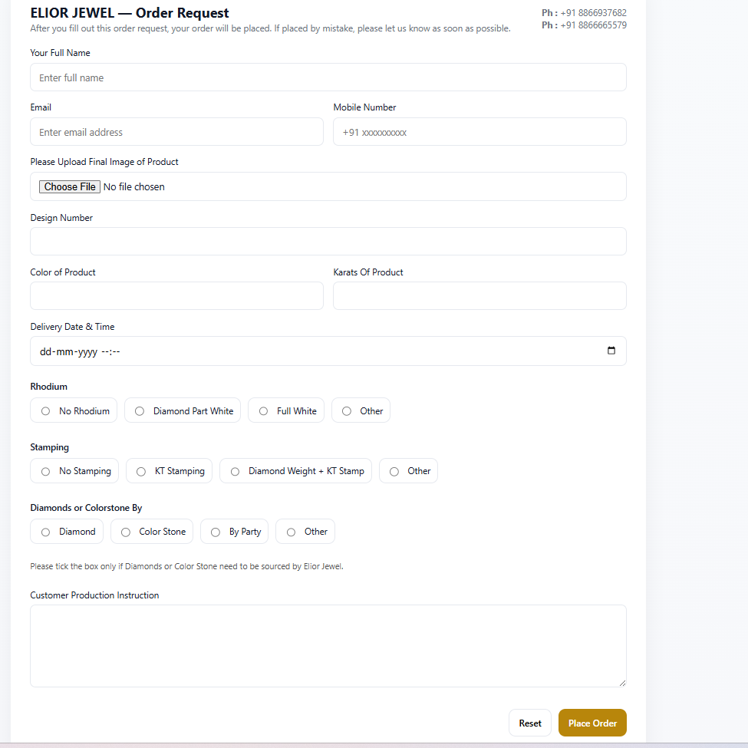
Add new field :
Email and mobile no.
Email L input box- auto filled (* Form submission details will be send on this email id)
Email id will consider to end email on.
Refrence ui for form : user black and white as color theme .
Visibility of form after login only .
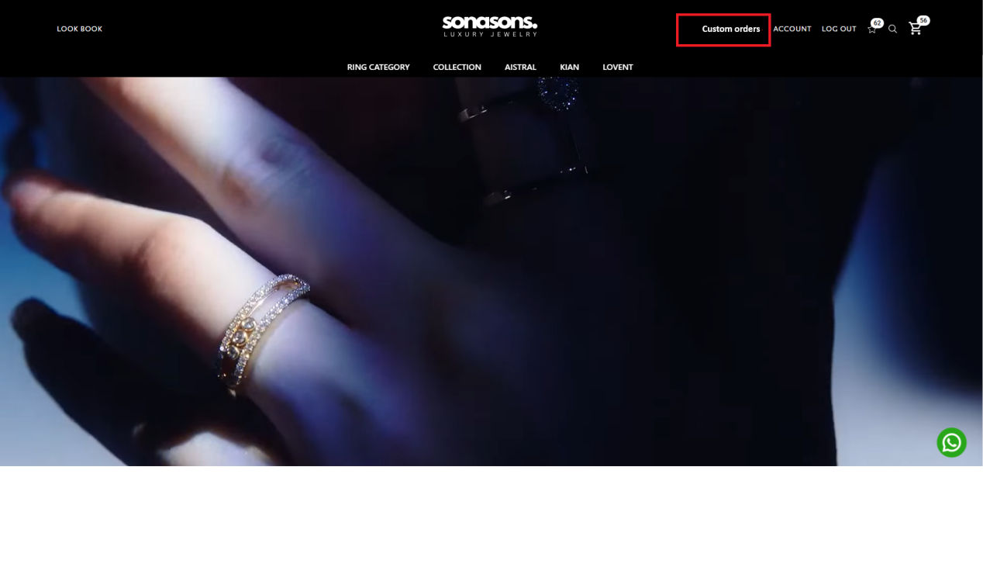
Auto filled field require:
Once customer logged in Full name , email and mobile no if added in account information Should auto fill in form automatically.
Full name
Email
Mobile no
Allow customer to edit auto filled details.
This form details need to submit via email:
\\evo\Project\Project\BODO\task#950Master website mail sms settings & tempaltes {template other working emails}
Email footer details  email template details | 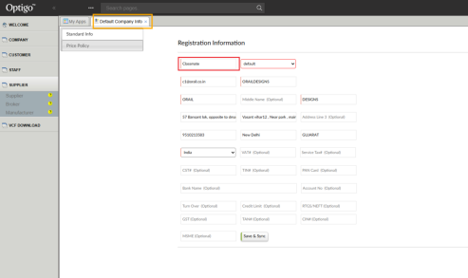 | company name |  | [Your Company Name]
 | 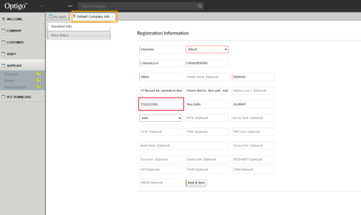 | change company tell no |  | [Your Contact Number]
 | Catch live domain name From API (ex: estore.web) |  |  | [Website URL]
Customer side : Email notification of order form submission
1. Email Template – For Customer (Order Confirmation)

Subject: Customize Order Request Has Been placed– {Company Name}
{Company Logo}
Dear {{CustomerName}},

Thank you for submitting your csutomzie order request.
We have successfully received your details and our team will now verify the design and specifications.

Below is a summary of your request:

Order Details

Design Number: {{DesignNumber}}
Uploaded Product Image: (Attached / Link)

Product Color: {{Color}}

Karat: {{Karat}}

Delivery Date & Time: {{DeliveryDateTime}}

Rhodium: {{RhodiumOption}}

Stamping: {{StampingOption}}

Diamonds/Color Stone By:: {{StoneSource}}

Customer Instructions: {{Instructions}}

If any of the above details need correction, reply to this email or contact us immediately.
We look forward to crafting your jewellery exactly as you imagined.

Thank you!
[Your Company Name]
[Your Contact Number]
[Website URL]

Company side: Email notification of order form submission

Email Template – Internal (Company / Production Team Notification)

Subject: New Customize Order Request received– {{CustomerName}}
{Company Logo}
Hello Team,

A new order csutomzie request has been submitted.Please review the details and proceed with verification .
Customer Information

Customer Name: {{CustomerName}}

Contact: {{ContactNumber}}

Uploaded Product Image: (Attached / Link)

Order Specifications

Design Number: {{DesignNumber}}

Product Color: {{Color}}

Karat: {{Karat}}

Delivery Date & Time: {{DeliveryDateTime}}

Rhodium: {{RhodiumOption}}

Stamping: {{StampingOption}}

Material Source

Diamonds/Color Stone By: {{StoneSource}}

Customer Production Instructions
{{Instructions}}
Thank you!
[Your Company Name]
[Your Contact Number]
[Website URL]

