Software Requirements Document (SRD)
Project Name: Airis

Version: 1.0
Author: Khushbu patel
Team: Requirement By- Hiren Patel

Project Lead - Khushbu Patel

Coder- Shivam

Tester-

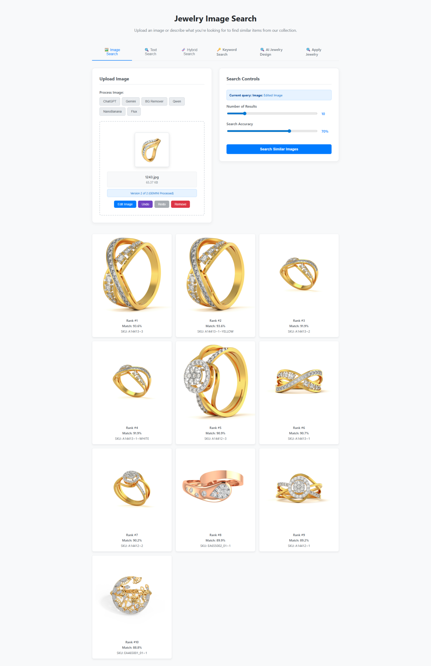

Navigation Tabs
1.Image Search
2.Text Search
3.Hybrid Search
4.Keyword Search
5.AI Jewelry Design
6.Apply Jewelry

1.Image Search

2.1 User Interface (Frontend)
Upload Image Panel
Drag & Drop / File Picker for image upload
Process Image Options:
ChatGPT
Gemini
BG Remover
Qwen
NanoBanana
Flux
Search Controls Panel
Number of Results (slider).
Search Accuracy (slider).
Search Button: "Search Similar Images".

2.2 Backend Services
Image Preprocessing Module
BG Remover (background removal).
AI models for feature extraction (ChatGPT, Gemini, Qwen, NanoBanana, Flux).
Search Engine
Vector similarity search (e.g., FAISS, Pinecone, Elasticsearch with embeddings).
Ranking based on accuracy threshold.
Metadata Store
Jewelry attributes (type, gemstone, metal, price, etc.).
Indexed for keyword/hybrid search.
Result Management
Filtering, ranking, and limiting results.
Returns top N results as per slider settings.

2.3 Database
Jewelry Image Database
Stores jewelry item images.
Preprocessed embeddings for fast similarity search.
Metadata Database
Stores jewelry details (ID, category, tags, description, price).
User Preferences
Search history.
Saved filters and accuracy levels.

3. System Workflow
User uploads image via drag & drop or file picker.
Processing Module applies:
Background removal (if selected).
Embedding extraction using AI models (ChatGPT, Gemini, etc.).
Search Request is sent with parameters:
Processed image embedding.
Number of results.
Search Accuracy threshold.
Search Engine performs similarity search in jewelry embeddings database.
Ranking & Filtering based on accuracy threshold.
Results Returned to UI with jewelry details & images.

4. Non-Functional Requirements
Performance:
Average search latency < 2 seconds for 10 results.
Scalability:
Supports millions of jewelry items with distributed vector DB.
Accuracy:AI models trained on jewelry-specific dataset.
Security:
Uploaded images stored temporarily and auto-deleted.
Secure HTTPS communication.

5. Technology Stack
Frontend: React.js, TailwindCSS/Material UI.
Backend: Node.js/Express or Python (FastAPI).
AI Models: OpenAI/ChatGPT Vision, Gemini, Qwen, custom jewelry-trained models.
Database:
Metadata → PostgreSQL/MongoDB.
Vector embeddings → FAISS, Pinecone, or Milvus.
Cloud Services: AWS/GCP/Azure for scaling & storage.

6. Future Enhancements
Support voice search for jewelry.
Integration with AR Try-On for jewelry
Multi-language support.
Personalized recommendations.

2.Text Search
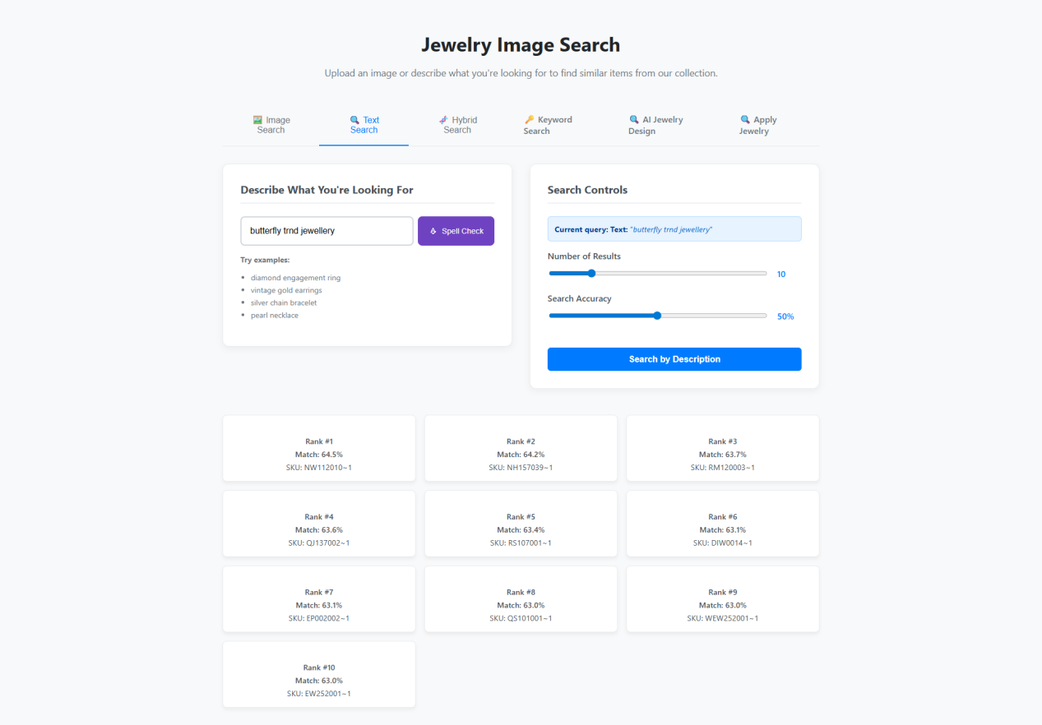

1. Introduction
The Text Search feature allows users to find jewelry items by entering descriptive text queries. The system interprets the query, applies spell-check, and retrieves jewelry items ranked by similarity scores.

2. Objectives
Enable users to search jewelry using natural language descriptions.
Support spell correction for user queries.
Allow adjustable search controls for fine-tuning results.
Return ranked jewelry matches with accuracy percentages and SKUs.

3. Functional Requirements

3.1 Input Features
Search Box’
Accepts free-text queries (e.g., "butterfly trend jewellery").
Provides example queries for guidance.
Spell Check Button
Suggests corrections for misspelled queries.
Updates search query if user accepts correction.

3.2 Search Controls
Number of Results
Slider to choose result count (default: 10).
Search Accuracy
Slider to set similarity threshold (default: 50%).
Search Button
Executes query against jewelry dataset.

3.3 Search Result Display
Results shown in ranked order:
Rank number.
Match percentage.
SKU (unique identifier).
Pagination (if results exceed chosen number).
Default results sorted by highest similarity score.

4. System Workflow
User enters search text.
Spell check runs (if selected).
System converts query into embedding/keyword vector.
Query passed to Search Engine:
Vector-based search (semantic similarity).
Keyword-based search fallback.
Results ranked based on Match %.
Top N results returned with SKU references.

5. Non-Functional Requirements
Performance: Query response within 2s for top 10 results.
Scalability: Handle 100K+ concurrent search queries.
Accuracy: Use AI embeddings (e.g., OpenAI, Gemini, Qwen) for semantic matching.
Security: User queries processed over HTTPS.
Usability: Intuitive sliders, spell-check support, result clarity..

7. Future Enhancements
Add synonym expansion (e.g., "necklace" → "chain").
Multi-language support.
Personalized search suggestions based on user history.
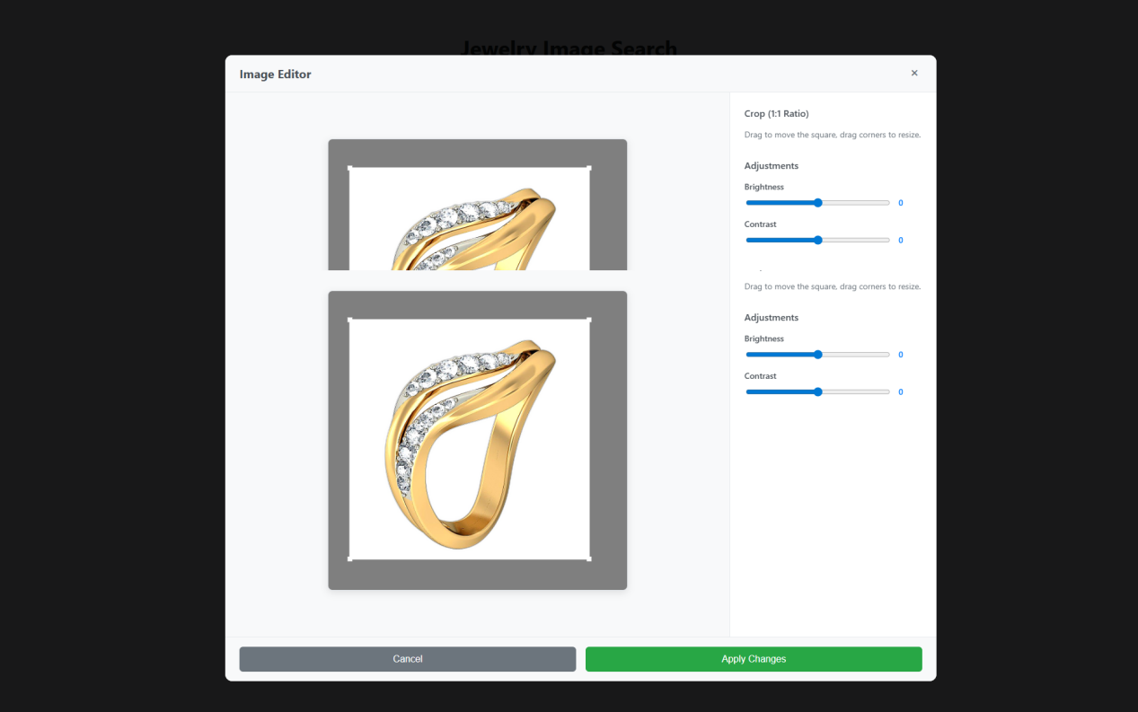

1. Introduction
The Image Editor module allows users to crop and adjust images before using them in the Jewelry Image Search system. This ensures high-quality and standardized inputs for similarity search.

2. Objectives
Provide basic image editing capabilities: crop, brightness, contrast.
Enable users to preview before applying changes.
Standardize input images for improved AI search accuracy.

3. Functional Requirements

3.1 Image Upload & Preview
Load the uploaded jewelry image.
Display before and after preview (top = original, bottom = edited).

3.2 Cropping
Crop with 1:1 aspect ratio (square).
Users can drag the crop box to reposition.
Resize crop box by dragging corners

3.3 Adjustments
Brightness Control
Slider range: -100 to +100 (default: 0).
Contrast Control
Slider range: -100 to +100 (default: 0).

3.4 Actions
Apply Changes
Save edits and pass modified image to the search engine.
Cancel
Discard edits and revert to original image.

4. System Workflow
User uploads jewelry image.
System displays original preview.
User applies:
Cropping (enforced 1:1 ratio).
Brightness/contrast adjustments.
Preview updates in real-time.
User selects:
Apply Changes → Processed image replaces original for search.
Cancel → Editor closes without saving.

5. Non-Functional Requirements
Performance: Real-time update (<200ms delay).
Usability: Intuitive sliders & drag handles for non-technical users.
Scalability: Handle high-resolution images (up to 10MB).
Security: Temporary image storage; auto-delete after processing.

System Components

Frontend:
Image rendering library (e.g., Fabric.js, Konva, or native HTML5 canvas).
Real-time brightness/contrast adjustments.
Backend (optional):
Server-side image processing for final save (e.g., OpenCV, PIL, Sharp).
Integration:
Edited image is forwarded to the Image Search module for embedding extraction.

7. Future Enhancements
Add rotation and flip tools.
Auto-enhancement (AI-based lighting correction).
Background removal option.
Support for multiple aspect ratios (1:1, 4:3, 16:9).

3.Hybrid Search
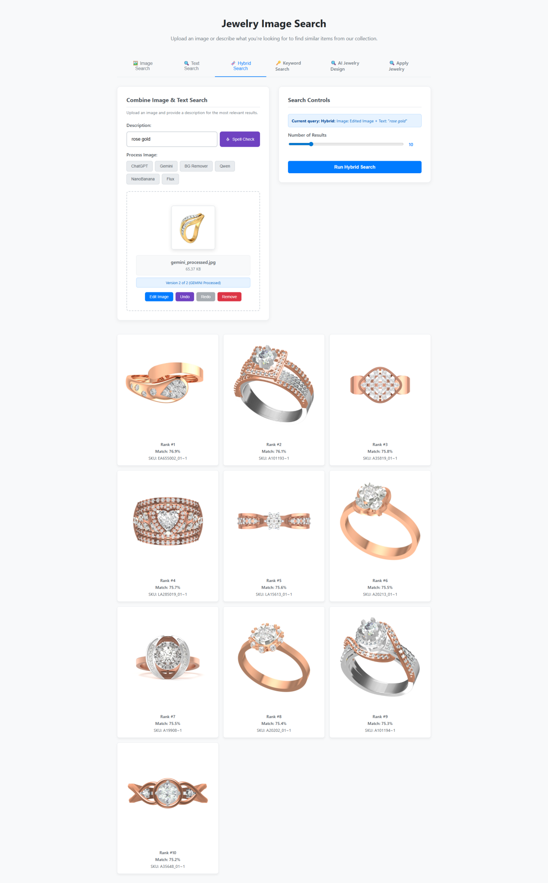

1.1 Purpose
The purpose of this system is to provide users with a web-based jewelry search platform that allows searching by image, text, or a combination of both. The system will return relevant jewelry items from a collection based on similarity to the input image or description.

1.2 Scope
Users can upload an image of a jewelry item and/or enter a textual description.
The system performs hybrid searches using both image recognition and natural language processing.
Matching jewelry items are ranked based on relevance.
Users can view search results with images, ranks, match percentages, and SKU details.

1.3 Definitions, Acronyms, and Abbreviations
SKU: Stock Keeping Unit, unique identifier for a product.
Hybrid Search: Search combining image and text similarity algorithms.
Process Image Options: Filters applied to the image (e.g., background removal).

2. Overall Description

2.1 Product Perspective
This system is a standalone web application that interacts with a jewelry database. It uses AI models for image processing and search ranking.

2.2 Product Features
Image Upload: Upload a jewelry image in supported formats (JPEG, PNG).
Text Input: Enter a textual description for the jewelry (e.g., "rose gold").
Hybrid Search: Combine both image and text for more accurate search results.
Process Image Options: Optional image processing tools like ChatGPT, Gemini, BG Remover, OpenAI, NanoClarence, and Flax.
Search Controls:
Set the number of results to display.
Run the search using the "Run Hybrid Search" button.
Search Results Display:
Show jewelry images with rank, match percentage, and SKU.
Results sorted by relevance.

2.3 User Classes and Characteristics
End Users: Customers looking to find jewelry items from an image or description.
Admin Users: Manage jewelry catalog, control search parameters, and monitor system performance.

2.4 Operating Environment
Web browser: Chrome, Firefox, Edge, Safari (latest versions).
Backend:Node.js (for AI model integration and database queries).
Database: SQL / NoSQL database for jewelry catalog.

2.5 Design and Implementation Constraints
Image size limit for upload (e.g., 5 MB).
Network connection required for hybrid search.
Response time for search should be under 5 seconds for ≤ 50 results.

3. Functional Requirements
ID | Requirement Description
FR1 | User can upload a jewelry image.
FR2 | User can enter a textual description.
FR3 | User can select image processing options.
FR4 | System should run a hybrid search based on uploaded image and text.
FR5 | User can set the number of results to display (slider control).
FR6 | Display ranked search results with images, match %, rank, and SKU.
FR7 | Option to remove or edit uploaded images before running the search.
FR8 | System should allow switching between search types: image, text, hybrid, keyword, jewelry design.

4. Non-Functional Requirements
ID | Requirement Description
NFR1 | System must respond to search queries within 5 seconds for ≤ 50 results.
NFR2 | Application should be mobile responsive.
NFR3 | Security: All uploaded images must be securely stored and encrypted.
NFR4 | Usability: Interface should be intuitive with clear labels for each control.
NFR5 | Reliability: System uptime ≥ 99%.
NFR6 | Scalability: Should support up to 1000 concurrent users.

5. User Interface Requirements
Upload Section:
Drag & drop or browse to select image.
Display thumbnail preview.
Buttons: Edit, Undo, Remove.
Text Description Input:
Input box for keywords or description.
Split check button for processing text.
Process Image Options:
Checkboxes or buttons for different processing methods.
Search Controls:
Slider to set number of results.
"Run Hybrid Search" button to trigger search.
Search Results Section:
Grid layout for jewelry images.
Display Rank, Match %, and SKU for each item.

6. System Requirements

6.1 Hardware
Server with GPU support for AI image processing.
Minimum 8GB RAM, 4-core CPU.

6.2 Software
Frontend: ReactJS.
Backend: Node.js
Database: MySQL / MongoDB.
AI Libraries: OpenAI API, TensorFlow/PyTorch, Gemini, BG Remover.

7. Future Enhancements
Allow filtering by jewelry type (ring, necklace, bracelet).
User account management for saving searches and favorites.
Support augmented reality (AR) preview of jewelry items.

4 .Keyword Search
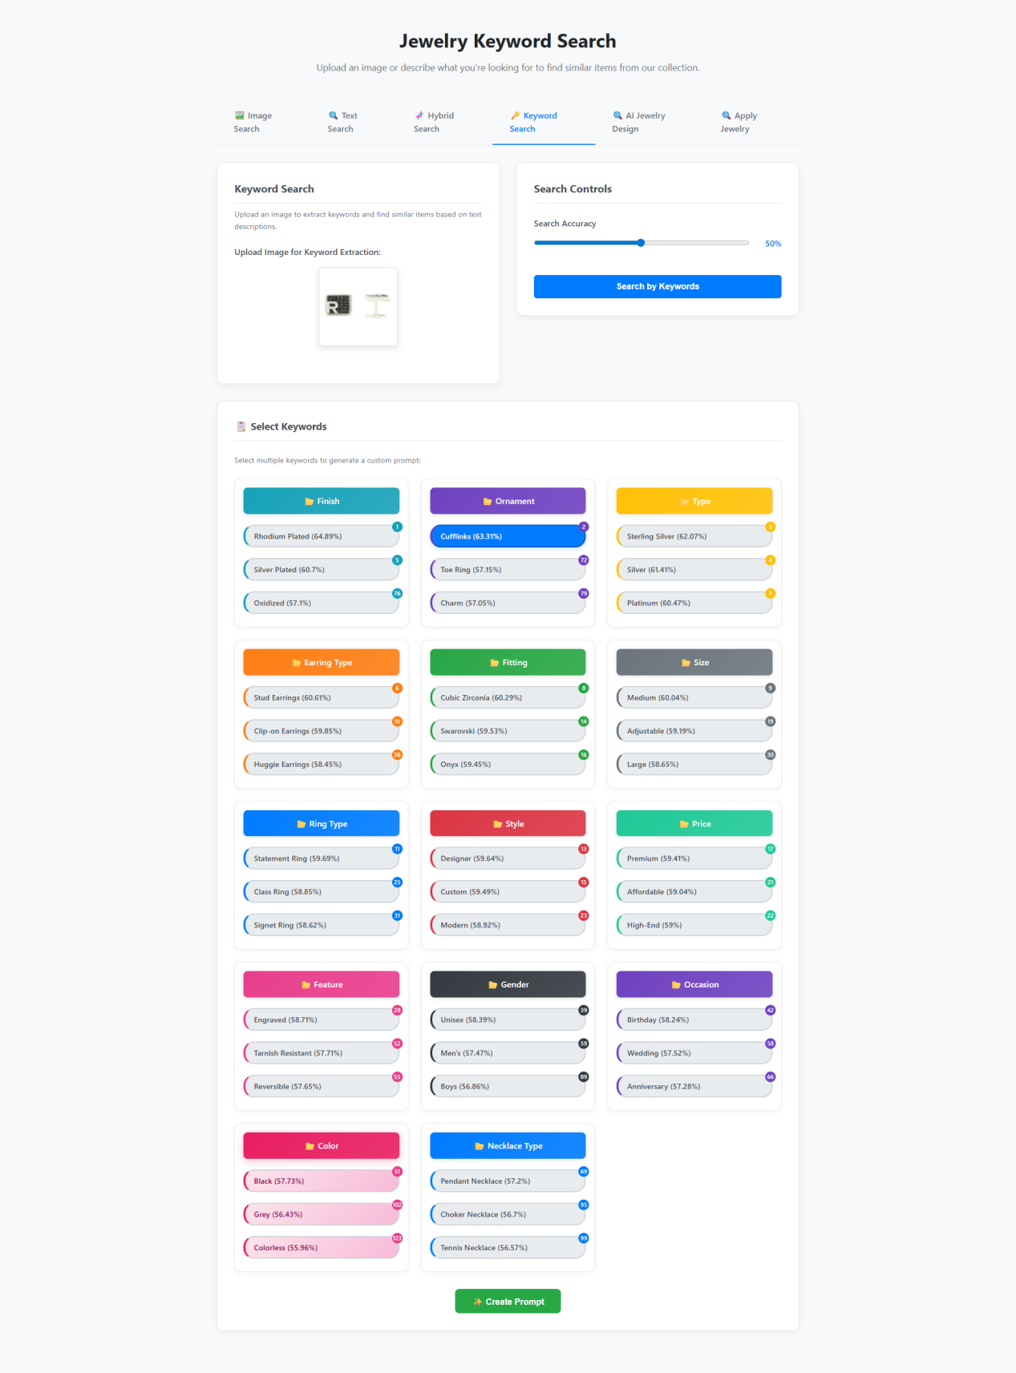
5.AI Jewelry Design
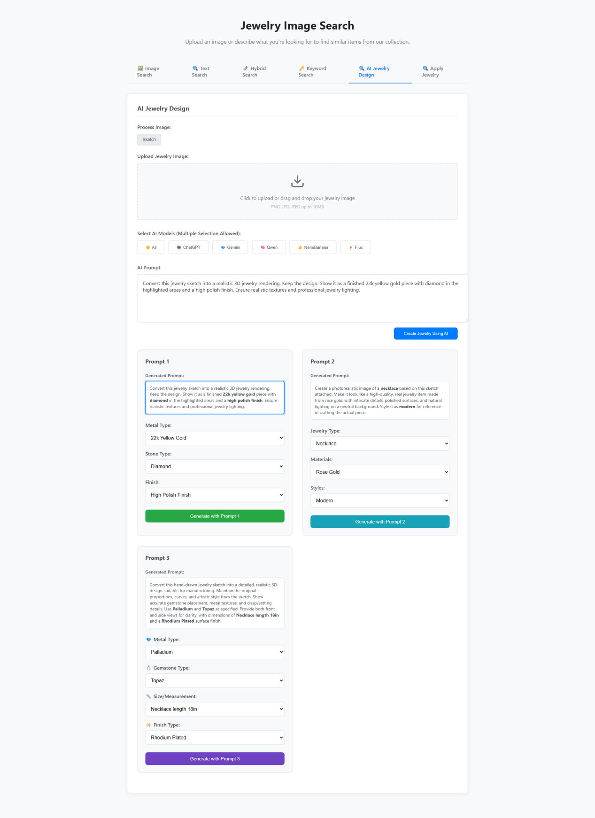

1. Introduction
The Jewelry Image Search system enables users to upload jewelry designs (such as sketches or photos) to find similar items from a collection. It offers multiple ways to search, including using images or descriptions and generating AI-based jewelry designs using specific input parameters.

2. Features
Image Upload Functionality:
Users can upload jewelry images (e.g., sketches, photographs) in PNG, JPG, or JPEG format up to 10MB in size.
The system supports drag-and-drop or manual file selection for uploading jewelry images.
AI Jewelry Design Generation:
Users can input a jewelry sketch and use AI models (such as ChatGPT, Gemit, Owen, NeonBanana, or Flux) to generate realistic 3D renderings of jewelry pieces.
The system will convert the sketch into a jewelry design with realistic textures and finishes, ensuring proper lighting and a professional appearance.
Users can modify or select specific design attributes, including metal type, gemstone type, and finish (e.g., high polish, rhodium plated).
Prompt Customization:
Prompt 1: Customizable options for metal type (e.g., 22k yellow gold), gemstone type (e.g., diamond), and finish (e.g., high polish).
Prompt 2: Options for jewelry type (e.g., necklace), material (e.g., rose gold), and styles (e.g., modern).
Prompt 3: Allows further customization with more detailed options like size/measurement (e.g., necklace length 18 inches) and gemstone (e.g., topaz).
AI Models for Generation:
Multiple AI models are available for generating designs: ChatGPT, Gemit, Owen, NeonBanana, Flux. Users can choose one or more AI models for the design generation process.
Search and Filtering:
The system allows users to search for similar jewelry items in the database by uploading a jewelry image or describing what they’re looking for.

3. System Requirements

3.1 Hardware Requirements:
Server: A robust server capable of handling image uploads, AI model processing, and high-volume traffic.
Storage: Adequate storage for storing uploaded images and generated design files (up to 10MB each).

3.2 Software Requirements:
Operating System: Web-based application, compatible with major browsers (Chrome, Firefox, Safari, Edge).
Database: Relational or NoSQL database to store user data, images, and AI-generated designs.
AI Model Integration: Integration of various AI models such as ChatGPT, Gemit, Owen, etc., using API calls for design generation.
Image Processing: Tools for handling and processing image uploads, such as resizing, cropping, and format validation.

3.3 API Requirements:
AI Model API: For connecting to external AI models like ChatGPT, Gemit, and others for generating 3D jewelry designs.
Image Search API: For querying the jewelry image database based on user-uploaded images and descriptions.

3.4 Security:
Authentication and Authorization: Ensure that users' data and images are protected with secure login mechanisms (e.g., OAuth, JWT).
Data Encryption: Encryption for uploaded image files and generated designs during storage and transmission.

4. User Interface
The system will have the following user interface components:
Image Upload Section: Drag-and-drop or file selection interface to upload jewelry images.
Prompt Customization: Dropdowns and selection boxes to specify jewelry details like metal type, gemstone, finish, and more.
AI Model Selection: Checkboxes or radio buttons to choose which AI models to use for design generation.
Generated Prompts: Display areas for showing generated prompts based on the user's selections and the AI's suggestions.
Generate Button: Button to trigger the AI design generation process for the selected prompts.
Preview Section: A section to display the generated jewelry designs.

5. Use Cases
Upload Image and Generate Jewelry Design:
The user uploads a jewelry sketch.
The system processes the sketch using selected AI models.
The user customizes the jewelry details (e.g., metal type, gemstone).
The AI generates a 3D rendering or photo-realistic image of the jewelry piece.
Search for Similar Jewelry:
The user uploads an image or describes the jewelry they are looking for.
The system searches its database for matching or similar jewelry items.
Modify Design Based on Prompts:
The user customizes the generated jewelry design by modifying prompts (e.g., changing material or adding a gemstone).
The system generates a new design based on the modified prompt.
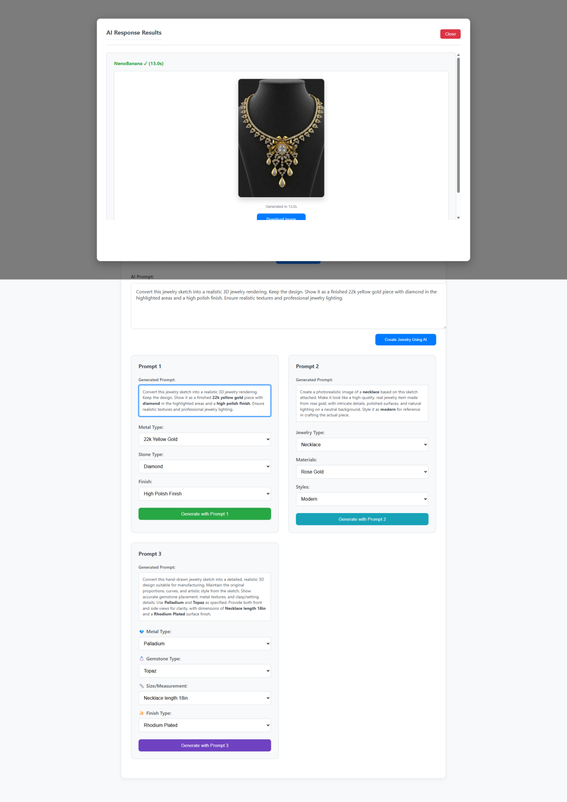

1. Introduction
This section focuses on the AI Response Results interface of the Jewelry Image Search system. It enables users to view and download AI-generated jewelry designs based on input prompts, and allows further customization and generation of jewelry designs with different attributes.

2. Features
AI Response Display:
After a jewelry design is generated by the AI, the system displays the result in the form of a 3D rendering or photo-realistic image.
Each generated design will show the AI model used (e.g., NeonBanana) and the time taken for the generation (e.g., 13.0s).
Download Button:
Users have the option to download the generated jewelry image to their device with a "Download Image" button. This allows users to save the generated jewelry designs for further use.
Prompt Customization (Continued):
The user can customize different aspects of the jewelry design using specific prompts, which affect the model’s rendering process.
Prompt 1: Focuses on basic parameters such as metal type (e.g., 22k yellow gold), stone type (e.g., diamond), and finish (e.g., high polish).
Prompt 2: Customizes details for a necklace, including material type (e.g., rose gold), style (e.g., modern), and gemstone references.
Prompt 3: Offers additional customization with specific details such as size/measurement (e.g., necklace length 18 inches), gemstone type (e.g., topaz), and finish type (e.g., rhodium plated).
AI Model Selection:
The system displays which AI model generated the current jewelry design. The options are modeled under specific AI systems like NeonBanana, ChatGPT, etc., and can be used to switch or refine the generated design.
Real-Time Results:
Once the user customizes the prompt and submits the request, the system processes and generates a realistic 3D or photorealistic image of the jewelry. The process time (e.g., 13 seconds) is displayed to ensure users are aware of the wait time.
3. System Requirements

3.1 Hardware Requirements:
Server: A high-performance server capable of processing image generation requests quickly (under 20 seconds per request) and handling multiple users concurrently.
Storage: Sufficient storage capacity for storing generated jewelry images and supporting files (up to 10MB each).

3.2 Software Requirements:
Operating System: Web-based application that supports all major browsers (Chrome, Firefox, Safari, Edge).
Database: For storing generated jewelry designs, user data, and metadata like AI model used and generation time.
AI Model Integration: Integration of various AI models (NeonBanana, ChatGPT, etc.) via API for generating jewelry images based on user input.
Image Processing: Software components for rendering and displaying high-quality jewelry images with realistic lighting and textures

3.3 API Requirements:
Image Generation API: A dedicated API for interacting with AI models that generate jewelry images from provided prompts.
Download API: Secure image download functionality that allows users to download the generated designs in the original resolution.
User Data API: To track users' selections and preferences, and save customizations for future use.

3.4 Security:
Authentication: Secure user authentication to protect user profiles, preferences, and design history.
Image Encryption: Encryption of generated jewelry images for storage and during transmission when users download them

4. User Interface
The system will have the following user interface components:
AI Response Display:
A section showing the generated jewelry image after processing, including the AI model used and time taken.
A Download Image button to allow users to save the generated design.
Prompt Customization Section:
Prompt 1: Allows users to select the metal type (e.g., 22k yellow gold), stone type (e.g., diamond), and finish (e.g., high polish).
Prompt 2: Options for jewelry type (e.g., necklace), material (e.g., rose gold), gemstone type, and styles (e.g., modern).
Prompt 3: Additional customization for size/measurement (e.g., necklace length 18 inches) and gemstone type (e.g., topaz).
Real-Time Processing Feedback:
A display showing the time it took to generate the jewelry design, with an option to retry or further refine the prompt.

5. Use Cases
Generate and Download Jewelry Design:
The user customizes the jewelry design by selecting parameters in the prompts (e.g., metal type, gemstone type).
The system generates a photorealistic or 3D rendering of the jewelry, which is displayed to the user.
The user clicks on the Download Image button to save the design to their device.
Modify Design and Regenerate:
After viewing the generated design, the user adjusts the prompts (e.g., changing metal type or gemstone).
The system regenerates the design based on the updated customization and presents the new image.
View AI Model Performance:
The user is shown which AI model was used for the design generation, including the time taken for processing.
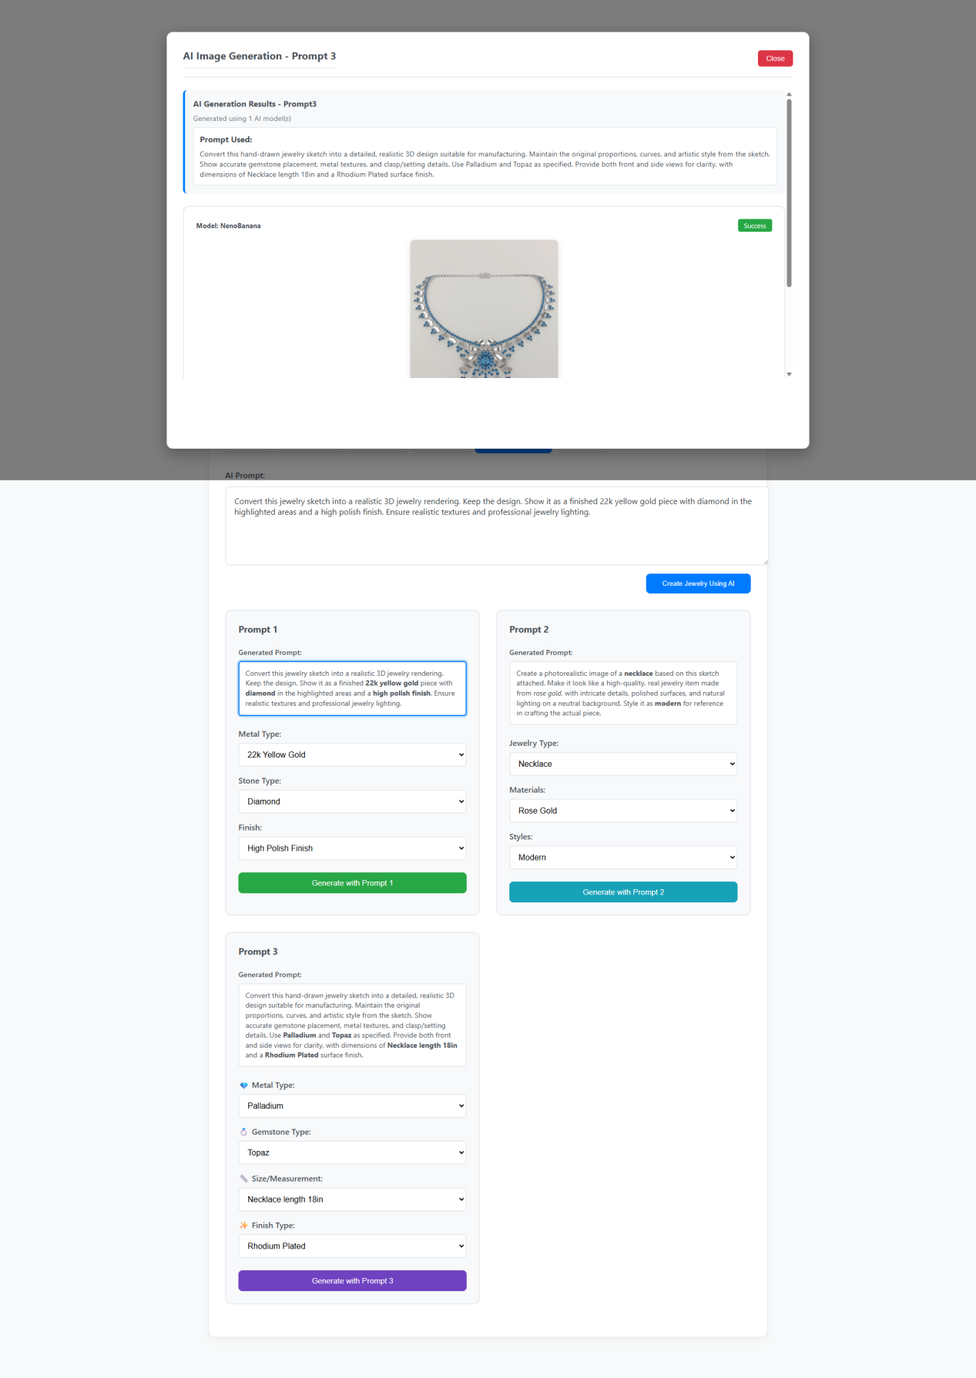

1. Introduction
This section of the Jewelry Image Search system focuses on the "AI Image Generation - Prompt 3" interface. Users can view detailed AI-generated jewelry images based on their inputs, with additional functionality for fine-tuning design details and visualizing the result.

2. Features
AI Image Generation Results:
Once the user submits their customization options (via Prompt 3), the system generates a highly detailed, realistic 3D or photo-realistic rendering of the jewelry design based on the provided instructions.
The design result is shown to the user, which includes the jewelry from both the front and side views for clarity.
The result section displays which AI model was used (e.g., NeonBanana) and the success message indicating successful generation.
Prompt Customization for Detailed Design:
Prompt 3 allows users to input detailed specifications for jewelry, such as:
Metal Type (e.g., Palladium)
Gemstone Type (e.g., Topaz)
Size/Measurement (e.g., Necklace length 18 inches)
Finish Type (e.g., Rhodium Plated)
This gives users more control over the specifics of the design and ensures a tailored output based on these details.
Success Indicator:
After processing, the system confirms successful image generation with a Success message, ensuring that the user knows the result is ready for download or review.
Download Option:
Users can click on the Download Image button to download the generated jewelry image in its full resolution for use in designs, presentations, or client reviews.
Generated Prompt Display:
The specific details entered by the user for Prompt 3 are shown in a clear, concise format, indicating how the input parameters influenced the resulting design.

3. System Requirements

3.1 Hardware Requirements:
Server: A powerful server with the capability to handle multiple design generation requests efficiently (under 15 seconds per request). It should also be capable of supporting high-resolution image outputs.
Storage: High storage capacity to accommodate detailed jewelry images generated for users (10MB or higher per image).

3.2 Software Requirements:
Operating System: A cloud-based or web application that supports all major browsers (Chrome, Firefox, Safari, Edge).
Database: A database to store user data, generated designs, and metadata such as prompt details and timestamps for each generation.
AI Model Integration: The system must be integrated with AI models (like NeonBanana) that process and generate 3D jewelry renderings.
Rendering and Image Processing: High-quality rendering software to ensure professional-grade 3D visualizations of jewelry designs with detailed lighting, texture, and reflection.

3.3 API Requirements:
Image Generation API: API responsible for handling image generation using the specified inputs in the prompts.
Download Image API: To allow users to securely download high-quality images after design generation.
Prompt Submission API: API that processes the input prompts (metal type, gemstone, finish, size) and generates the appropriate output design.

3.4 Security:
Authentication: Secure login and user verification systems to protect personal data and design history.
Data Encryption: Encryption for the transmission and storage of images, ensuring privacy and integrity.
Access Control: Proper user access control to ensure that generated designs are only accessible to the original user or authorized individuals.

4. User Interface
The system will feature the following UI components:
AI Image Display:
The generated jewelry image is shown to the user, with options to view both front and side angles.
A Success message is displayed to confirm that the design has been successfully generated.
Prompt Customization Section:
Prompt 3 includes dropdowns and input fields for customizing details such as Metal Type, Gemstone Type, Necklace Length, and Finish Type.
The system will generate a summary of the entered specifications, showing the user how their choices are reflected in the resulting design.
Download Button:
Users can download the image of the jewelry once the generation is complete, using a simple Download Image button.
AI Model Information:
The interface will display which AI model (e.g., NeonBanana) was used to generate the jewelry design, ensuring transparency in the design process.

5. Use Cases
Generate Jewelry Design:
The user customizes the jewelry design using Prompt 3 by selecting a metal (e.g., Palladium), gemstone (e.g., Topaz), size (e.g., necklace length), and finish (e.g., rhodium plated).
After submission, the system generates a high-quality 3D image of the design.
The user can view the result, and if satisfied, they can download the image.
View and Modify Design:
After reviewing the generated jewelry design, the user can modify the specifications (e.g., changing gemstone or size).
The system processes the changes and generates a new design, displaying the updated results.
Download and Use Design:
After a successful design generation, users can download the jewelry image to use for other purposes, like presentations, sales, or further design modification.

6. Conclusion
This part of the Jewelry Image Search system focuses on providing users with fine-grained control over the customization of jewelry designs through Prompt 3. It enhances the user experience by delivering realistic 3D renderings based on user inputs and offering high-quality downloads for professional use.

