Jewellery tag 2 (reference)
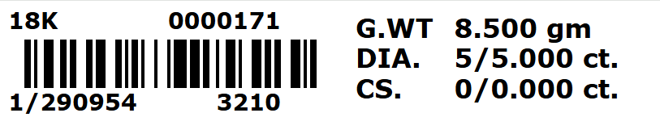

New tag
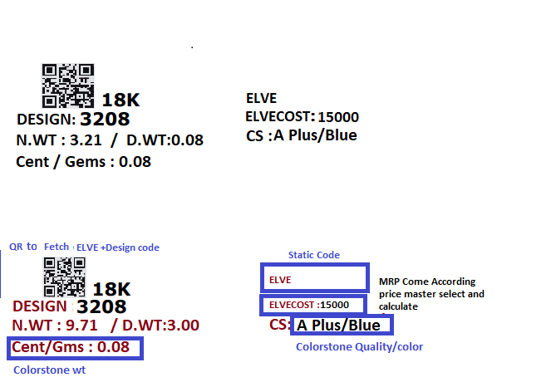

Client :elveester
Step:1 Make a new tag
Tag Name: Mrp cost tag E
Clone of :jewellery tag 2

Description :
Create a QR that represents ELVE + Design Code(3208).
ELVE:static line
ELVECOST (caption): value will come mrp according price master select and caluclate
Design Code: Design number of the job (e.g., 3208).
N.WT: Net weight of job .
D.WT: Diamond weight.
Cent/Gms(caption): Total Colorstone weight.
CS: Colorstone quality or color (e.g., A Plus/Blue).

Example
1/290954
Design no 3210
G.WT |  | 8.500 gm
DIA. |  | 5/5.000 ct.
CS. |  | 0/0.000 ct.

ELVE Cost:
75034 /-

