Step: add Feedback option for customer side (on help.optigoapps.com/training dashboard) with following details
- Start
- remark option

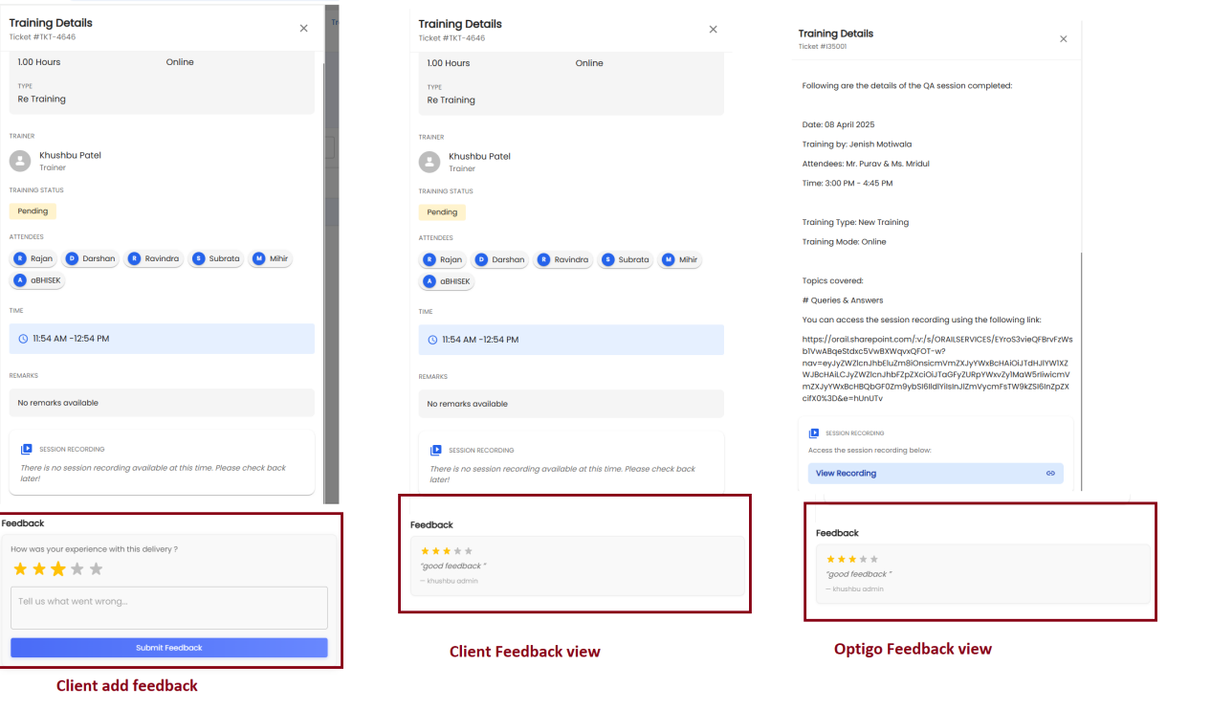

View feedback on both side as per image
- client side
- Optigo side

