Step:1 Add new button in task page( myapps> task mgt> task >task mgt)

Step:2 Make the slider with 4 image .
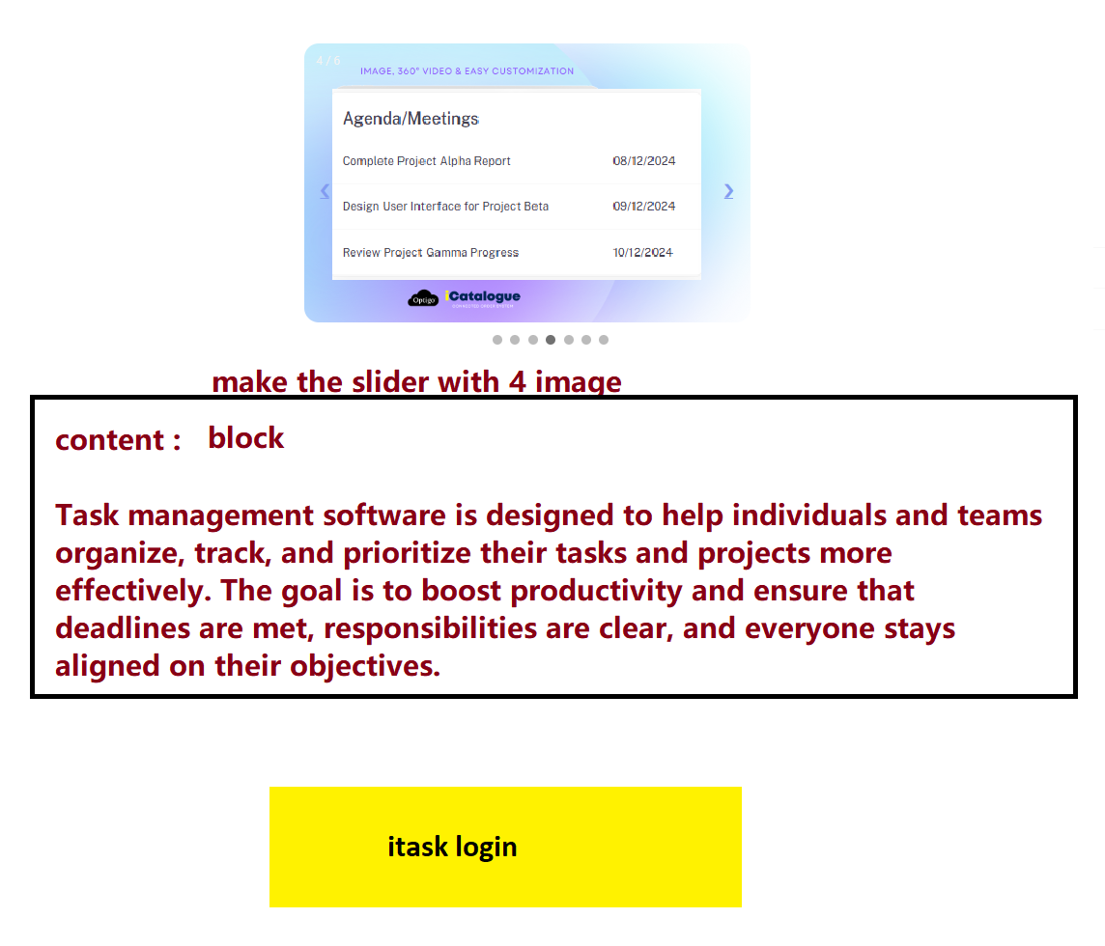
Content :Task management software is designed to help individuals and teams organize, track, and prioritize their tasks and projects more effectively. The goal is to boost productivity and ensure that deadlines are met, responsibilities are clear, and everyone stays aligned on their objectives.

Assignee as per orail project-document process

Step ;1 If button clicked then fire new page with the link : https://testitask.optigoapps.com/tasks with token number

If click on login button following ui page willl be open in new tab

USe following page of optigo
- Department
- Desigantion
- Itask
- Employee
- Reset password

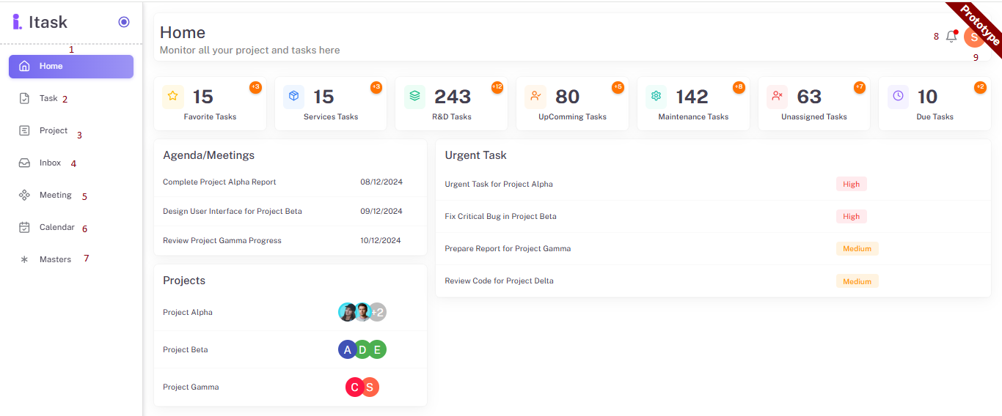

1.Home

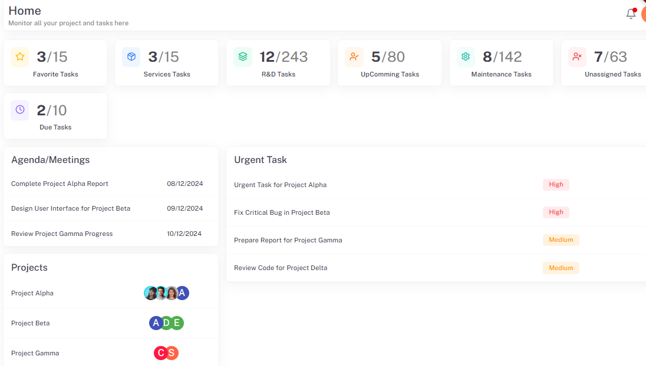
- Favorite task
Number of Favourite task/total task

- R & D task
Today date task /total RND task

- upcoming task
Today date task/total upcoming task

- maintenance task(category)
Today date task /total maintenance task

- unassigned task
Today date task /total number of assassine task

- due task
Today date task /total number of due task

2.task

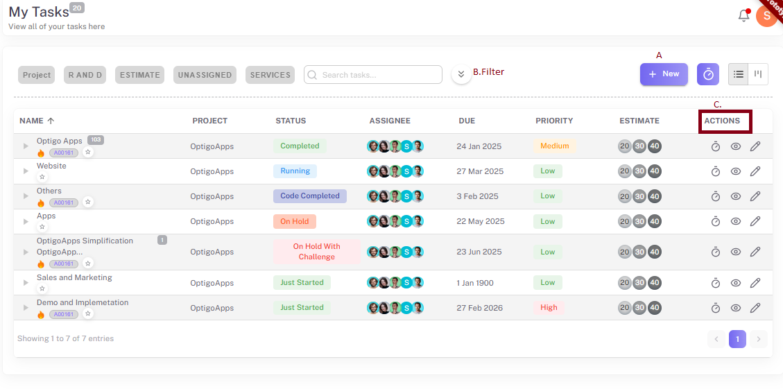
If task is forwarded to another employee its status will update in parent task

- add new task from here with new popup slider on recent page

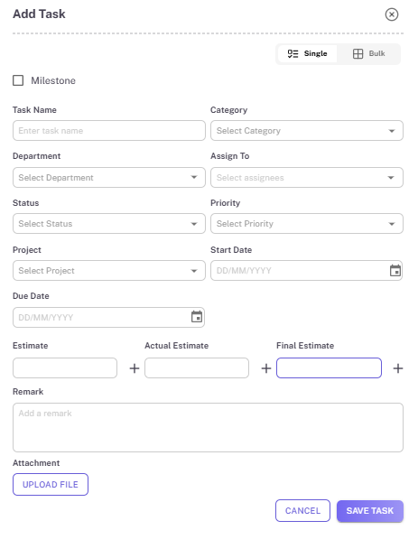

- task name:inpute type: text -> id=taskname
- Departmnet :input type: TYPO
- Assignee: INPUT TYPO > first bind department - designation and then employee
- Status: input type: dropdown-> data come from master > status ->status names
- Priority: input type: dropdown-> data come from master >priority > priority names
- Project :input type: dropdown -> data come from project module -> project names which bind with department (master >department )
- Repeat:
- start date: input type:date
- Due date: input type:date
- Estimate: input type:number (two didgit -two decimal )
- Actual estimate:input type:number(two didgit -two decimal )
- Final estimate:input type:number(two didgit -two decimal )
- Remark : input type: text area
- Attechment: file-select field
- cancle:input type:button
- Save task::input type:button
- Roll:team leader>select option

Parent task estimate :child task estimate +
Child task status different from parent task

If all child task status is completed then parents task status is complete

Multiline task
Add multiline task
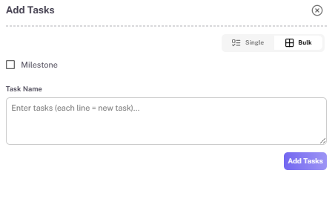
-Add task is in multi-line and task will be separated .

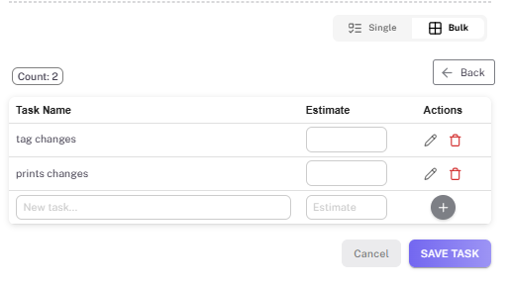

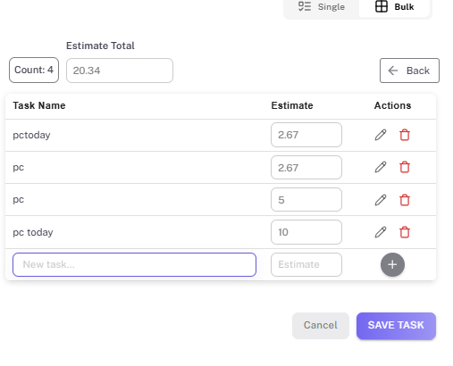
seStimate total time distribute in child task

Set reverse calulation too
Example: Main task has 3 hr
Add subtask its will 3 hr
If add another task with 2 hr then first child task will be 1 hr

In action can edit and delete the task

Step :added task list will show in task list grid.

- filter
- Status: input type: dropdown-> data come from master > status ->status names
- .Department: input type: dropdown: data come from master > department ->department names
- .Assignee: :input type: dropdown: data come from master > employee ->employee names
4. projects:
5.Due date: input type:date->if due date is selected data will come as per due date of task .

Show filter:
All :

task according to filter /if no any filter all task show as per user login: input type: table

- task name:all task with subtask button
Subtask:when click on button subtask list showing
- Status:task status
- Assignee
- Due date
- Priority
- Summary
- Action
Edit symbol: edit the task ->pop open of task

- Action

View :view the task in new popup ui

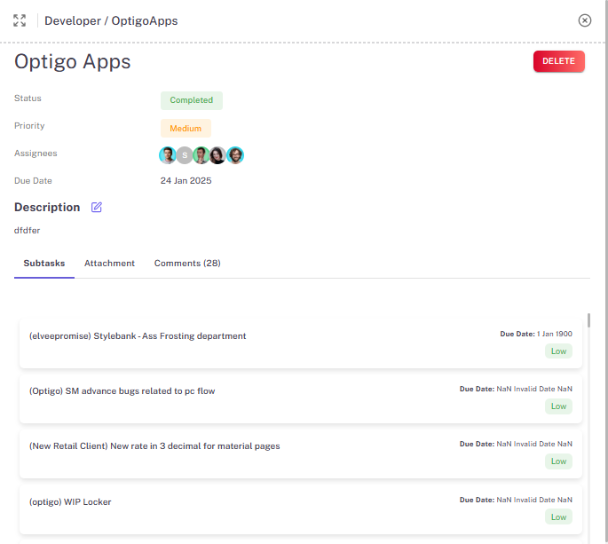
- Delete:delete the task with confirmation popup- validation :only main assignee can delete the task

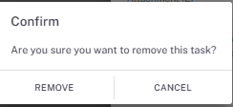

05-june changes

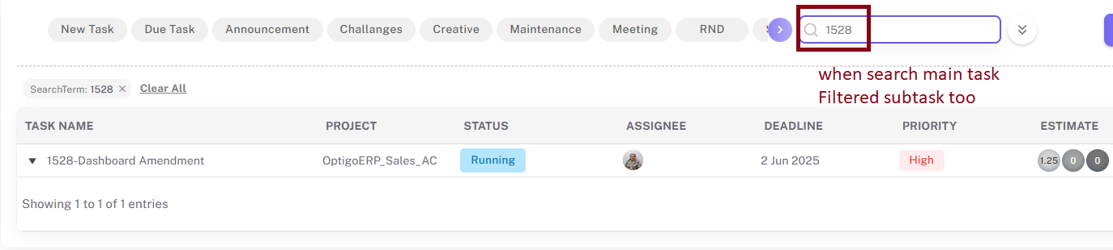

3.Projects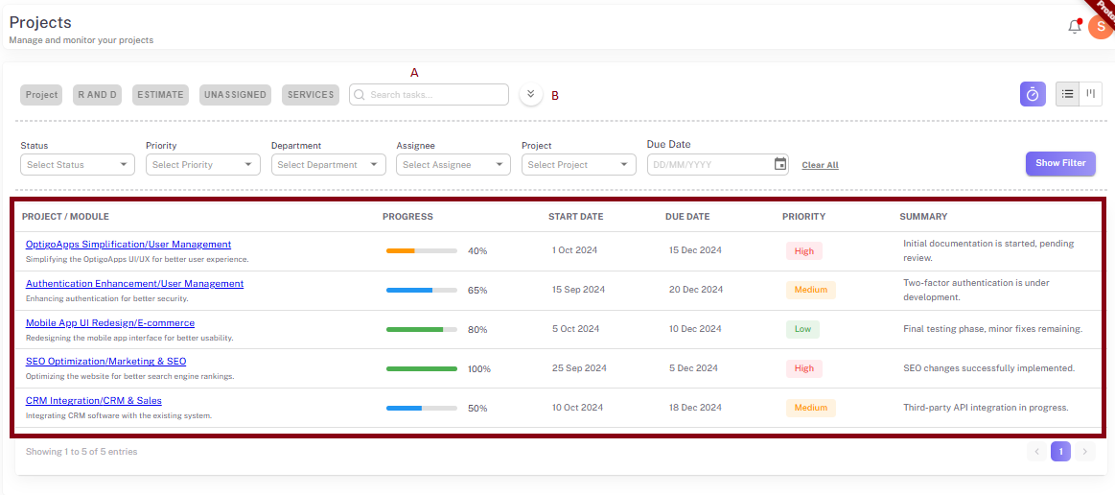

- search :input type:search (search with alphabet)

- Filter
1.Status: input type: dropdown-> data come from master > status ->status names
2. Department:inpute type: dropdown: data come from master > department ->department names
3.Assignee: :inpute type: dropdown: data come from master > employee ->employee names
4.project:which added in projects
5.due date: date filter

Step: Show the data as per filter apply/if no filter then show all data as per added date(ascending )

- project list grid
1.task name:all task with subtask button
Subtask:when click on button subtask list showing
- Status:task status
- Assignee
- Due date
- Priority
- Summary
- Action
Edit symbol: edit the task ->pop open of task
- View :view the task in new popup ui
- On project name hyperlink click project name with open in new tab with project all task page
- 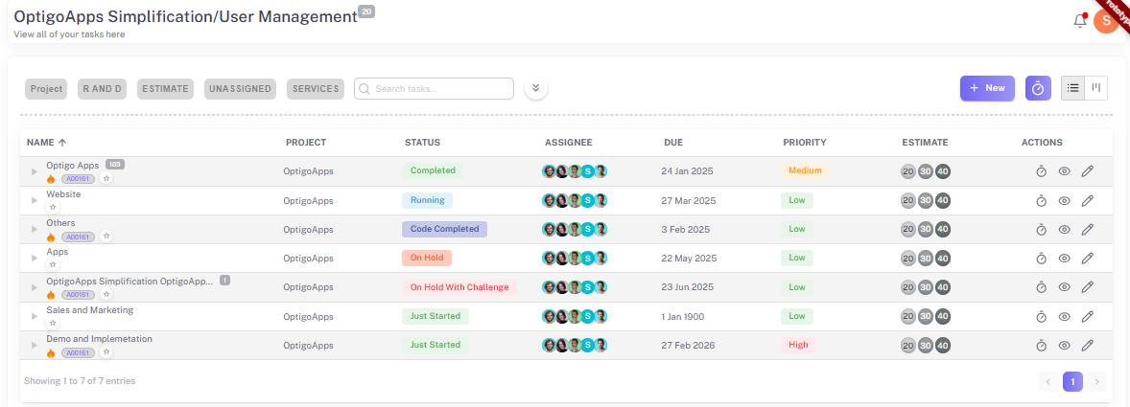

Project dashboard with following details

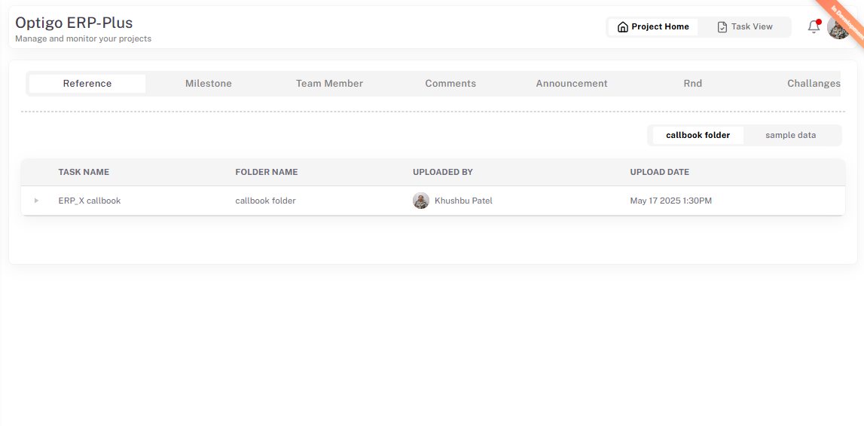

)reference(attachment of task )
2)milestone(task flag)
3)sop category
4)team(assignee of project tasks)
Add role bind on project dashbord project
5)comment(comment of project’s task)
6)rnd (category wise task of project)t
7)challenges(category wise task of project)

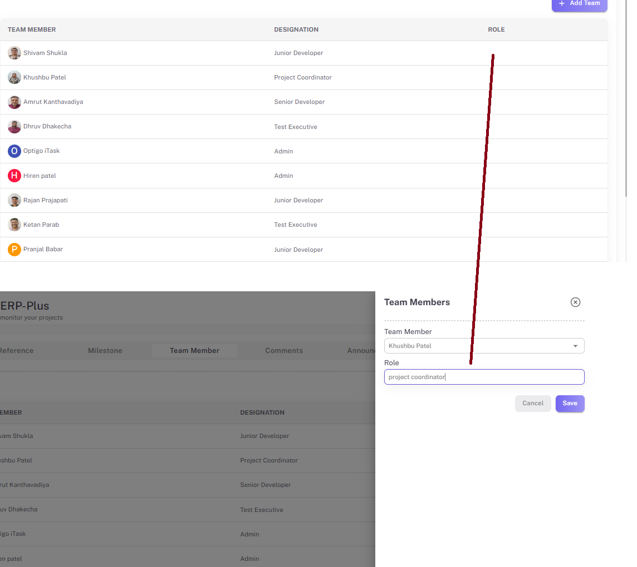

- Inbox-currently on hold

- Meeting page

- 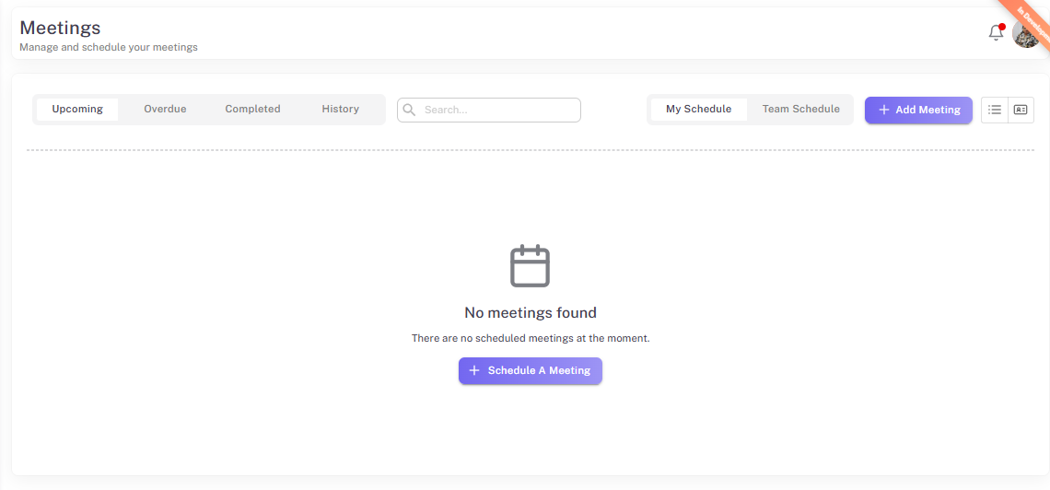
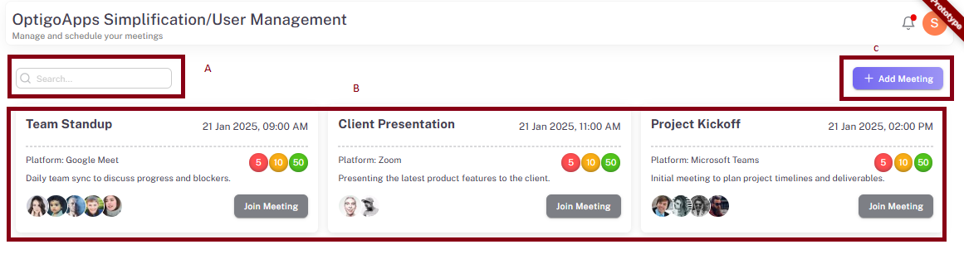
- search :input type: search
- Show upcoming :show today ‘s date meeting (according to start date )
- overdue :according to due date
- completed history :completed(status) meeting
- meeting according to filter

- Meeting grid
Meeting headline
Date :dd:MM:yyyy timing-> 00:00 AM/PM
Meeting platform
Meeting brif
Attendees ‘s profile
Join meeting:input type:button

C.Add meetings
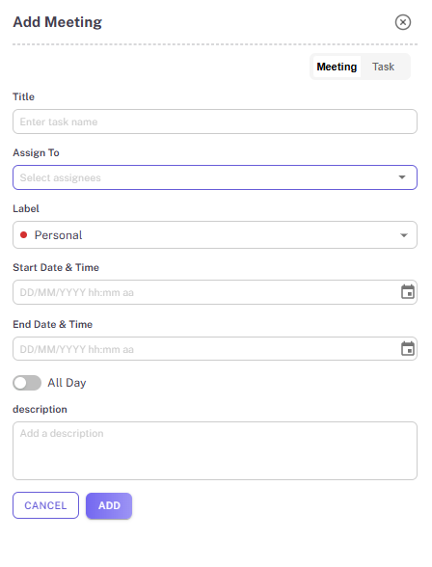
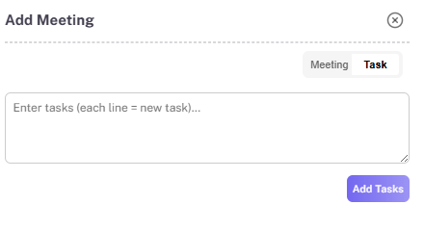

- Calendar

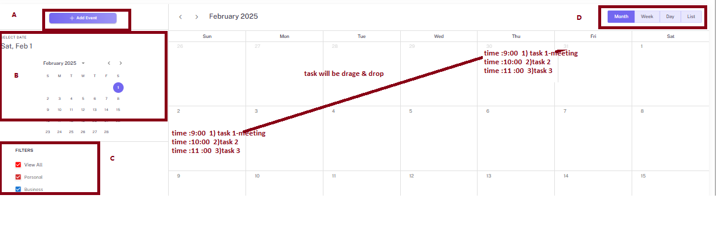

7 .Master –on hold
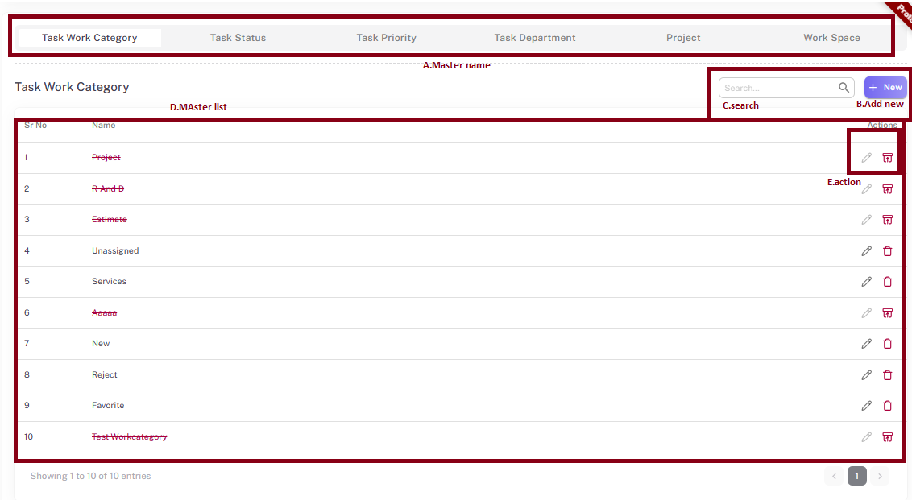
- master name
1.task work category
2.task status
3.task priority
4.task department
5.project
6.work space

8. Notification -not working
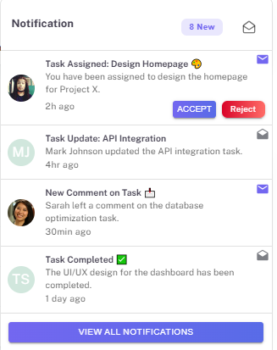
1.Accepted :input type=button
2.Reject:input type=button

9.Profile-not working

Profile pic size:26 X 26
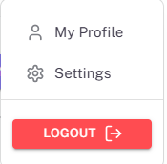
My profile: edit the profile with following details
Setting :open setting details

Logout: logout function

Limitation 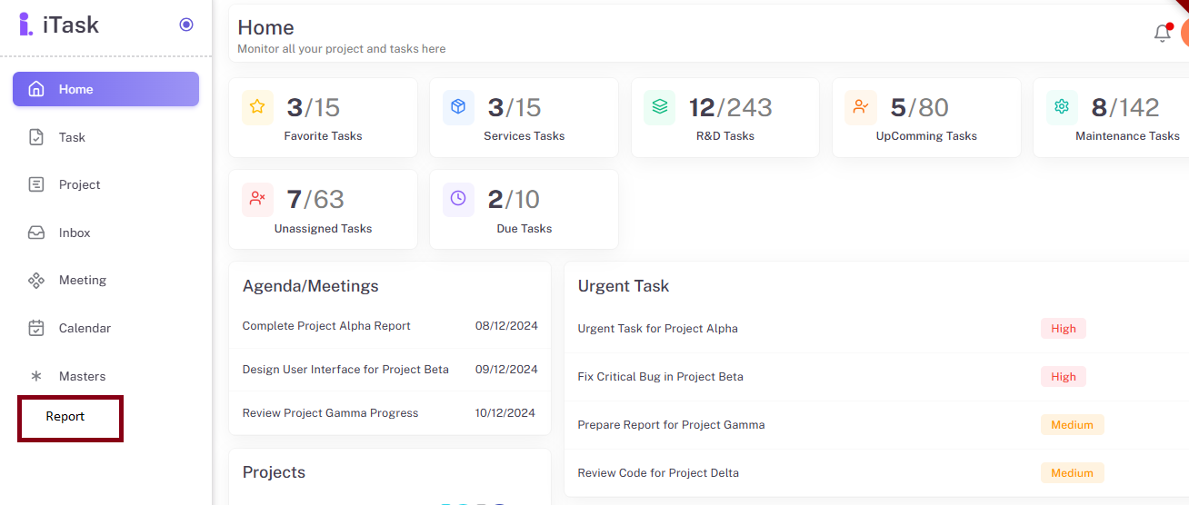

Limitation :meeting
- project and module name should be unique.
- Upcoming:today tomorrow meeting
- Over due:
- Completed:not editable
- History:not editable
- Favorite:not category
- employee rights limitation with no selected employee rights is apply to another employee

->calender page show schedule employee (assignee ‘s calender schedule wise)

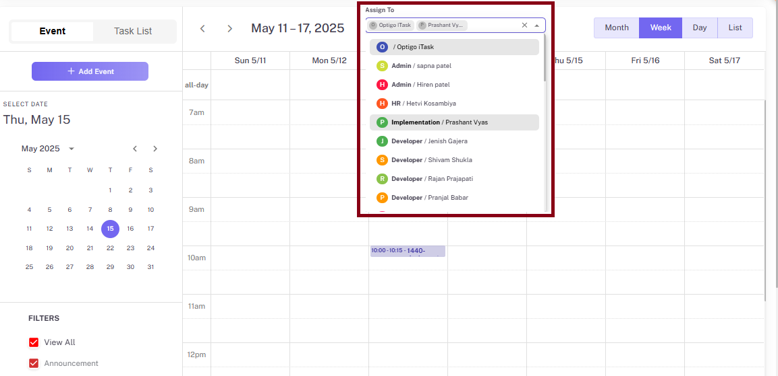

04-june updated

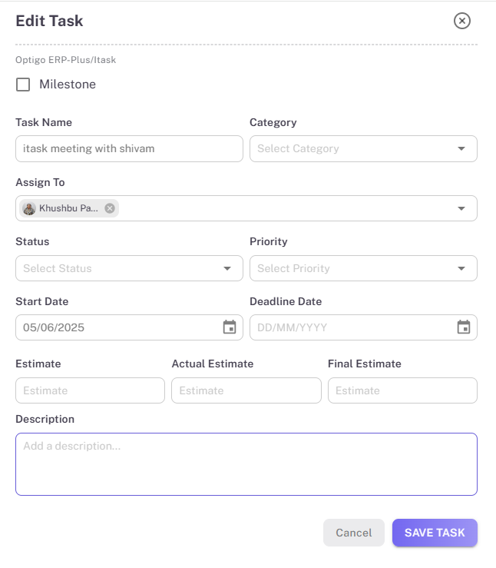
By default start date is entry date

- show category count
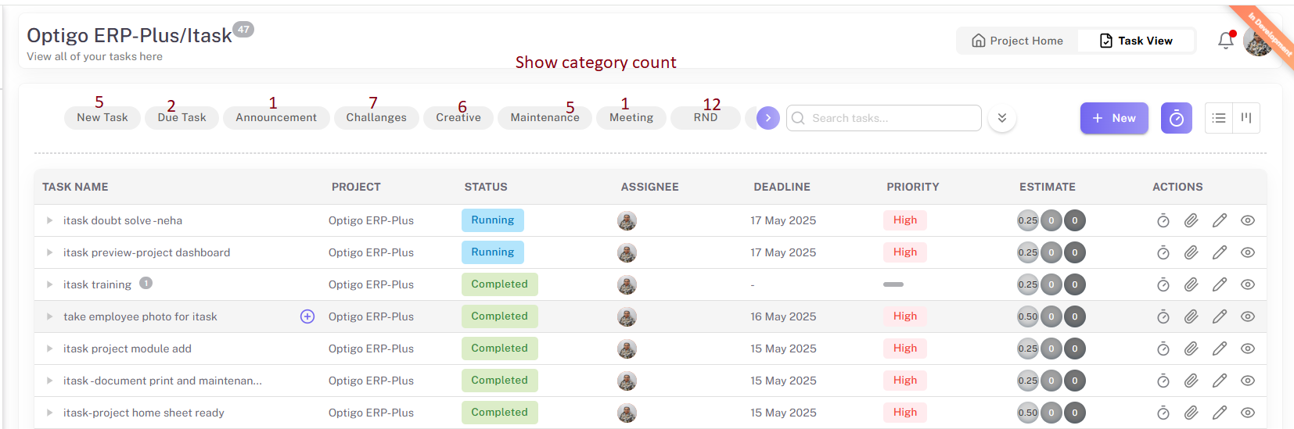

Special Note: if choose project /module then show only project/module total count of category
On task page show all project /module total count of category

- add task and calender view
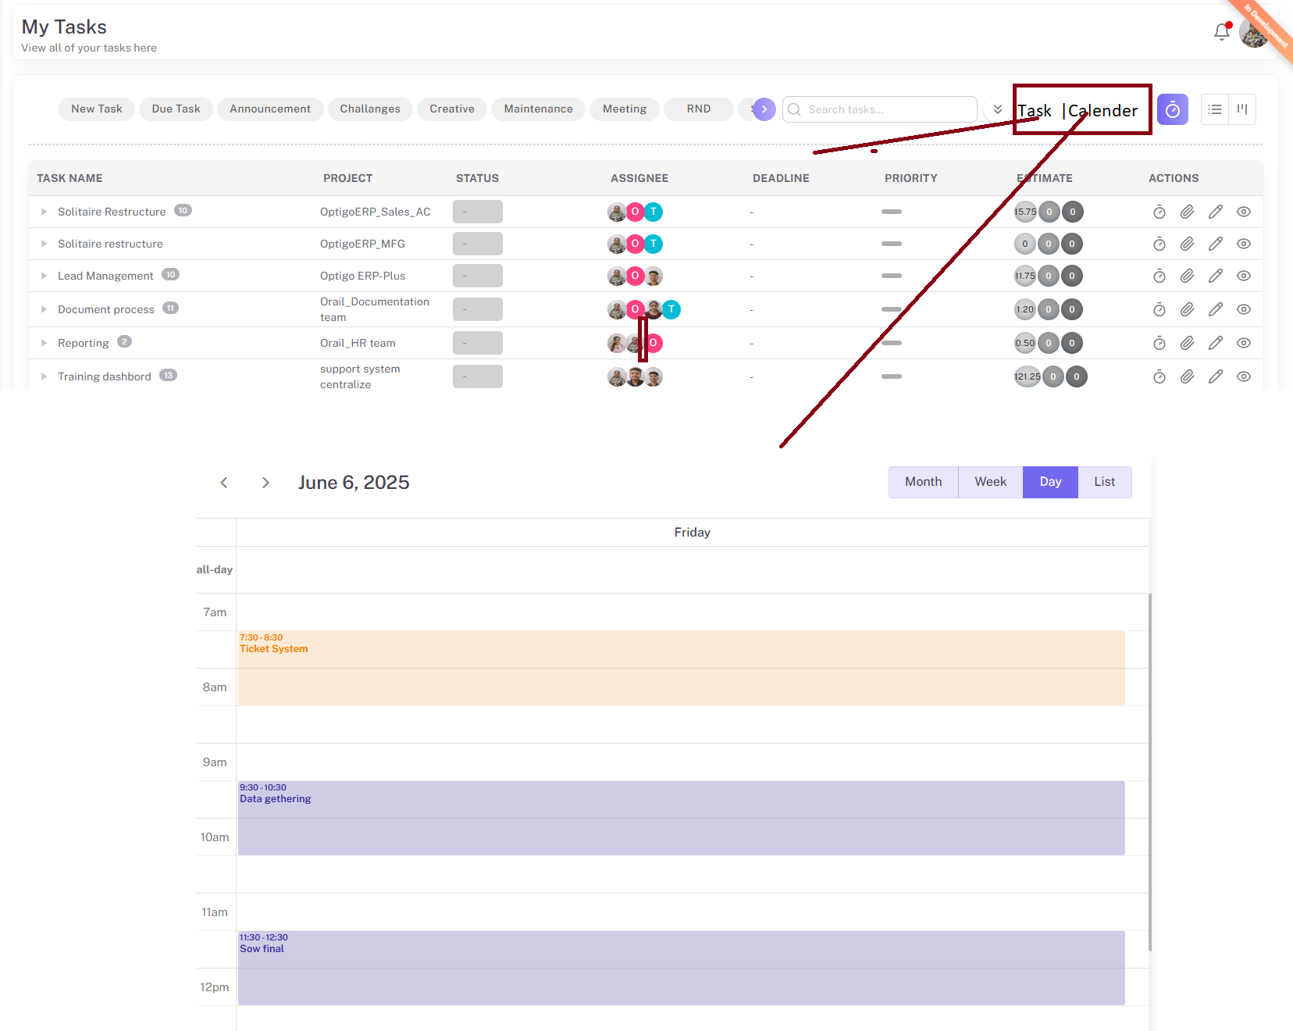

In this calender view show today/ week /month task list according to start date(by default add date) and time according to estimate time

- bind task list in calender
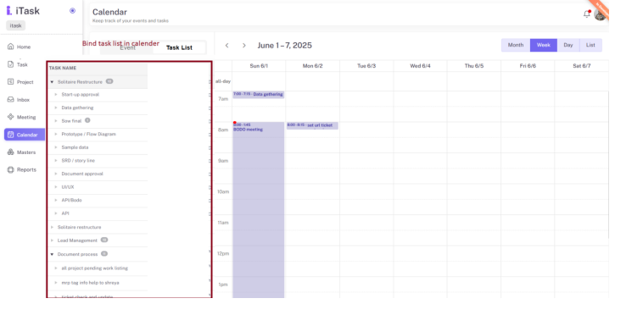
Remove task which is already set in calnder
Give option of cancel in task to re do

06-june-2025

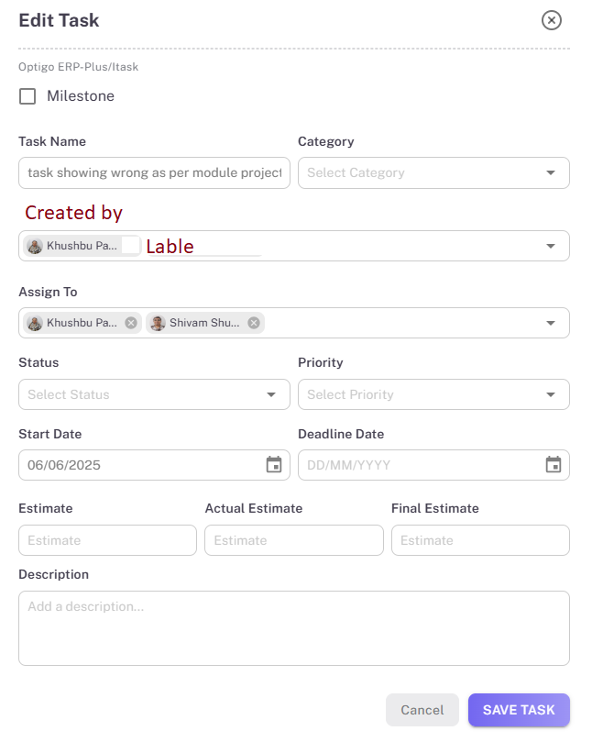
Step: Add created by in task add page
Step: using created by and assign dived me and team function as shown in image
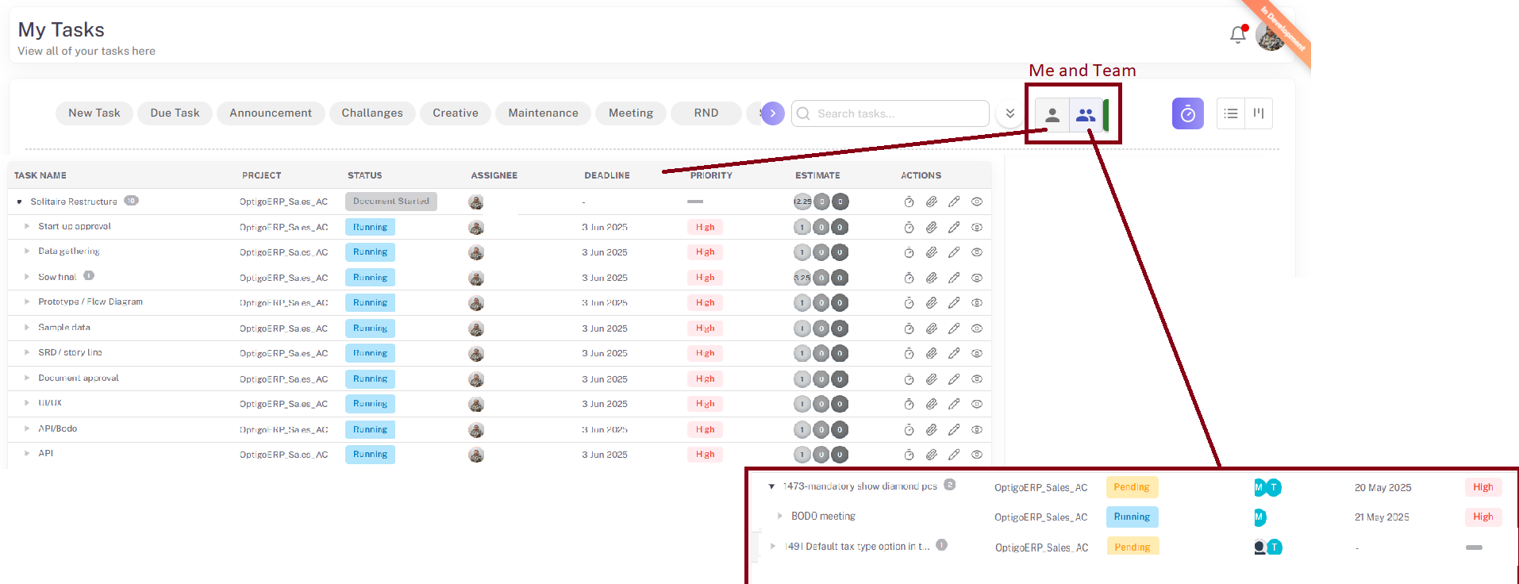
In me task :created by ans assignee by are equable
In team task: created by and assignee by are different different

07-june-2025

Todo list calender
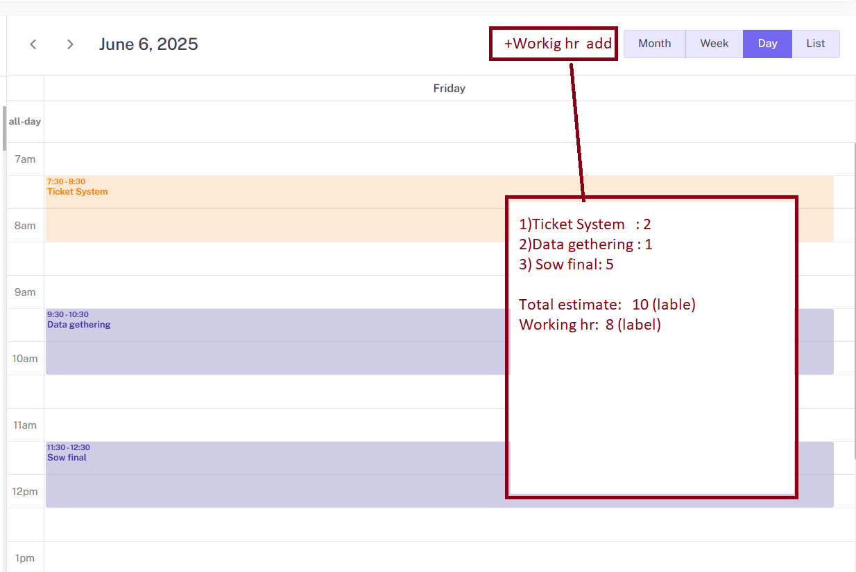

Step: in todo list calender add working hr button
Step: if click on that button new popup is open for add working hr of today task

07-june-2025

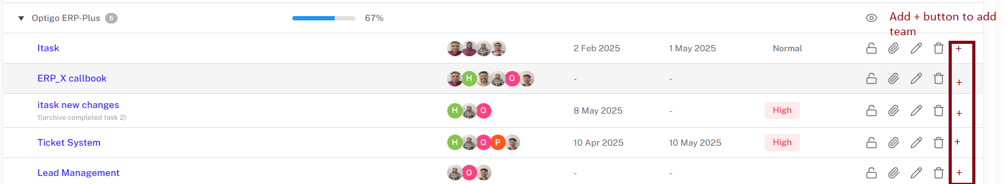

Step:add + button in project > Module for add team

- june-2025

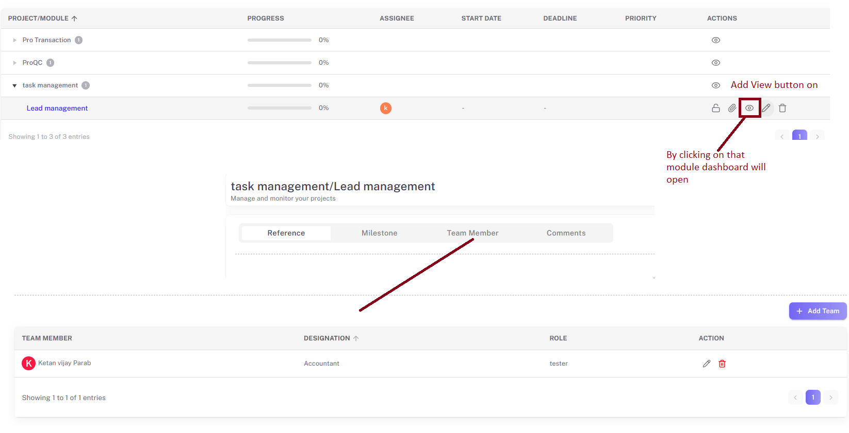
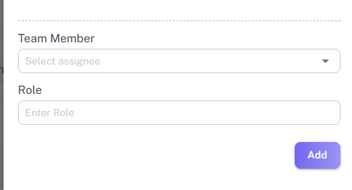
Team member: Mandotory field:input type:dropdown
Role:Mandatory field :input type:text field

Step: add view button on module
Step:by clicking on view button following details are open
- reference:show attachment of module
- Milestone: show task which has milestone flag

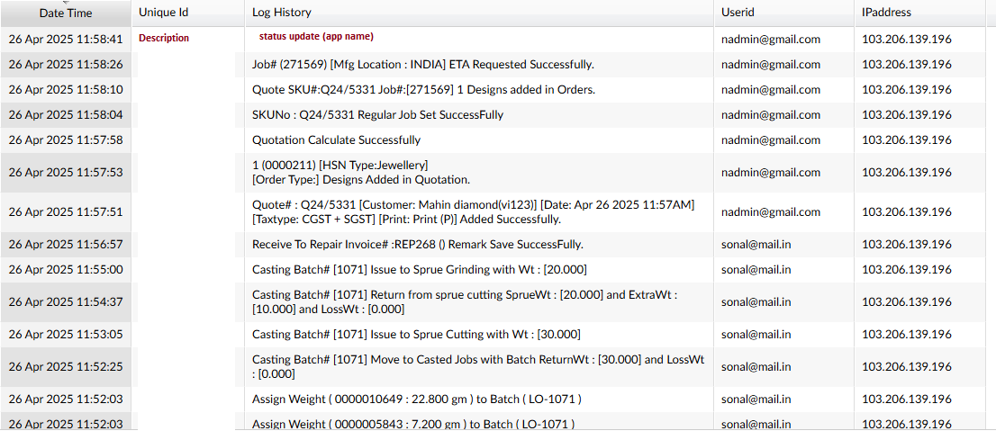

Database backup

Show completed task in archive mode

13-june-2025
Move task in another module and project

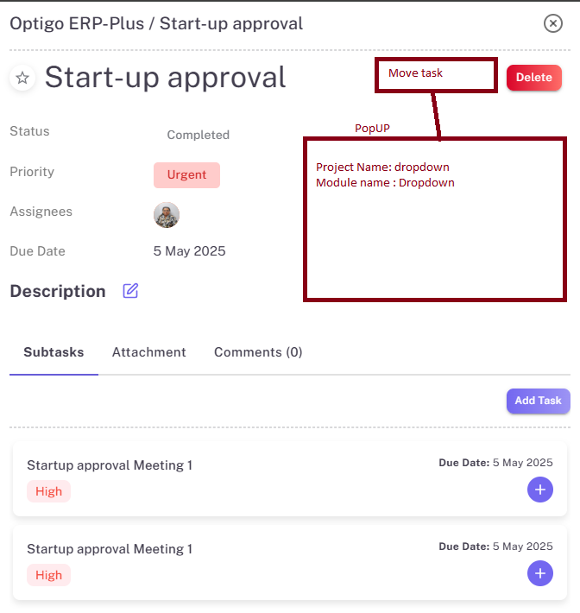

Step: add other details in bulk task as shown in image.
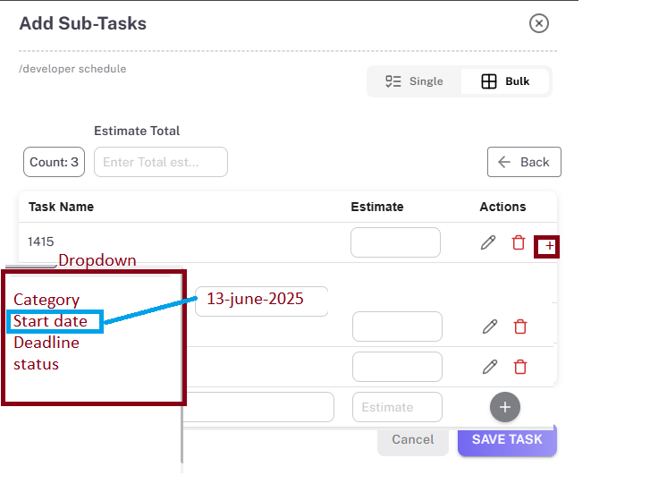
8-11-2025 Deadline days showing

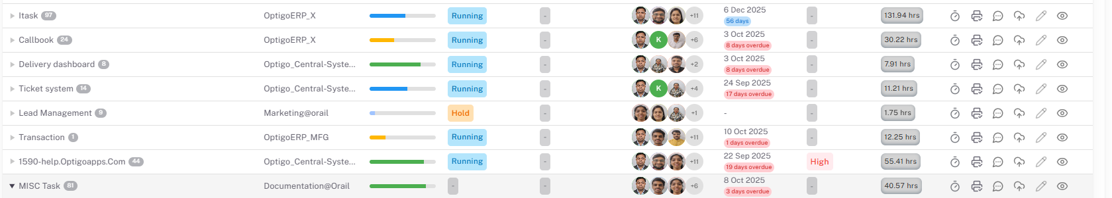

Step:1 show deadline overdue days in deadline
Example
- Deadline is set :3 oct 2025 task complete on 5 oc 2025 then show 2 days overdue in red
- Deadline is set :3 cot 2025 task completed on 3 oct 2025 then show ontime
- Dealine is set:3 oct 2025 task completed on 2 oct 2025 the show early

Give Error message

1. 404 Not Found
- Description: The server can’t find the requested page.
- Cause: The URL is incorrect, the resource has been moved or deleted.
- Example: Trying to access example.com/oldpage when that page no longer exists.

2. 500 Internal Server Error
- Description: A generic server error indicating that something went wrong on the server.
- Cause: Misconfigured server, broken backend code, or unhandled exceptions.
- Fix: Check server logs to debug the issue.

3. 403 Forbidden
- Description: The server understands the request but refuses to authorize it.
- Cause: Permissions issue – the user doesn’t have access to the requested resource.
- Example: Trying to access an admin page without proper credentials.

4. 502 Bad Gateway
- Description: One server acting as a gateway or proxy received an invalid response from an upstream server.
- Cause: Issues with server communication, network errors, or crashes in dependent services.

