Pupose:print the document sheet in itask
Story line:
Step:1 make new document sheet as per following
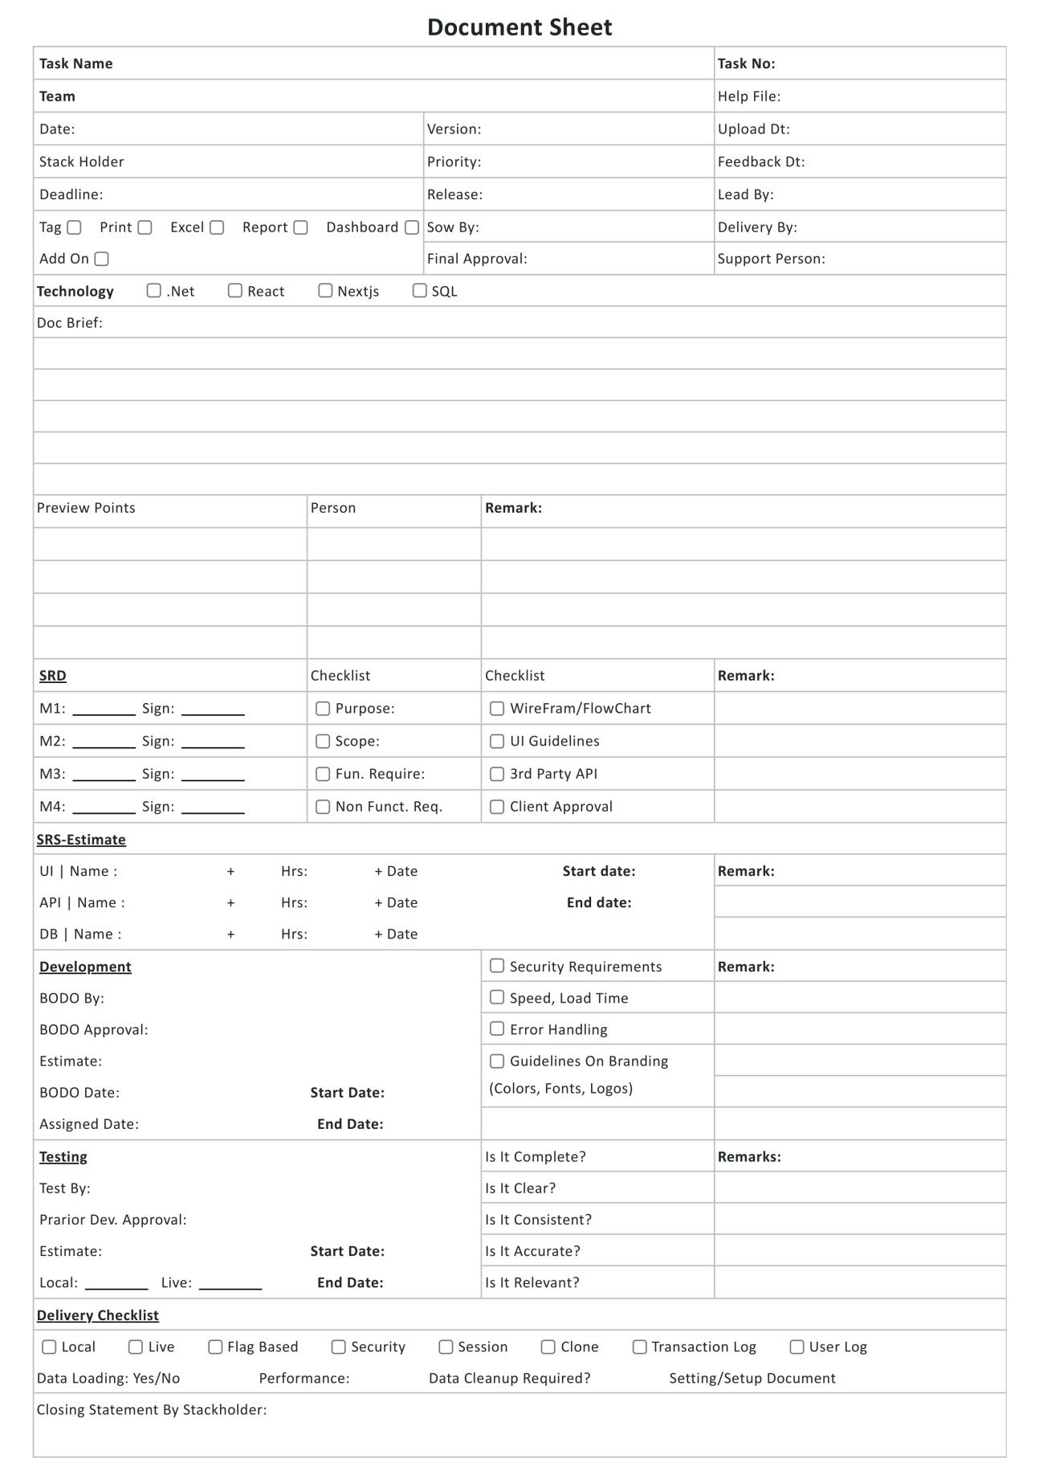

🧾 Document Header
Task Name:bind the task name from main task
Task No:bind the task number from main task
Team:bind the assignee of task
Help File
Date:bind date of start date of task
Version
Upload Dt
Stack Holder
Priority
Feedback Dt
Deadline
Release
Lead By
Tag: (☐ Print ☐ Excel ☐ Report ☐ Dashboard)
Sow By
Delivery By
Add On ☐
Final Approval
Support Person

⚙️ Technology☐ .Net
☐ React
☐ Nextjs
☐ SQL

📘 Doc Brief
(Multi-line text area for document description)

👁 Preview Points Table
Column | Description
Preview Points | Items or milestones
Person | Responsible individual
Remark | Comments or status

🧩 SRD Section
Code | Fields | Checklist
M1 | Sign | ☐ Purpose ☐ WireFram/FlowChart
M2 | Sign | ☐ Scope ☐ UI Guidelines
M3 | Sign | ☐ Fun. Require ☐ 3rd Party API
M4 | Sign | ☐ Non Funct. Req ☐ Client Approval
Remark column | For each checklist item

🕒 SRS-Estimate Section
Module | Name | Hrs | Date | Start date | End date | Remark
UI
API
DB

💻 Development Section
BODO By
BODO Approval
Estimate
BODO Date
Assigned Date
Start Date
End Date
Checklist:
☐ Security Requirements
☐ Speed, Load Time
☐ Error Handling
☐ Guidelines on Branding (Colors, Fonts, Logos)
Remark field at right.

🧪 Testing Section
Field | Purpose
Test By | Tester name
Prior Dev. Approval | Developer who approved
Estimate | Estimated effort/time
Start Date | Testing start
End Date | Testing end
Local | (checkbox/flag)
Live | (checkbox/flag)
Checklist questions:
Is It Complete?
Is It Clear?
Is It Consistent?
Is It Accurate?
Is It Relevant?
Remarks field for comments.

🚀 Delivery Checklist
Checkboxes:
☐ Local
☐ Live
☐ Flag Based
☐ Security
☐ Session
☐ Clone
☐ Transaction Log
☐ User Log
Additional fields:
Data Loading: Yes/No
Performance:
Data Cleanup Required?:
Setting/Setup Document

🧾 Closing Statement
Closing Statement By Stackholder: (free text area)

Step: bind the sheet in main task
