Task Name: Add Repair Remark for Material Issue Vouchers from Detach Material

Team
Documentation: Deepak
Stake Holder: Kuldeep
Developer: Mahesh + Team
Tester: Vidhi
Support: Kuldeep

Purpose and Goal:
The goal of this task is to help users easily identify material issue vouchers generated from detached materials during Product Alteration Receive or Receiving Repair Jobs from Manufacturer.
This will improve clarity and reduce confusion between normal vouchers and detach-material vouchers.

Story Line and Current Flow:
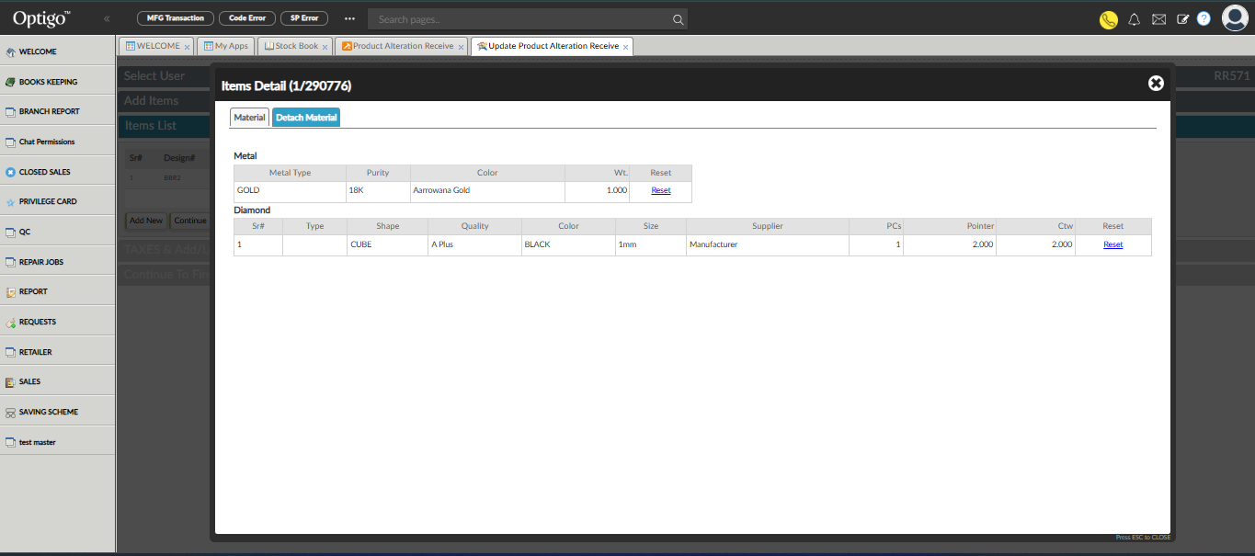
In Vendor > Manufacturer MGT > Product Alteration Receive:
- When a material is detached, a material issue voucher is generated for that manufacturer (Refer the above Image).
- The voucher appears in the Material Issue page.
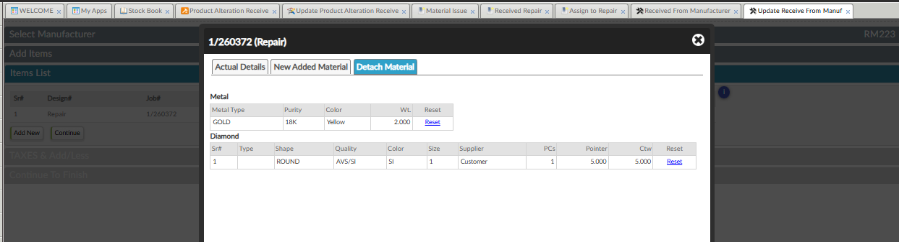
Vendor > Manufacturer MGT > Assign to Repair
- And same while Receiving Repair Jobs from Manufacturer:
- When a material is detached during, a material issue voucher is also generated for the same manufacturer
- Currently, users cannot distinguish between normal material issue vouchers and those created from detached materials.

Change Request to Get Developed
- Whenever a material issue voucher is generated due to material detach in either:
1. Product Alteration Receive
2. Receiving Repair Jobs from Manufacturer
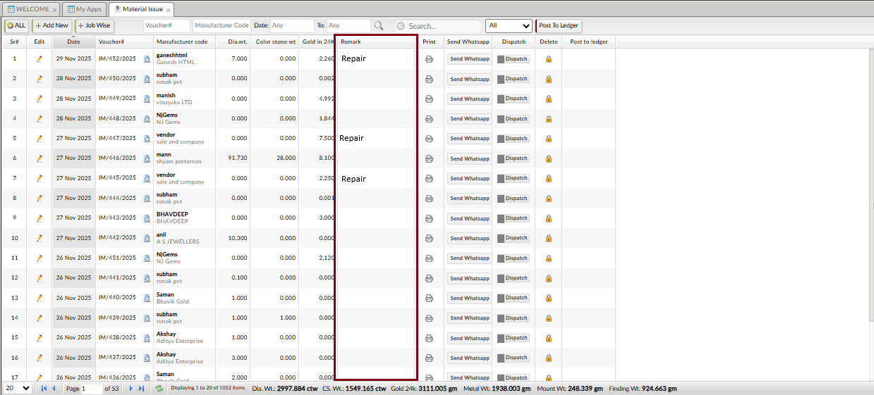
Vendor > Manufacturer MGT > Material Issue

→ The voucher should automatically include the remark as: “repair” in the Remark column. (Refer the above Image)
If detach materials from both events come from the same manufacturer and merged in one voucher:
- The Remark column should only show one “repair” Remark, not duplicate remarks.
- This change will allow users to identify detach-material vouchers easily by looking at the remark.

Sample Entry:
Case 1: Product Alteration Receive
1. Reference Voucher: RR572 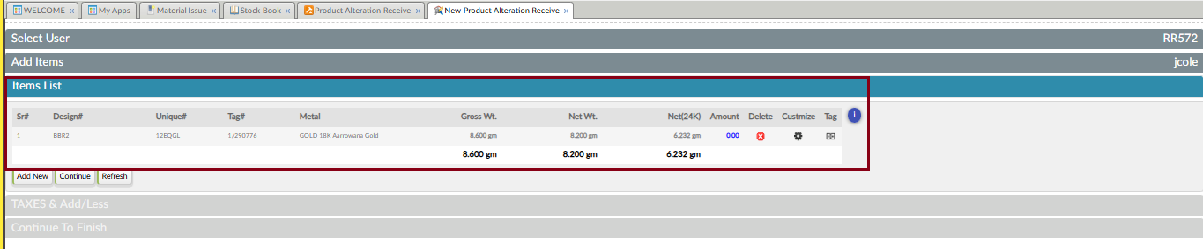
We make product alteration receive of 1/290776 from manufacturer: Jcole.
There when we click on customize an Item detail popup open up as shown in the below Image Open up. (Refer the below Image).
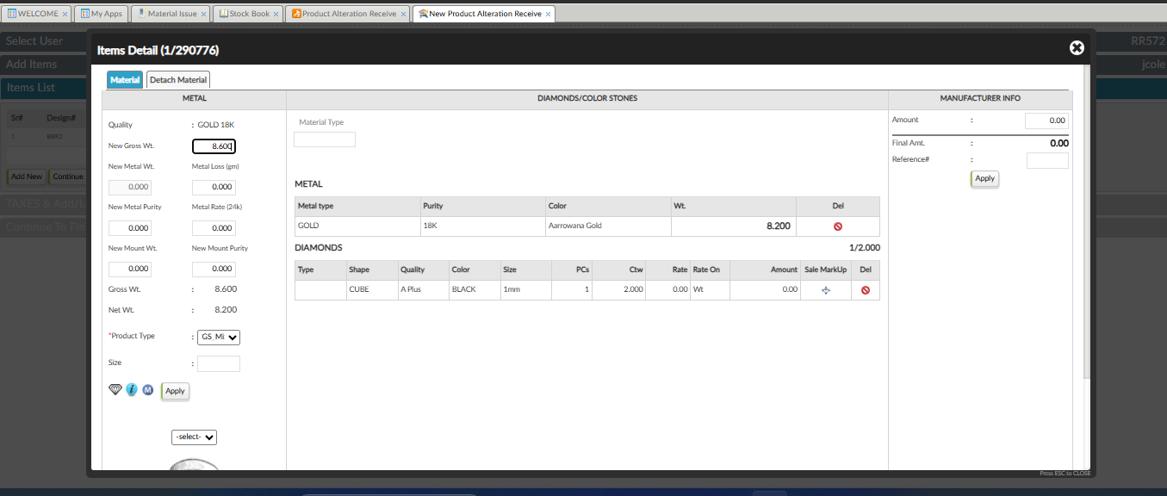There by clicking icon in Del column we detach 2 gm GOLD with 76.000 purity. (Refer below Image)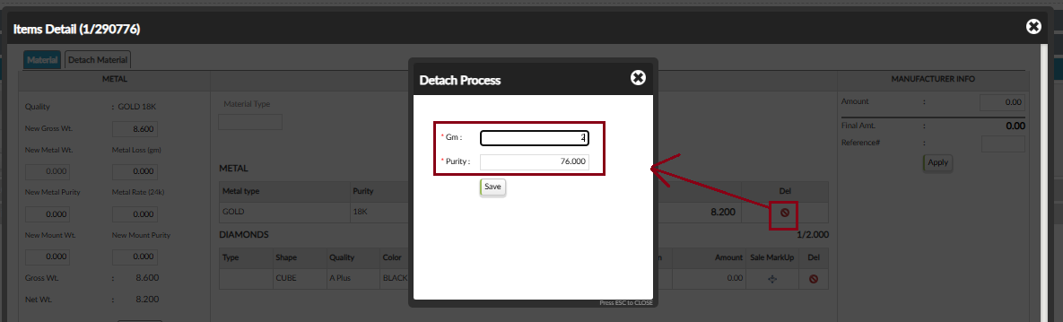
And also detach 1 ctw of diamond.
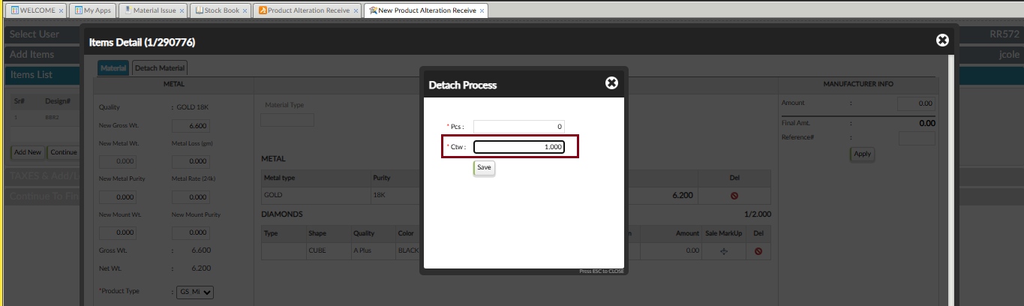
So, when we detach material, a material issue voucher (Voucher No: IM/453/2025) got generated for Jcole.
(Refer the below Image)
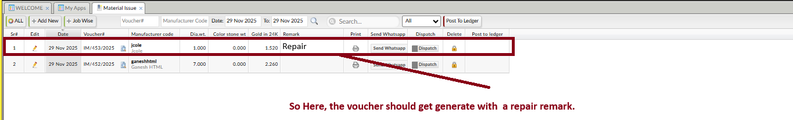

Case 2: Receiving repair jobs from manufacturer
Reference Voucher No.: RM227
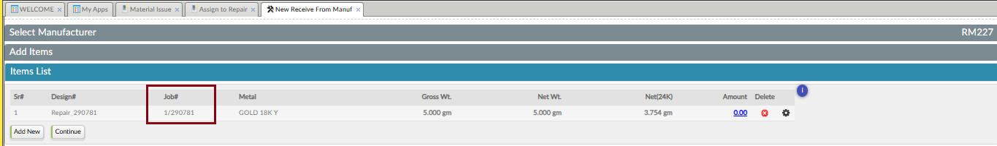
Here we received repair job :1/290781 from manufacturer: Maruti Jewels.
There when we click on customize a popup open up as shown in the below Image Open up. (Refer the below Image).
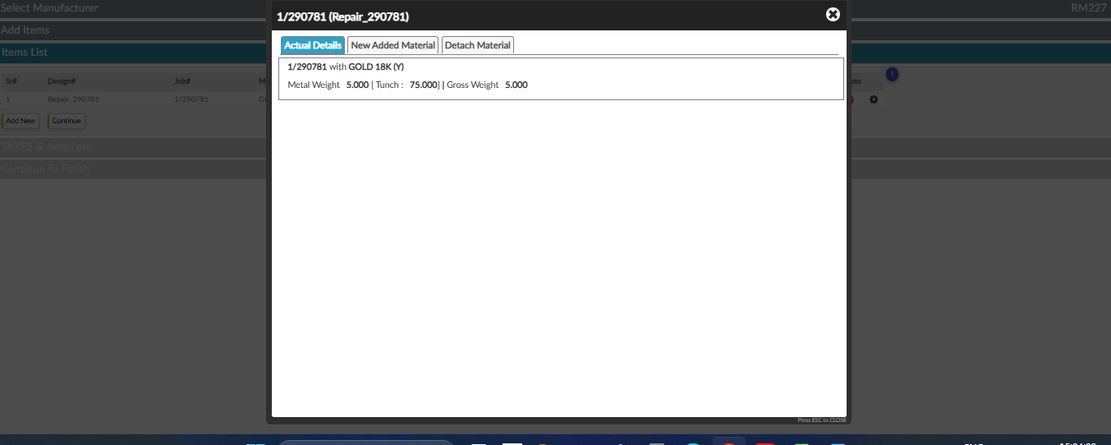
So, there in New Added Material section we detach 2 gm of metal by clicking on icon present in Detach column. (Refer the below image)
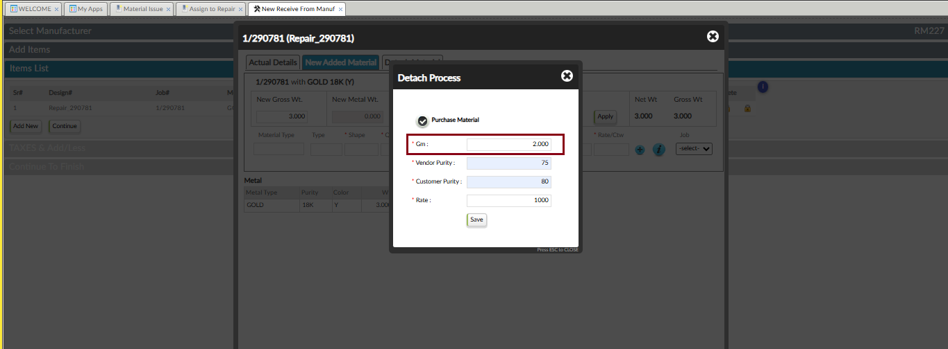
So, when we detach material, a material issue voucher (Voucher No: IM/457/2025) got generated for Maruti Jewels.
(Refer the below Image)
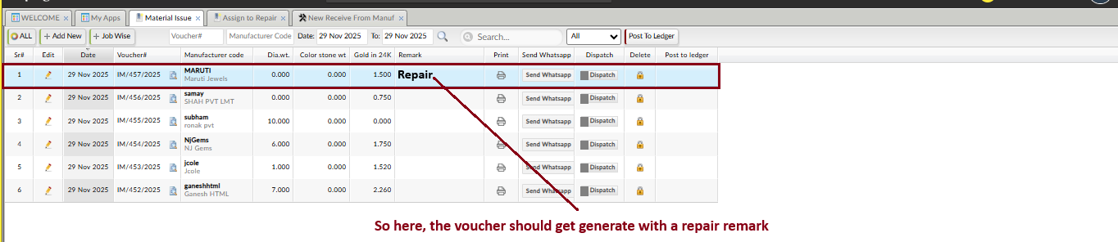
Case 3: Product Alteration Receive and Receiving repair jobs from same manufacturer
- Reference Voucher: RR576
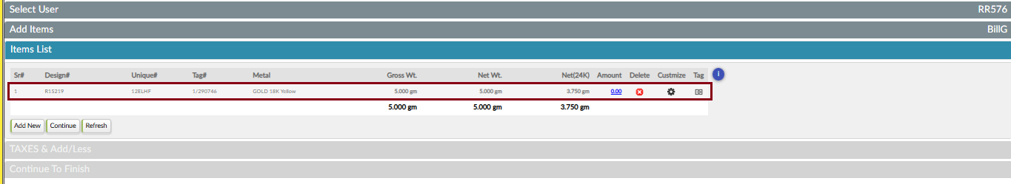
We make product alteration receive of 1/290746 from manufacturer: BillG.
There by clicking icon in Del column we detach 3 gm GOLD with 76.000 purity. (Refer below Image)
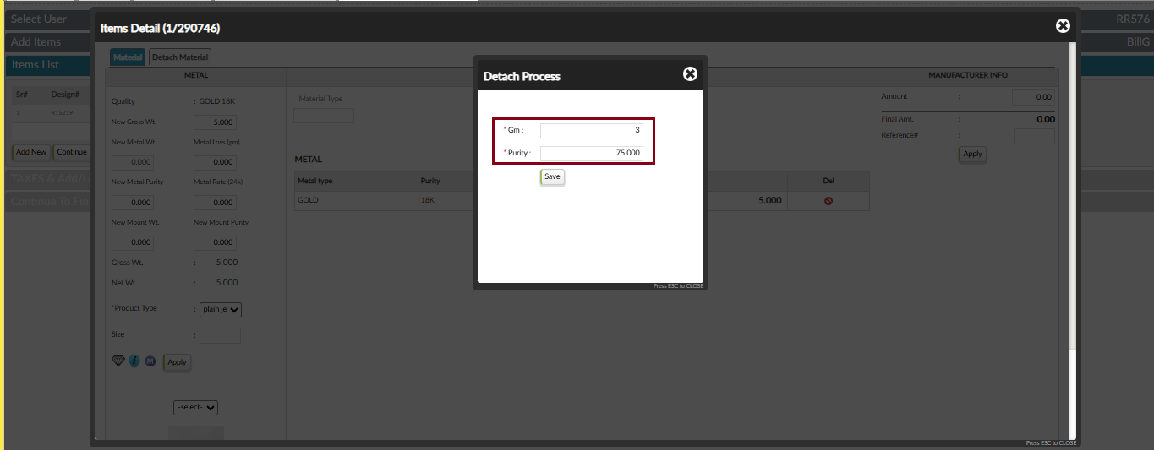
So, when we detach material, a material issue voucher (Voucher No: IM/458/2025) got generated for BillG.
(Refer the below Image)
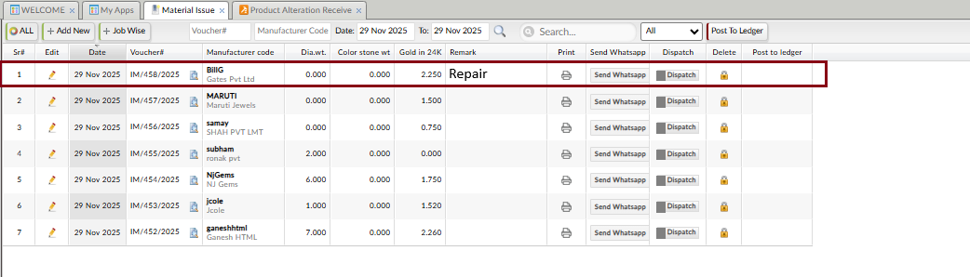
So here, the voucher should get generate with repair remark.
--------------------------------------------------------------------------------------------------------------------------------------
After it we receive repair job from same manufacturer.
Reference Voucher No.: RM229
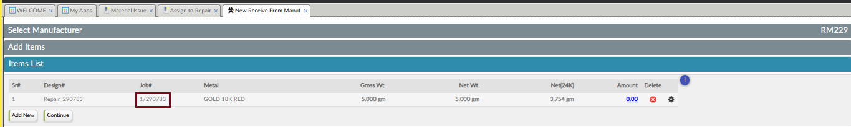
Here we received repair job: 1/290783 from same manufacturer: BillG.
So, there in New Added Material section we detach 3 gm of metal by clicking on icon present in Detach column. (Refer the below image)
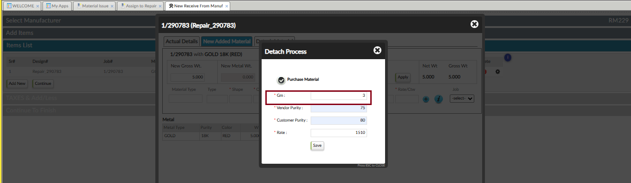
So, when we detach material from same manufacturer, the detached material got merged in the same voucher (Voucher No: IM/458/2025) which got generated for BillG at the time or product alteration receive. (Refer the below Image)
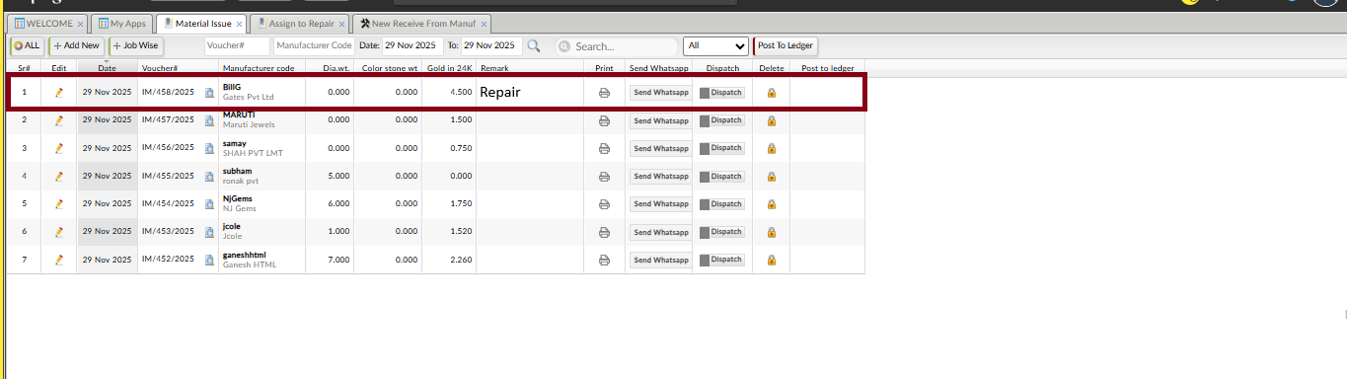
So here , The Remark column should only show one “repair” Remark, not duplicate remarks.

