Task No: TT5832
Task Name: Add Diamond Type Dropdown in Quote

Team
Documentation - Deepak
Stake Holder - Trupti
Developer -
Tester – Vidhi
Support - Kuldeep

Purpose and Goal:
- To introduce a new "Diamond Type" dropdown for better diamond management.
- To change the behaviour of Metal Type and Metal Color dropdowns so changes apply accurately.
Story Line and Current Flow:
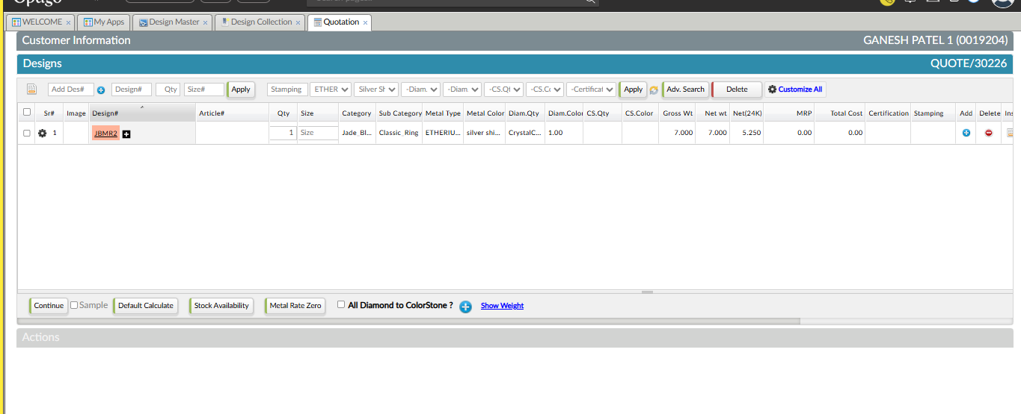
Sales CRM > Sales > Design Collection > Quote
Currently, while making quotation in the Designs section:
- There are multiple dropdowns in the header (e.g., Stamping, Metal Type, Metal Color, Diamond Quality, etc.).
- When a user selects a value in a dropdown and clicks "Apply," it updates all items in the grid.
- But there is no "Diamond Type" dropdown yet.
- For Metal Type and Metal Color, if a design has multi -metals (primary and secondary), applying changes updates both metals regardless of type.

Change Request to Get Developed:
1. Add a new dropdown “Diamond Type” next to Diamond Quality.
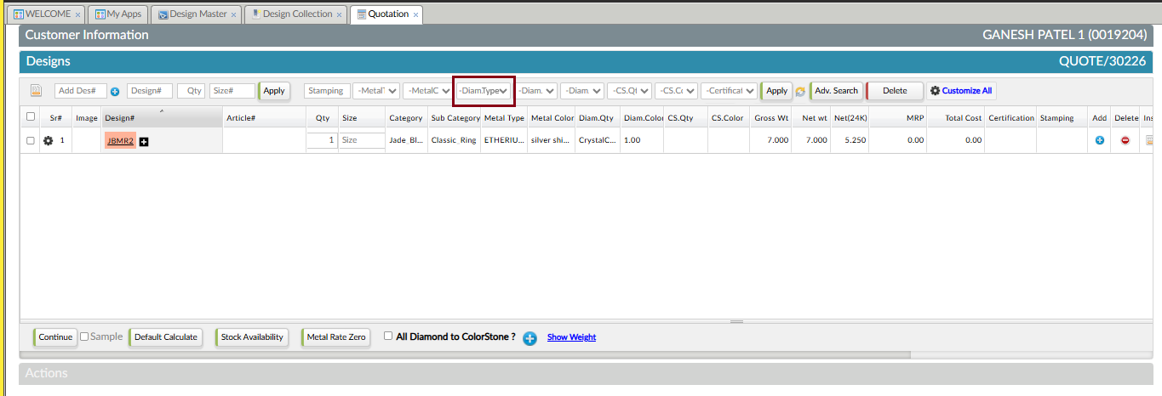
- The options for this dropdown will come from Masters & Policy > ACCOUNT > Item Master.
- When a value is selected and "Apply" is clicked, designs with diamonds in the grid should have their Diamond Type updated accordingly.
2. Update the behaviour of Metal Type and Metal Color dropdowns:
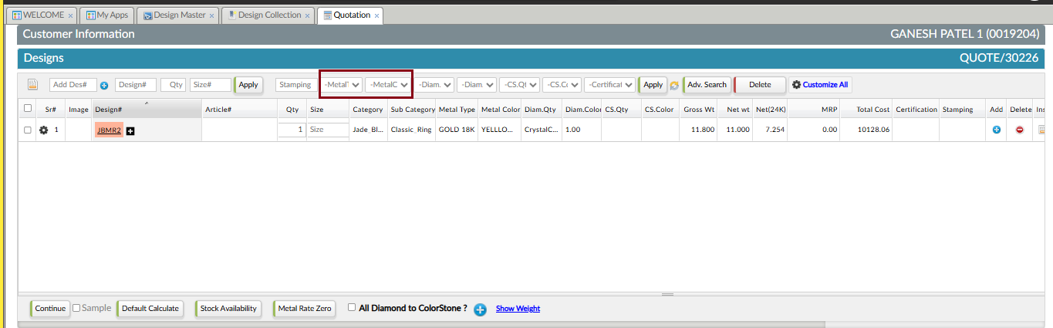
- If a design has multiple metals with different types, applying a change from the header should **only update the primary metal**.
- If both metals are of the same type, the changes should apply to both metals.
- This ensures correct and precise application of Metal Type and Metal Color in multi-metal designs.

Sample Entry to Understand Current Behaviour:
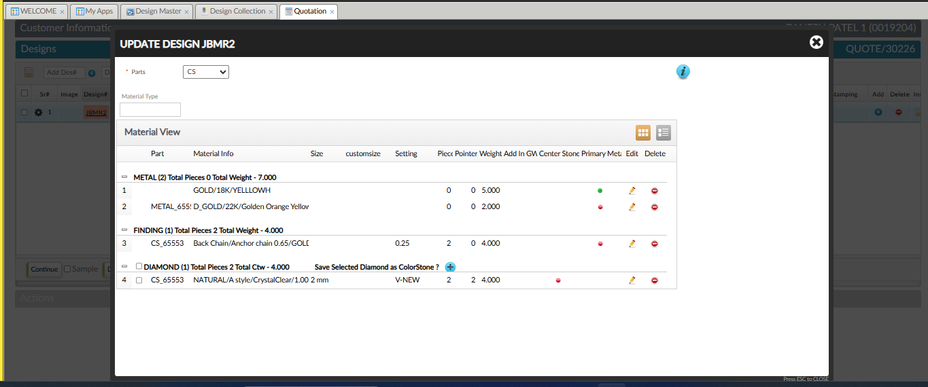
Design- JBMR2 contains:
Primary Metal – GOLD/18K/YELLOWH
Secondary Metal – D_GOLD/22K/ Golden Orange Yellow
Finding - GOLD/10K/Aarrowana Gold

Then, we select Metal Type – ETHERIUM 18K and Metal Color – T1 Yellow and click on apply button.

So, the effect of it got applied on Primary Metal, Secondary metal and Finding (Refer the below Image).
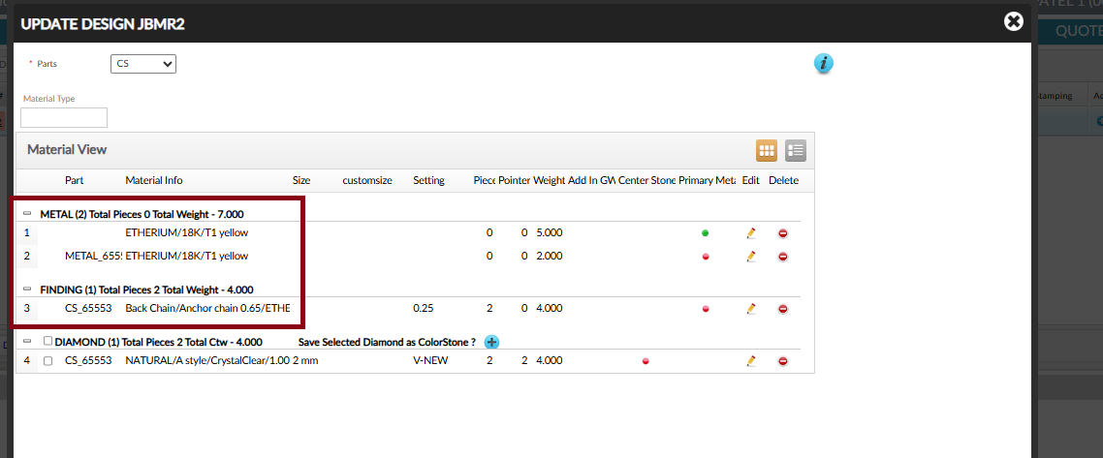

Sample Entry of New (Expected Behaviour):
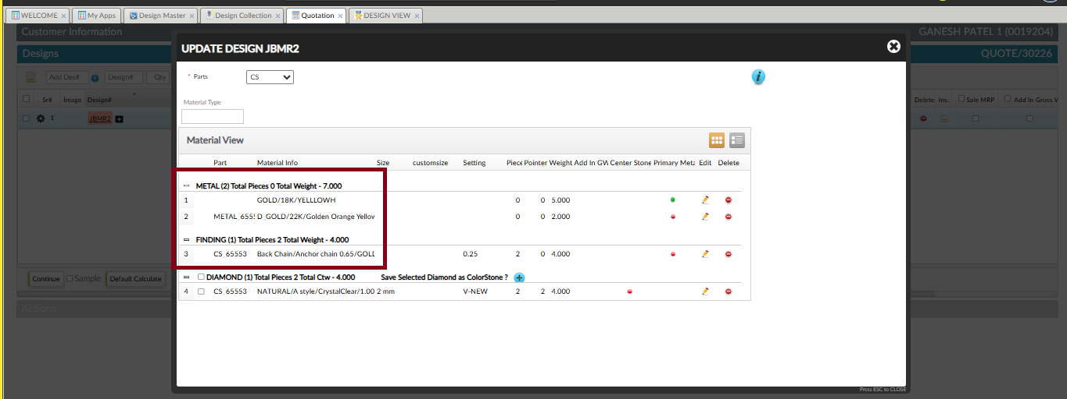
Let take the same design – JBMR2 which contains:
Primary Metal – GOLD/18K/YELLOWH
Secondary Metal – D_GOLD/22K/ Golden Orange Yellow
Finding - GOLD/10K/Aarrowana Gold

Then, we select Metal Type – ETHERIUM 18K and Metal Color – T1 Yellow and click on apply button.

So, Now in this case only metal type of primary metal should get updated:
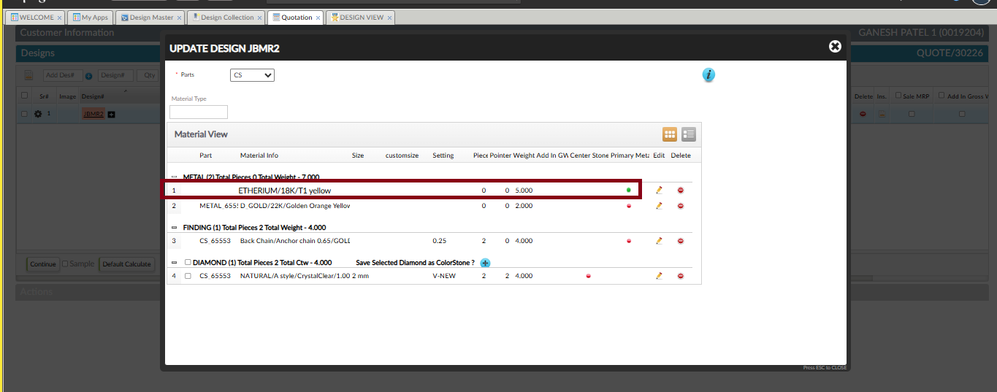
__________________________________________________________________________________
If metal type of primary, secondary and Finding are same then only the metal type and metal color of all should get updated.
Let Say the Same Design JBMR2 has same Metal Type for primary metal , secondary metal and Finding. (Refer the below Image)
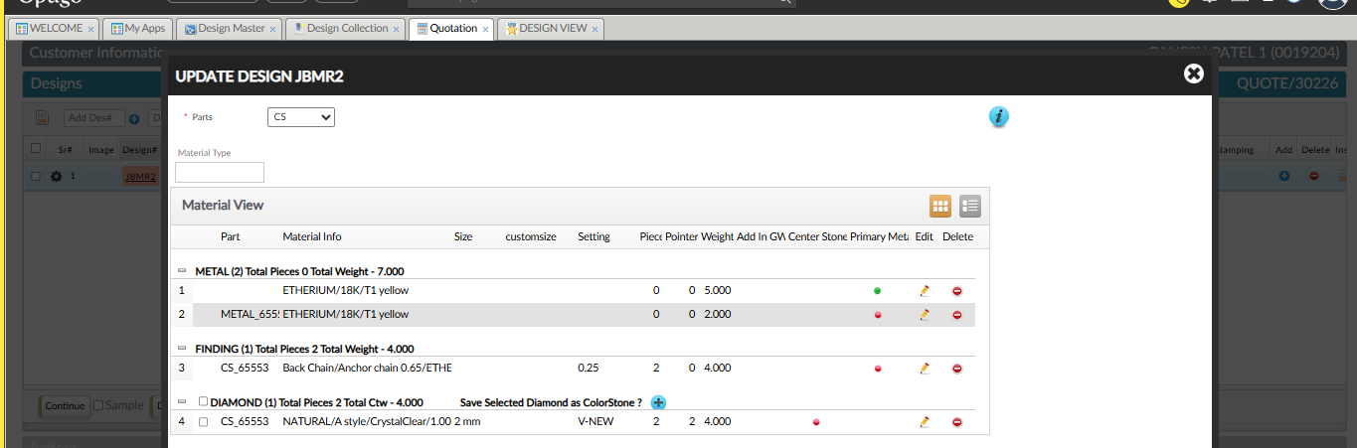
Now we set Metal Type: SILVER 925, Metal Color: Silver Shine White and clicked on Apply. (Refer the below Image)
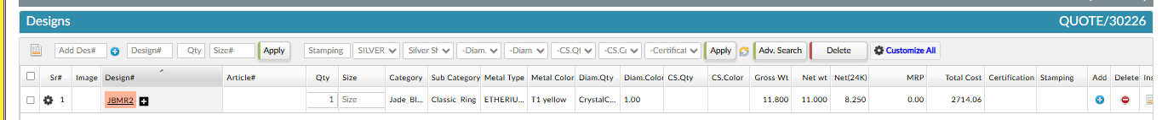

Then, in this case metal type and metal color of Primary, secondary and Finding get updated with selected criteria. (Refer the below Image)
