Task Name: JWT Security Deployment
Team
Documentation – Deepak
Stake Holder – Shreya
Developer – Amrut, Rajan
Tester – Vidhi
Support –

Purpose and Goal
The goal of this task is to implement JWT-based authentication only for:
- Login
- Logout
- Remember Me
This change will improve login security and remove dependency on server-side sessions for authentication.

Story Line and Current Flow
Current Flow (Before JWT)
- User logs in using credentials
- Server creates a session

Change Request to Get Developed
JWT authentication will be implemented only for login-related actions in the following areas:
- Optigo Main Login
https://login.optigoapps.com/Default.do
https://nxt23.optigoapps.com/login
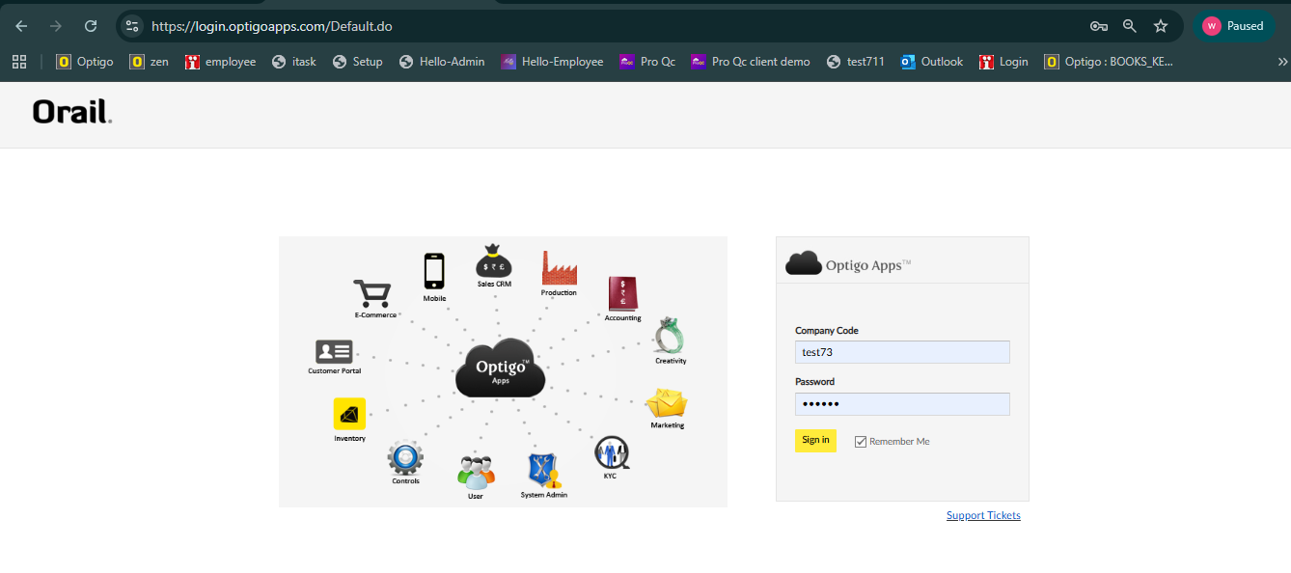
- CSystem Login
https://csystem.optigoapps.com/login
https://nxt28.optigoapps.com/
- To get csystem activation login into
https://nxt23.optigoapps.com/login
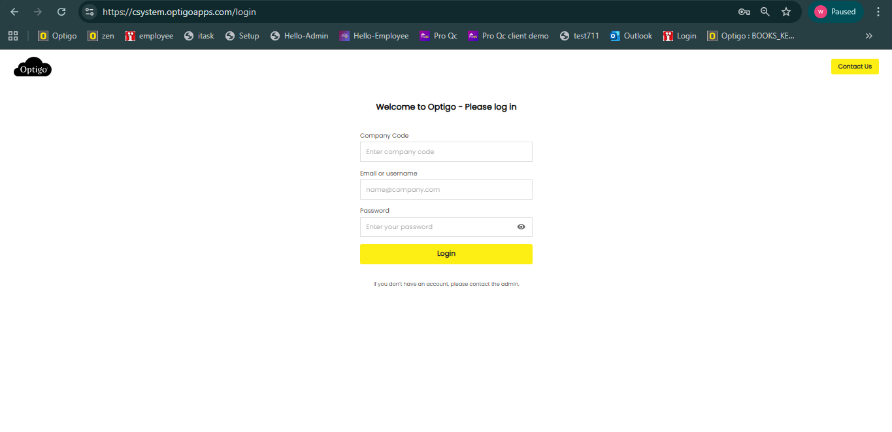
- TeCo Task Login
https://itasklive.optigoapps.com/login
