SRD: Optigo LOGIN new feature and security updates
14-2-26 (saturday)
Need to apply below points in https://loginpro.optigoapps.com/login
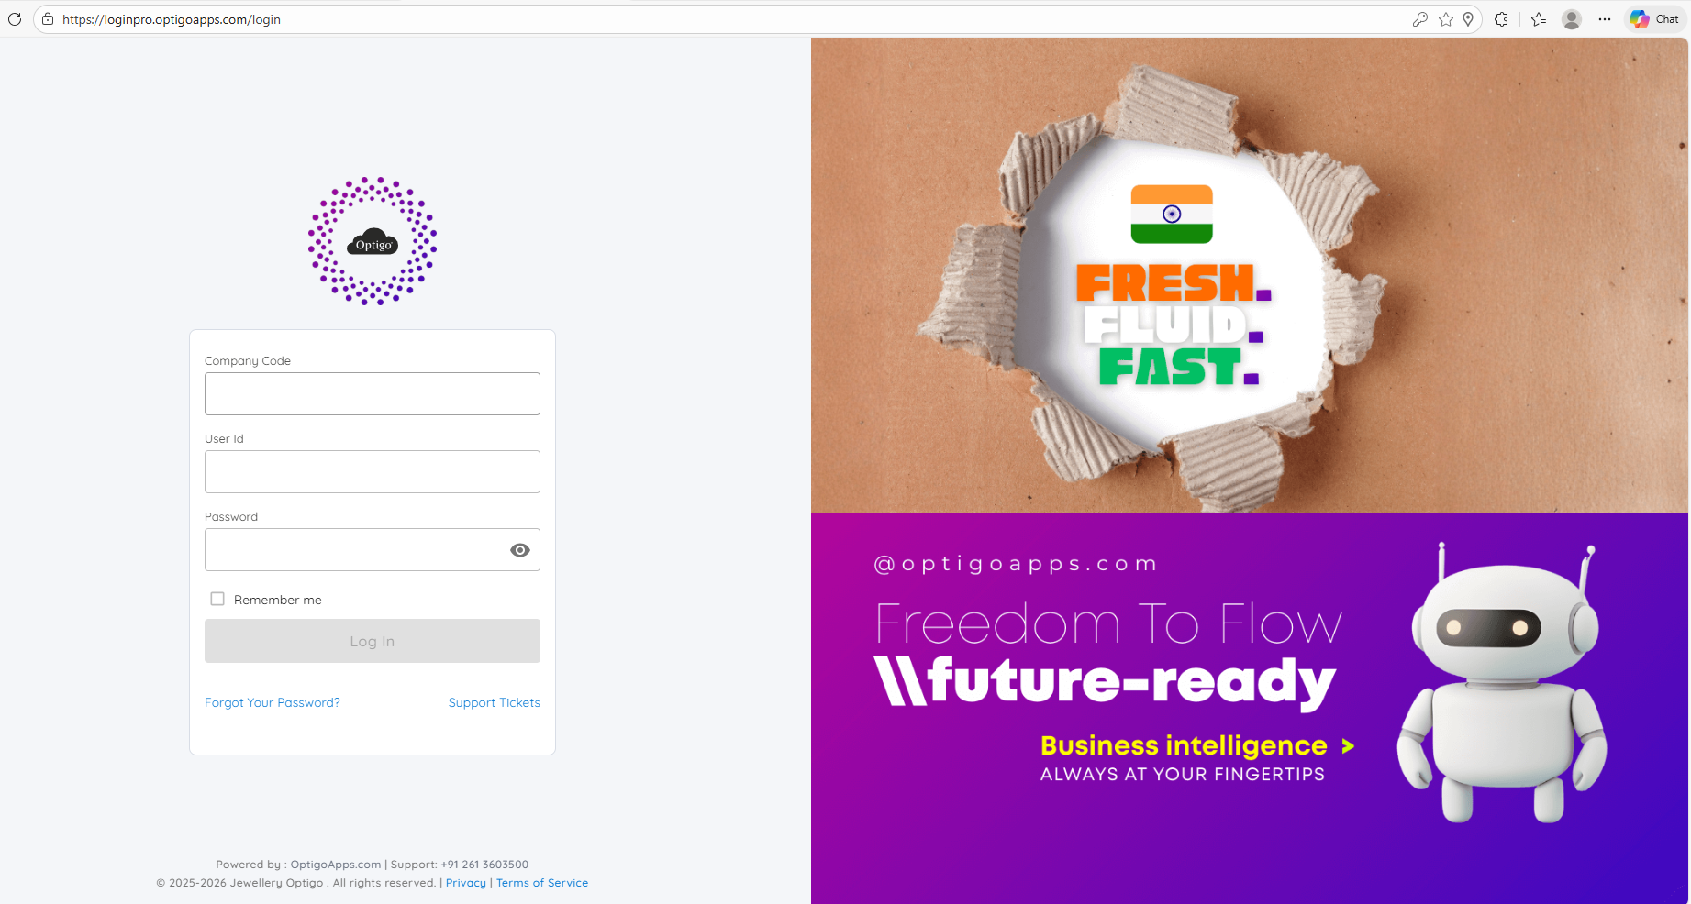
After below points covered in new login menthod we will add JWT and new feature in it
1. login method – New scope
- Rommy on/off: Admin – ‘NO OTP ask’, Employee – ‘OTP Require!’ – Review? + IP
With error code: 2,9
2. Expiry date → Renewal date closing / Expiry date
- Alert day → 30 (Alert 1, 2, 3)
- Grace days – 15 days

3. Multi company – single browser
4. Multi Branch – 5 copy (live1, live2… lives)
5. Multi year – 2010, 11, 12…
6. DB Switching (Demo)
- DB1, DB2 (demo)
7. Setup → login off (Login Control) → forced ‘logout’
8. Go link
9. Support & setup
10. Single PC user (flag)
11. Designation wise – Default APP (page, access, permission)
12. Mobile link (optigo login) + Desktop link
Assigned to amrut sir (18-2-2026)
Old code need to work in new login ui and enhance feature

Not in available / not found / Need to build new feature
- Login – logout → save session time (report level)
- Footprint report (MA) – IP address (multi user, multi location)
- Carony – hitting
- Page hit – count
- Page access binding

