Task Name: Customize Policy in Sale Bill
Documentation – Deepak
Stake Holder – Trupti
Developer –
Tester – Vidhi
Support – Prashant
Requirement by client: AngitJ

Purpose and Goal:
The purpose of this requirement is to allow users to control which price policy should be applied at the time of billing.
Currently, while billing, the price got calculated based on the customer’s price policy.
But client want flexibility so that they can manually choose pricing policies while making the bill.
This feature will help users to select or change Price Policies directly during billing.

Story Line and Current Flow:
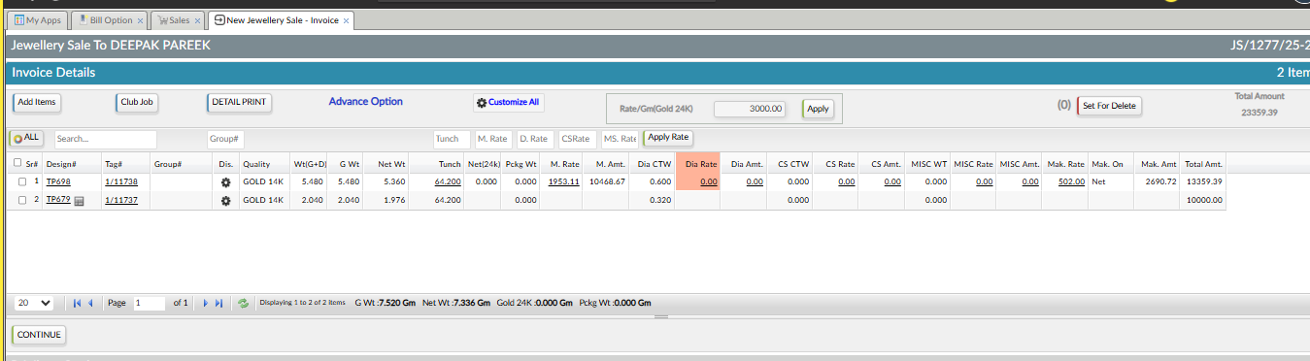
Books Keeping > Sales Process > Bill Option > Jewellery Sale
When a normal Jewellery Sale bill is created:
- The system automatically applies prices based on the Price Policies selected for that customer.
- User does not have any option to change the policy during billing.
- Price automatically get calculated, as per policy set for customer (Refer the below Image).
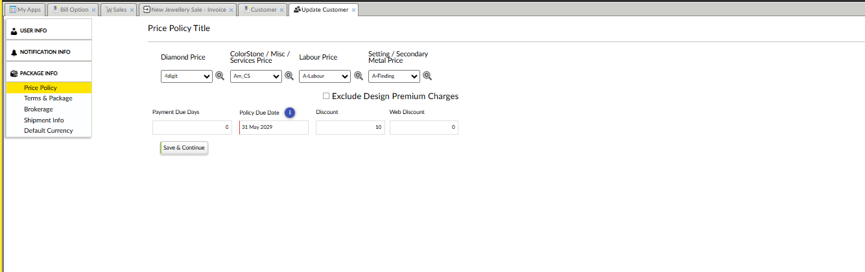
User > Customer > Customer
This is the current working behaviour.

Change Request to Get Developed:
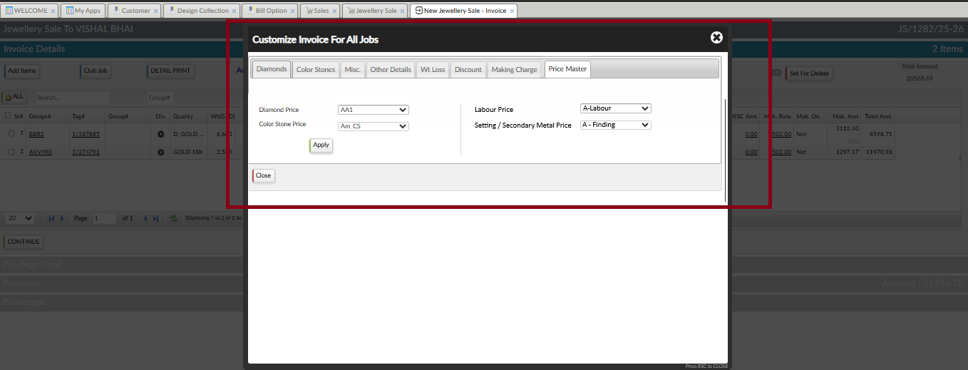
Books Keeping > Sales Process > Bill Option > Jewellery Sale
During Jewellery Sale billing, inside Customize All popup:
- A new Tab named “Price Master” needs to be added.
- This tab will appear in last after Making Charge tab.
Inside the Price Master tab, four dropdowns will be available:
Diamond Price
- Options in Dropdown come from Diamond Price Policy (Masters & Policy > Pirce Master > Diamond Price Policy)
ColorStone / Misc / Services Price
- Options in Dropdown come from Color Stone Price Policy (Masters & Policy > Pirce Master > Colorstone Price Policy)
Labour Price
- Options in Dropdown come from Labour Price Policy (Masters & Policy > Pirce Master > Labour Price Policy)
Setting / Secondary Metal Price
- Options in Dropdown come from Setting / Multi Labour Price Policy (Masters & Policy > Pirce Master > Setting / Multi Labour Price Policy)

By Default
- Fetch the price policies of customer, according to the selected customer. (Refer the below Image)
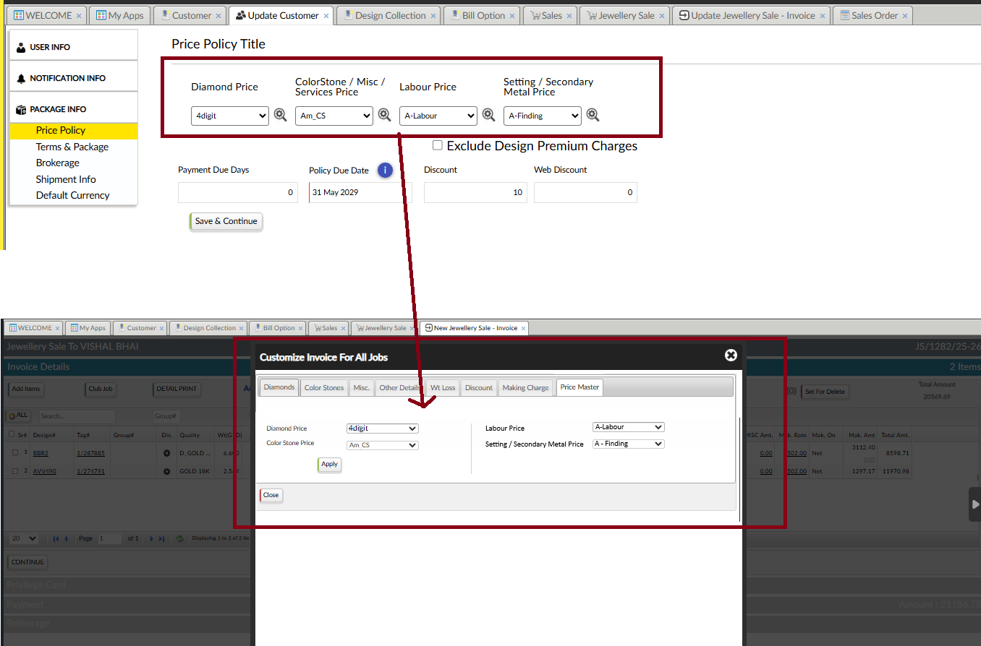
- User can change any policy manually if required.
Validation
- All four dropdowns are mandatory.
- If the user tries to proceed without selecting any one of the policies,
→ System should not allow to apply.
→ Show required alert message.

Pricing Behaviour Flow
- When bill opens → Pricing will applied according to policy of customer (as it is working now).
- If the user changes policies from Customize All → New selected policies should be applied and pricing should refresh as per selection.
Access Control / Rights Requirement
- This functionality will be controlled through Rights.
- A new permission will be added in Access Rights:
“Customize Policy in Sale” (Refer the below image)
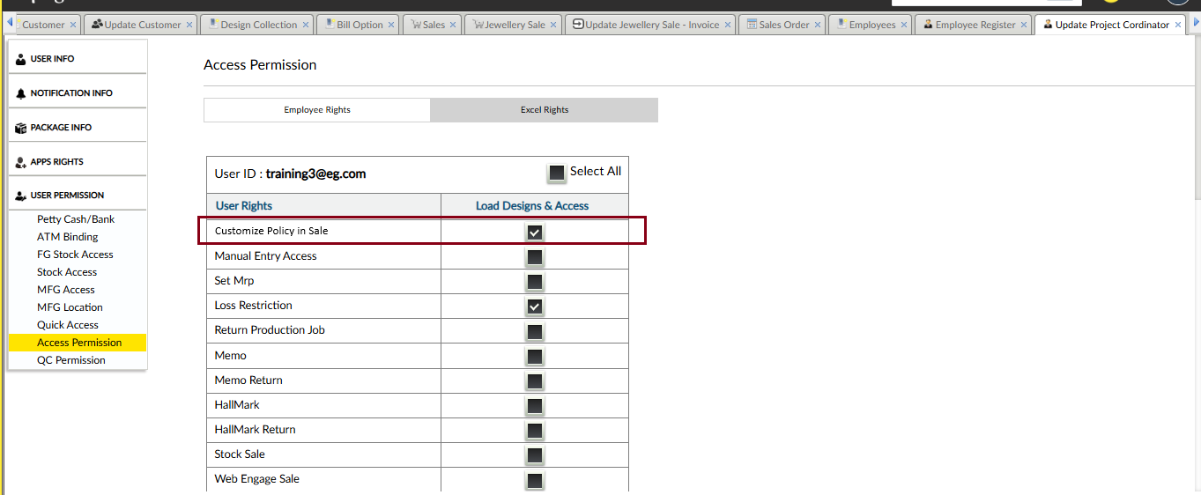
- Only users having this right can view and use Price Master tab.
- If right not given → Price Master tab will not appear.

Scope Limitation
- This feature is applicable only for customer.
- For Manufacturer and Supplier billing, current process will continue.
- No Price Master tab in billing should appear, when user= Manufacturer / Supplier.

Sample Entry:
For example, we make sale bill of customer:05121 of job: 1/292200
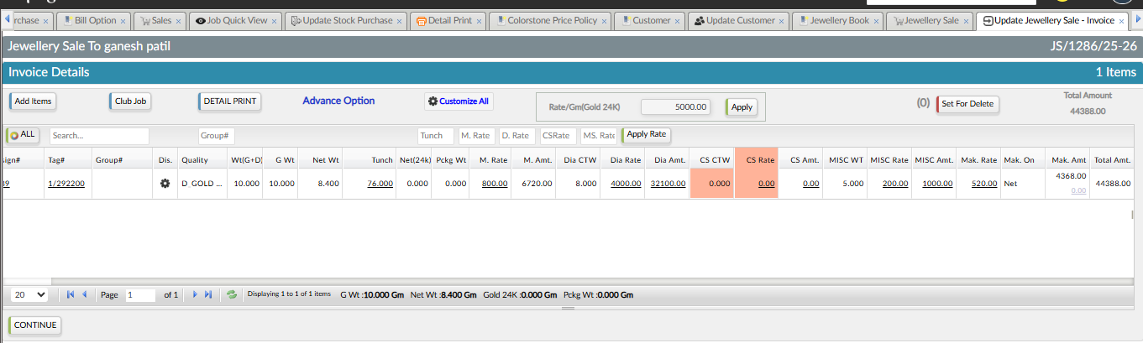
Reference voucher: JS/1282/25-26
So, initially when we make bill by adding item the calculation of price is done according to policies applied for customer.
So, in customer 05121:
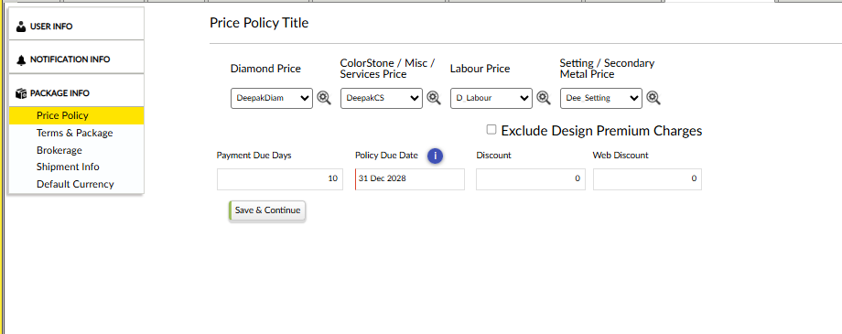
For,
Diamond Price: DeepakDiam
Color Stone Price: DeepaksCS
Labour Price: D_Labour
Setting / Secondary Metal Price: Dee_Setting

So, Diamond Price here got calculated according to the Diamond policy applied: (Refer the below Image)
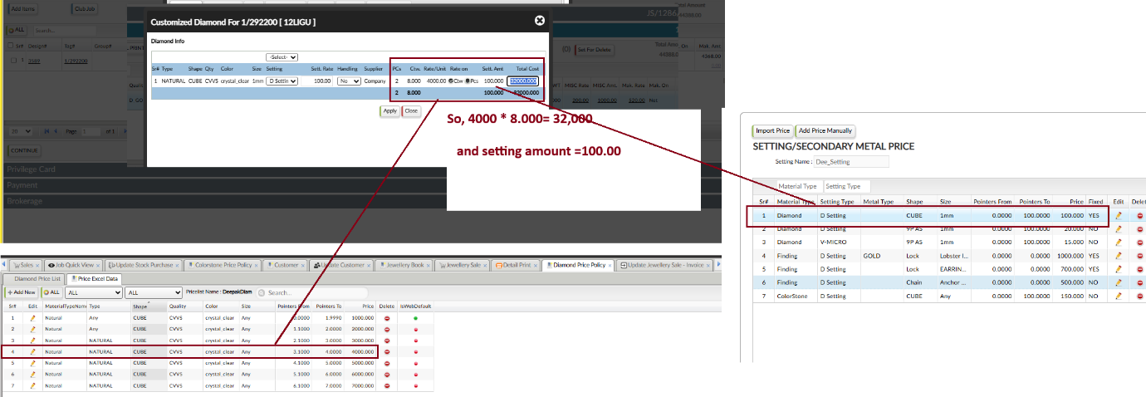

So, Color Stone Price here got calculated according to the ColorStone/Misc/Services policy applied: (Refer the below Image)
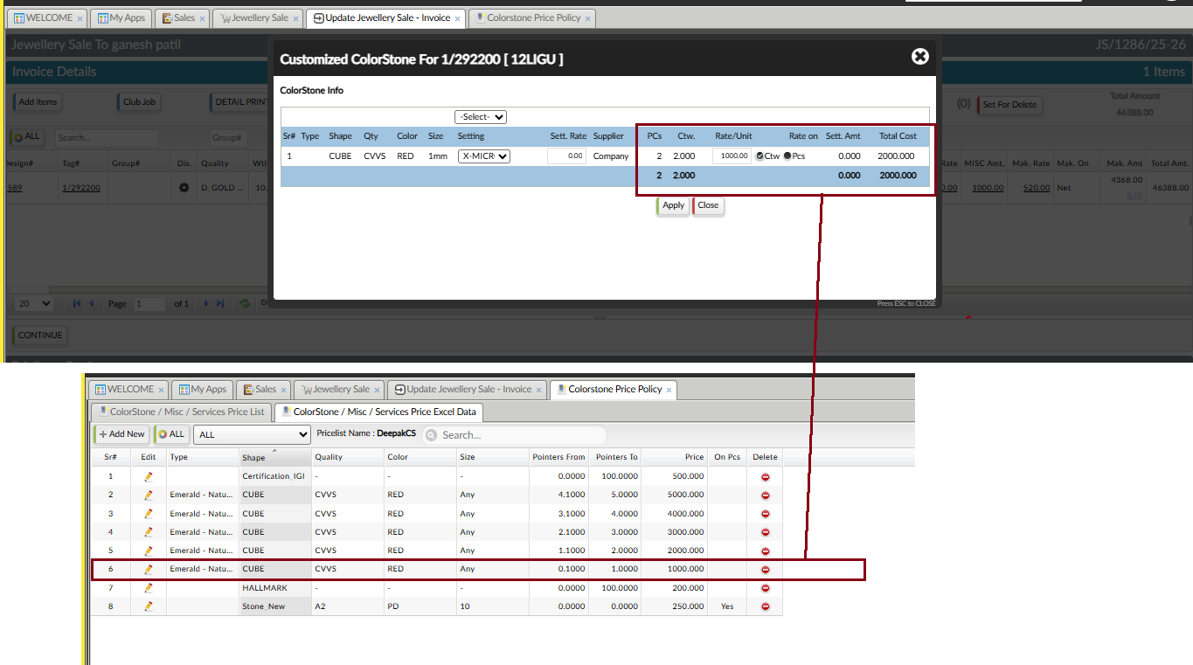
So, MISC Price here got calculated according to the ColorStone/Misc/Services policy applied: (Refer the below Image)
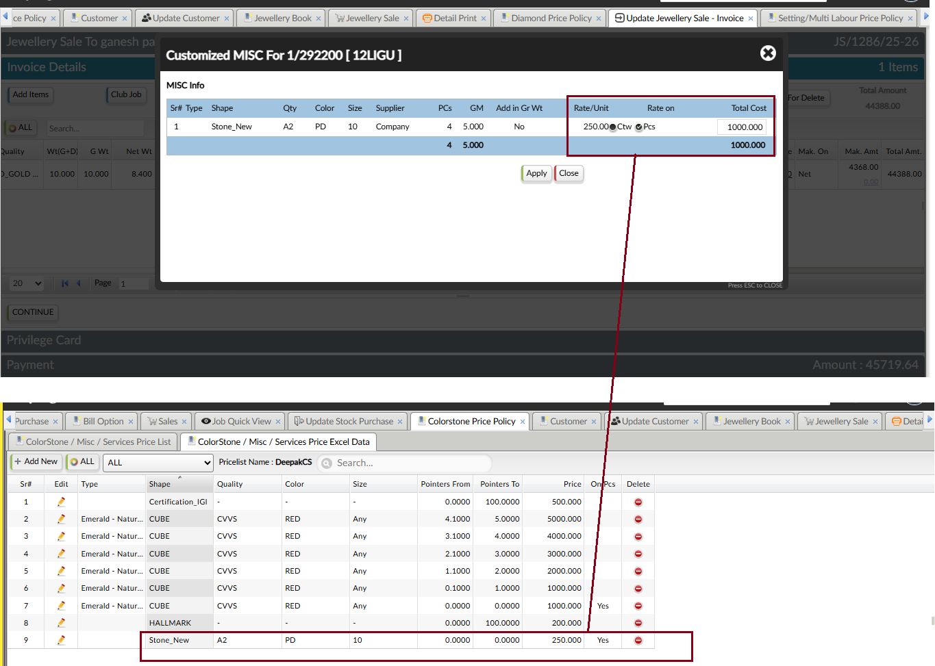

So, Making here got calculated according to the Labour policy applied: (Refer the below Image):
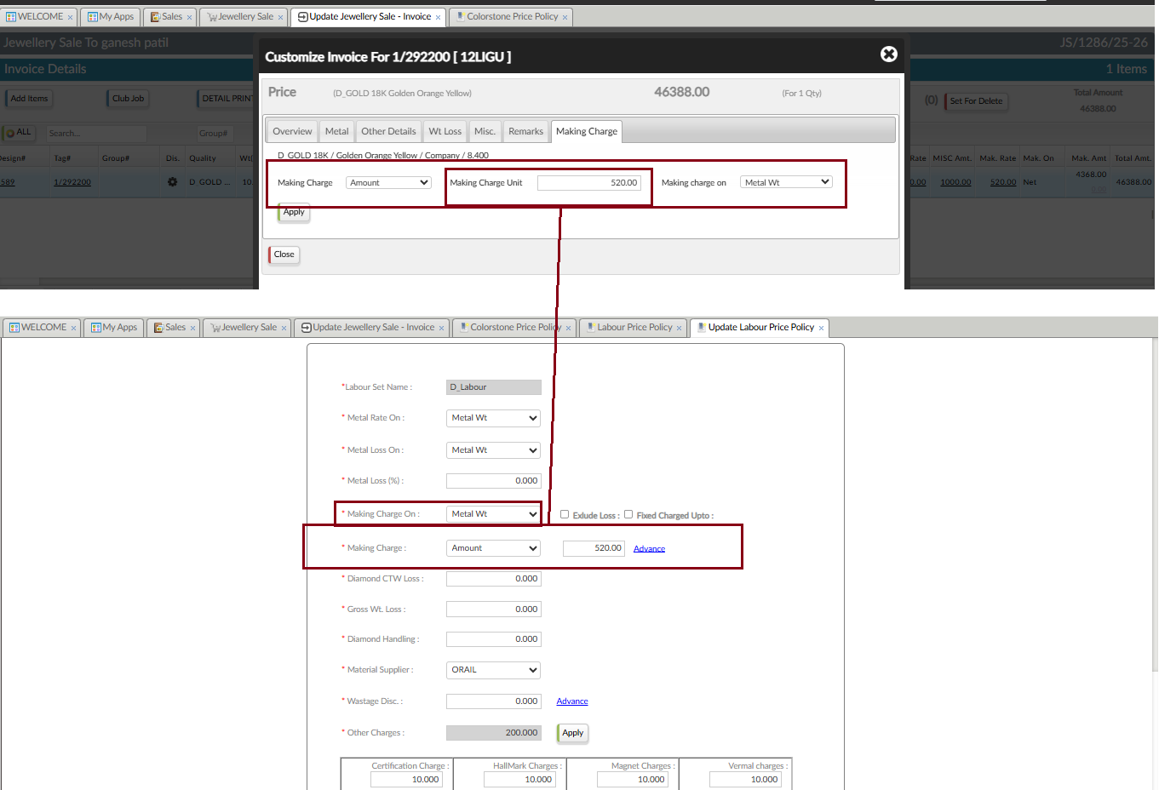

And same other charges are applied as per labour policy (Refer the below Image):
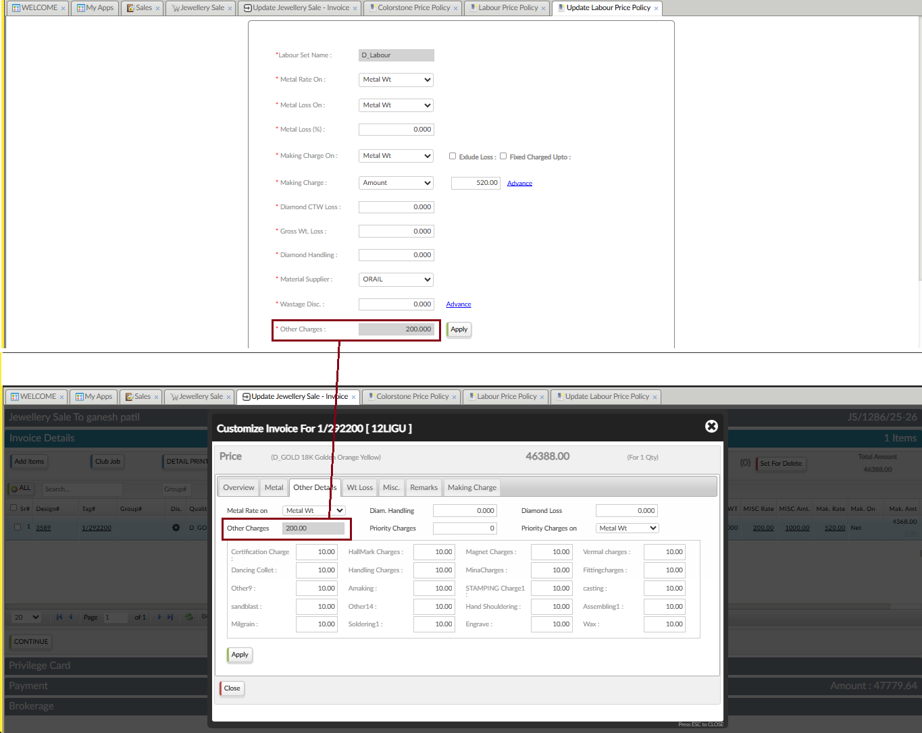
So, Total amount: 46,388.00, as:
Metal Amount: 6720.00
Diamond Amount: 32100.00
Color Stone Amount: 2000.00
MISC Amount: 1000.00
Making Amount: 4368.00
Other Charges: 200.00

So now, for example we change the diamond price policy (Refer the below Image):

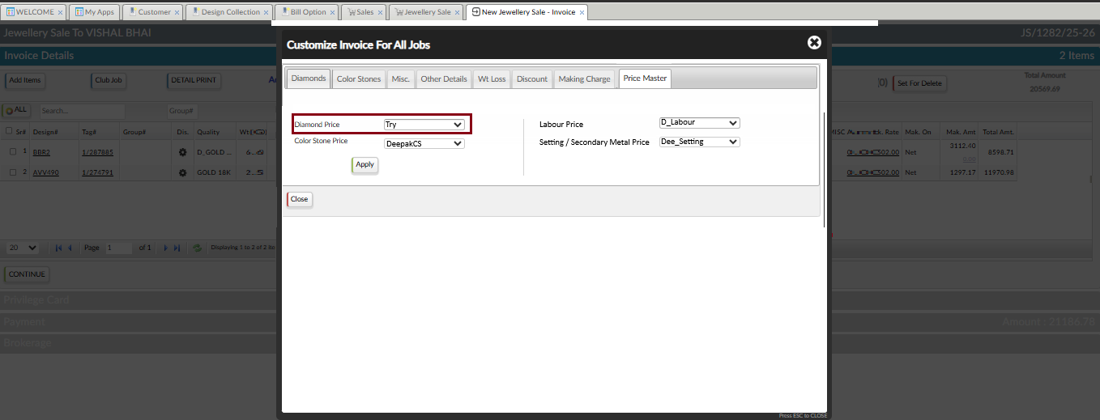
So, the rate of diamond is applied according to the Diamond price policy: Try
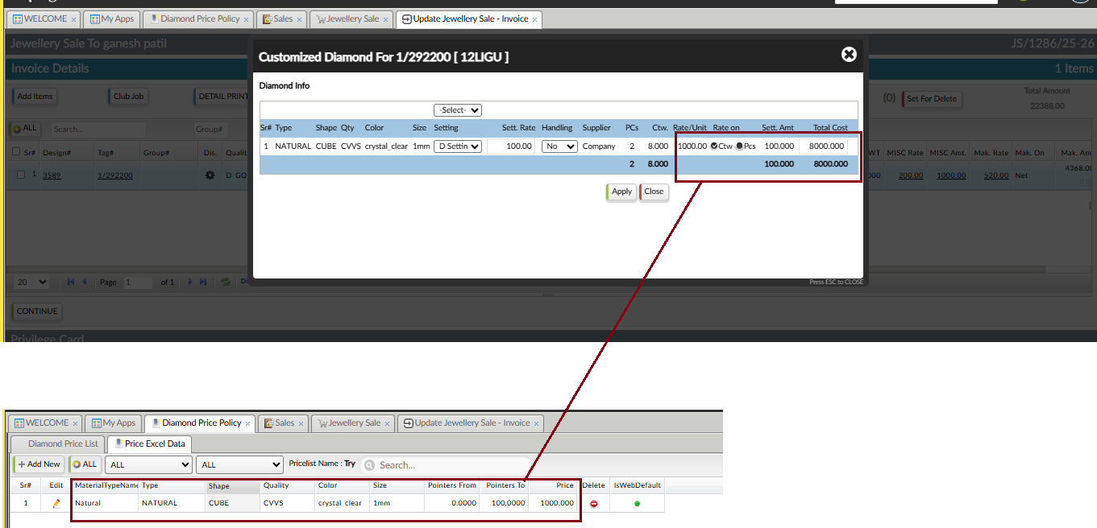

So total amount get calculated accordingly (Refer the below Image):
