Requirement Document :
Ecommerce UI and functional changes
UI Modification:
before login page & after login page
Given reference
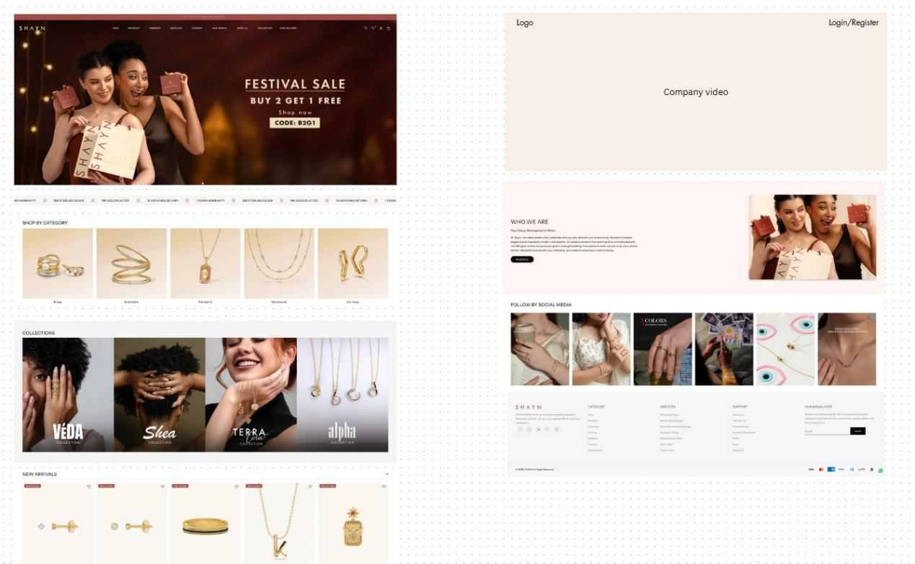
Menu
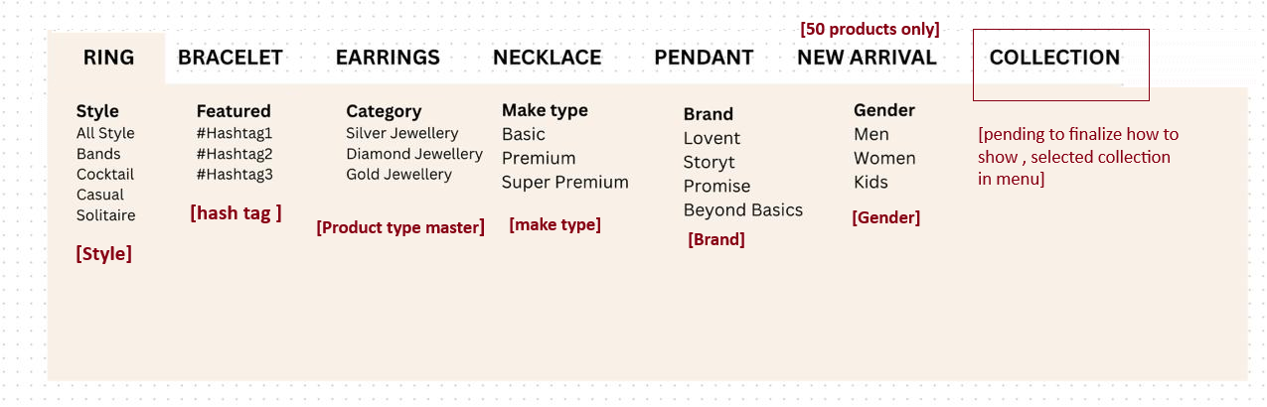

Customize cart : bulk customization
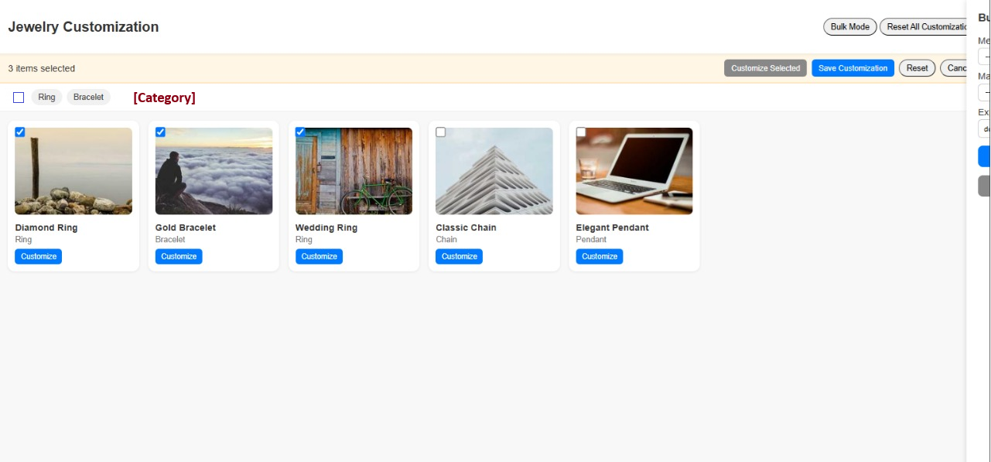
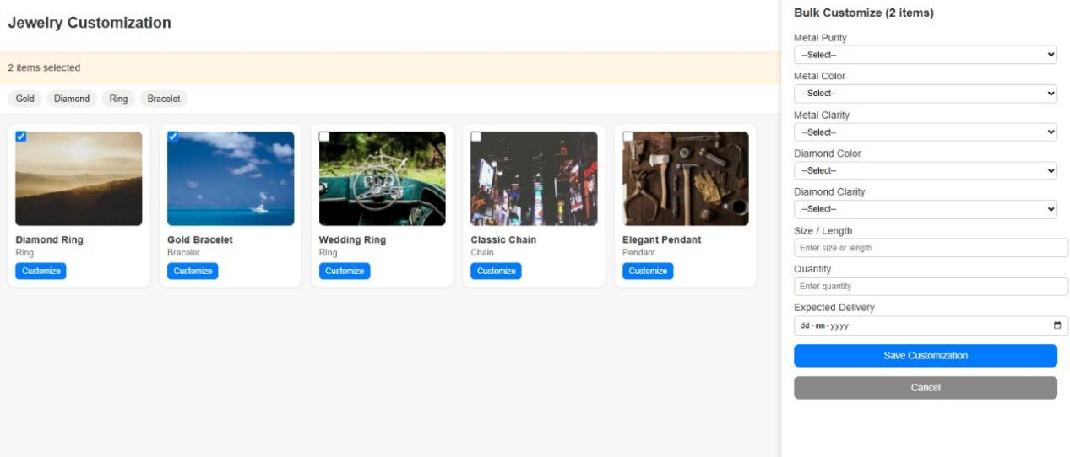
Given details for customization
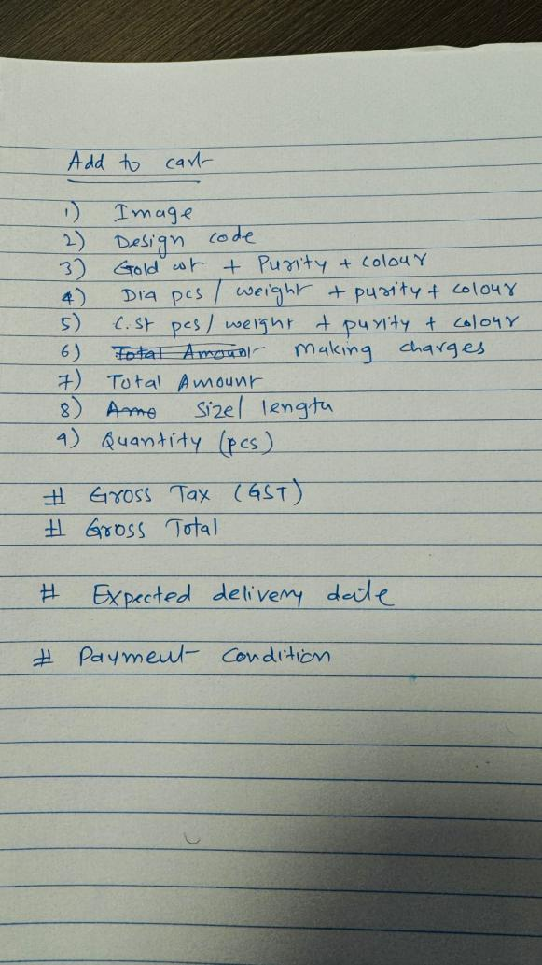
In customization need clarification:
What cafeteria need to be in customize product.
Need clarification on below points :
c.st - color stone customization is not available
making charge - what to change
Szie / legnth customization
Expected delivery date
Gold wt

