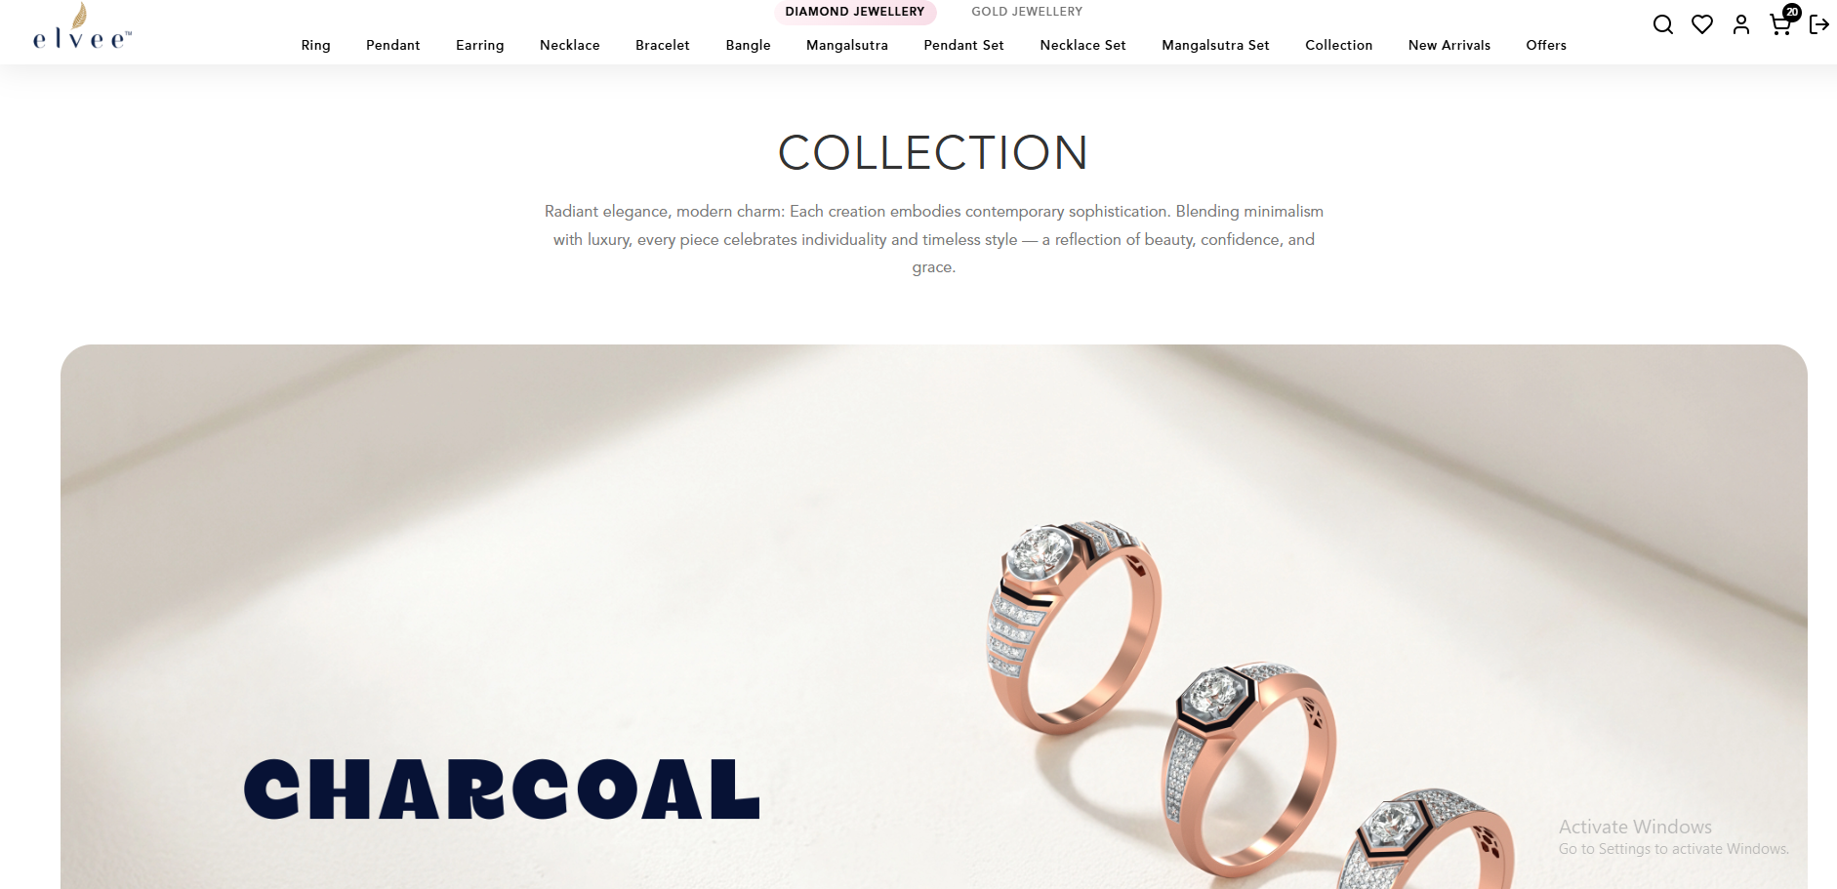

In Collection tab, banner should be visible as per the Diamond and Gold category.
If clicked on Diamond category and collection, then only Diamond jewellery collection should be visible and same as Gold Jewellery vice-versa.

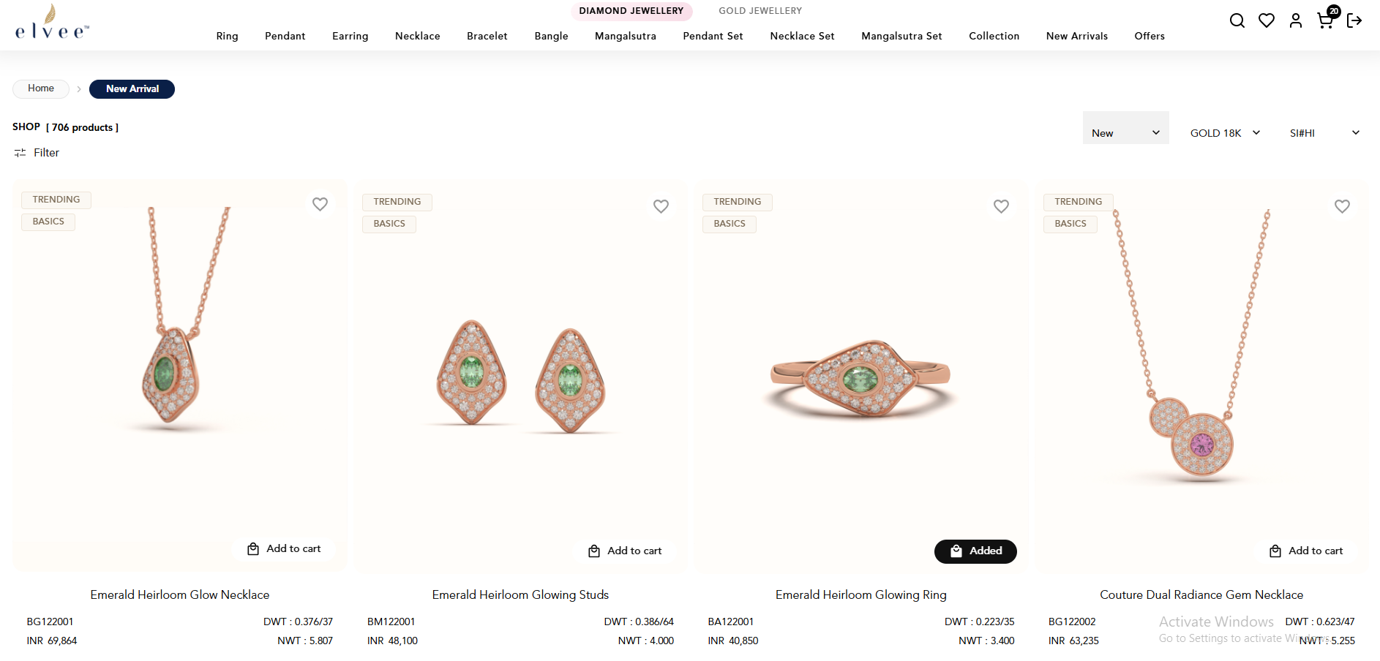

In New Arrivals tab, products should be visible as per the Diamond and Gold category.

If clicked on Diamond category and New Arrivals, then only Diamond jewellery products should be visible and same as Gold Jewellery vice-versa.

