Task : Brokerage in Stock Purchase
Purpose and Goal:
- Auto fetch brokerage with multi brokerage option in Manufacturer in Stock Purchase
- MultiBrokerage option in Sales Return
- Brokerage in sales return (old tag ) too ( Customers old jewellery which is not in system come as Sale Return )
=======================================================
- Books keeping > Return Goods >Sales Return
There will be option of multiple brokerage in Sales Return as below screen.
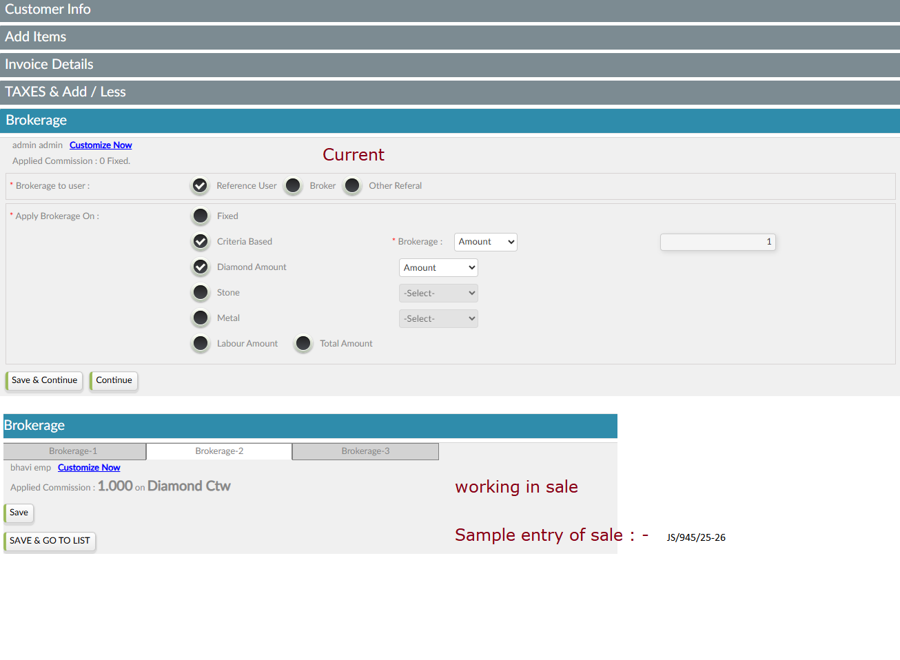
- User > Supplier> Manufacturer
We do have brokerage tab in Manufacturer same as customer
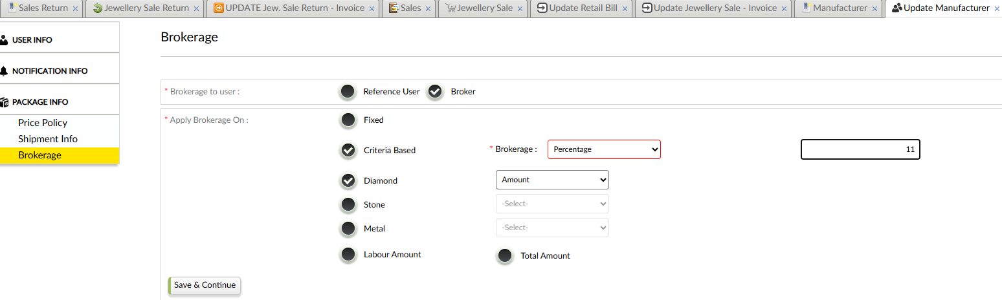

Books keeping> Purchase Book > Purchase Bill Option
There will be Option of brokerage option in stock purchase same as currently running in sale
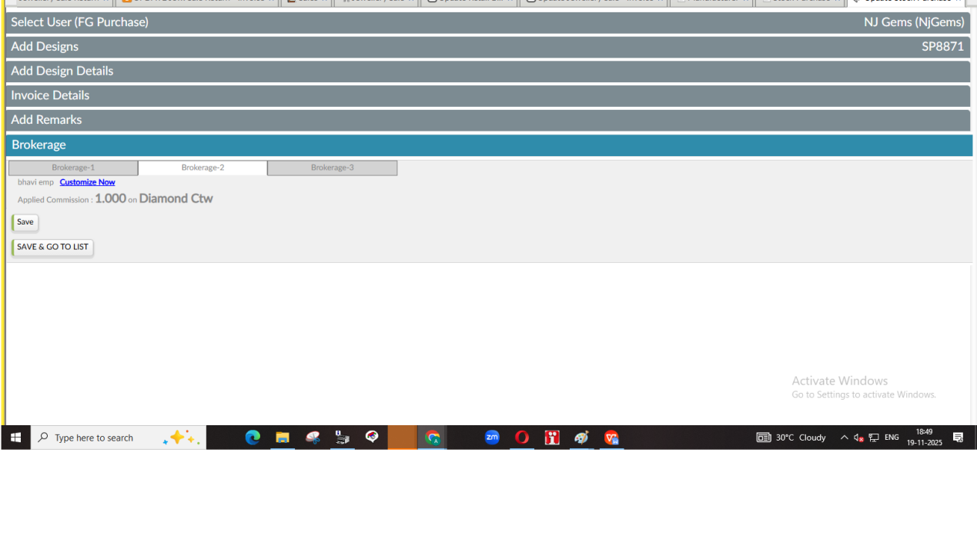
Action will work same as currently running in sale
Effects of multiple brokerage entry will also be considered
Effects in ledger while stock purchase as per below
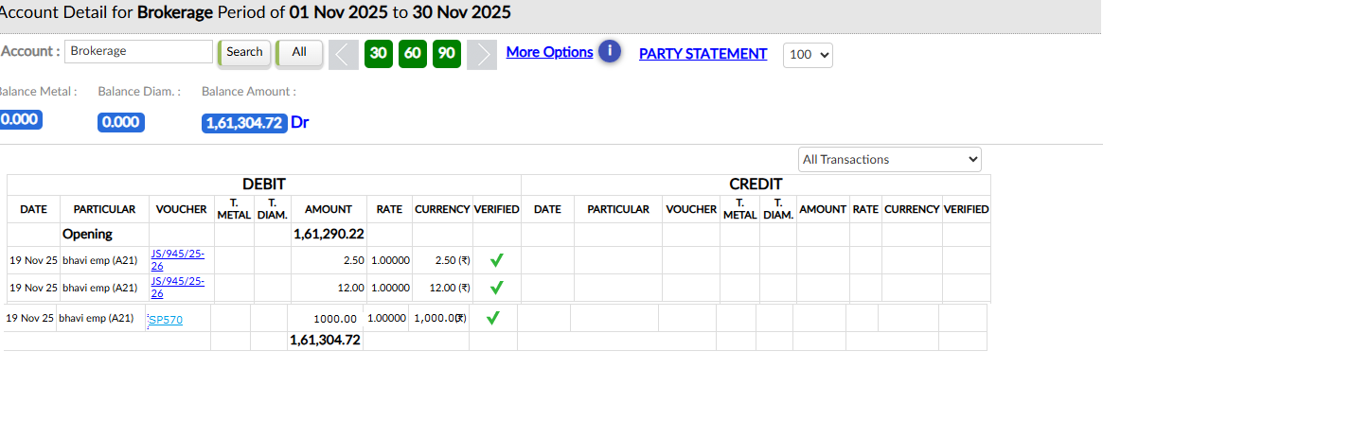

brokerage section will be in Sales Return(old tag ) too ( Books keeping > Return Goods> Sales Return (Old Tag) )
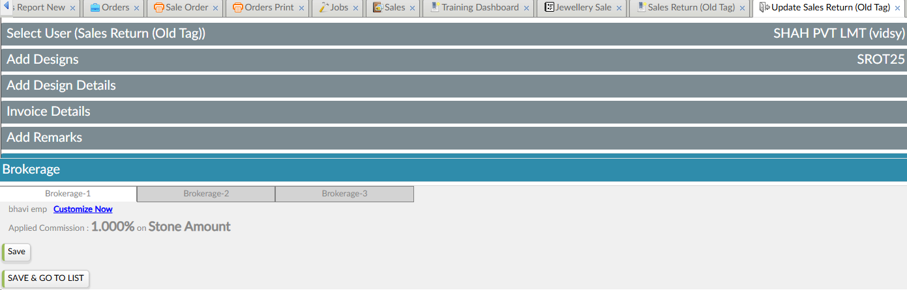
It will work same as currently running in sales Return including multibrokerage system.
Effects in Ledger
It will come in Return Brokerage
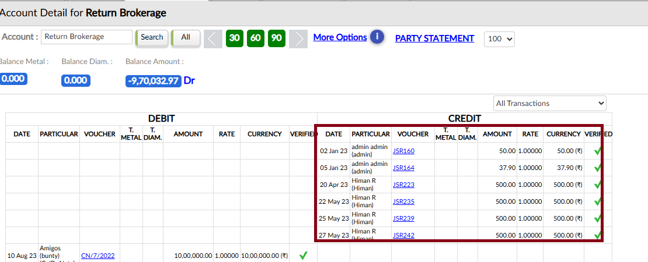

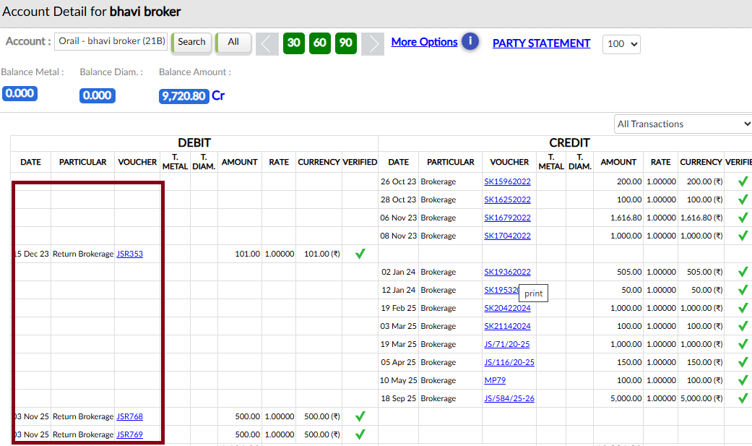

The same effect should come in following event too :
Books keeping> return goods> stock purchase return
