Customer registration fields which will be added e-commerce
all dropdown will be fetched from ERP 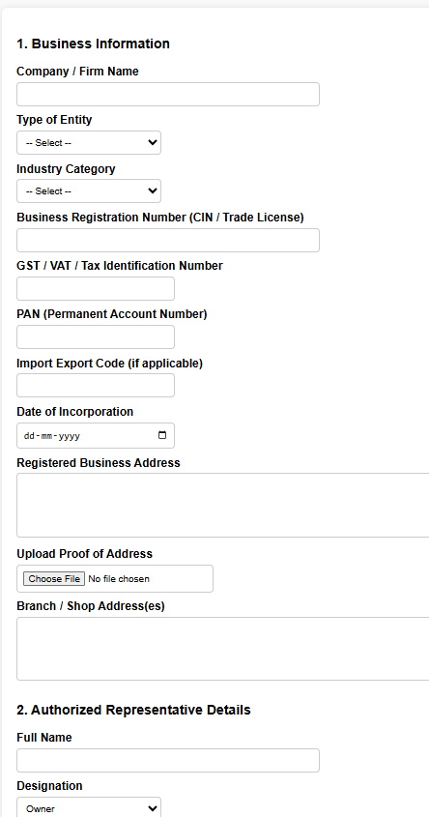

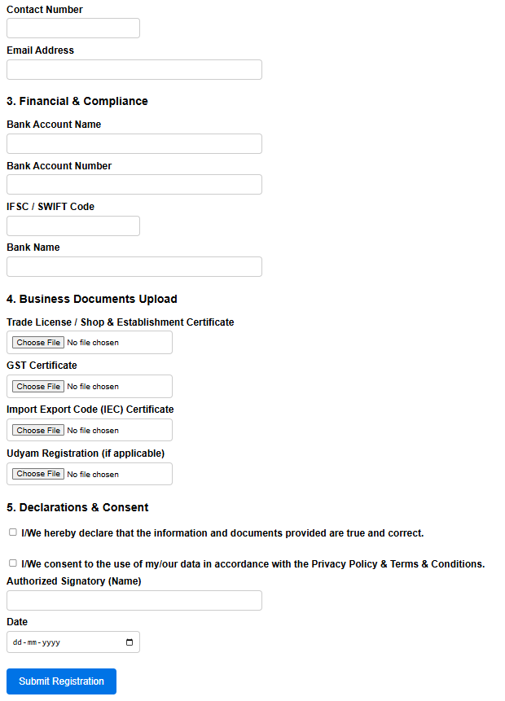

Discount master which will be added in ERP the master will be bifurcated by mentioned fields only and same detailing will be apply 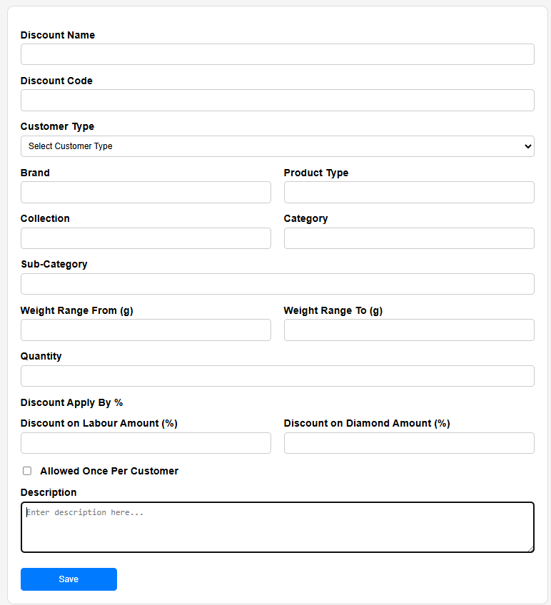
Discount Coupon code