EVO(Enhance visitor operation)
Software Requirements Specification (SRS)
Module: Jewelry Sales App – Sales Flow
Platform: Android/iOS Mobile App
Users: Sales Executives, Store Employees
Back-end: Connected to ERP (for customer, product, and billing sync)

Team:
Requirement by : harsha , prahshant, customer(khurana jewels)
Doc: shreya
App developer: darshan
react js : jensih
tester : dhruv
SQL: mahesh
API: mayur
support: All support team
Approval : Hiren sir
Overview:
EVO App by optigp -The digital jewellery showroom process offers a smooth experience for both new and returning customers. New customers register online, while existing ones are identified through a search. Once added to the "On Floor Customer" list, their session begins and products are showcased via tablet or physically. Customers can add jewellery and refreshments to their cart, with selected items shown in "My Selection." When ready, they can download their bill directly from their page.

User :
Employee / sales person/manager of jewellery store
All login type allow to manage from ERP (who have this page permission)
Back-end:App and device grid
To view connected device list
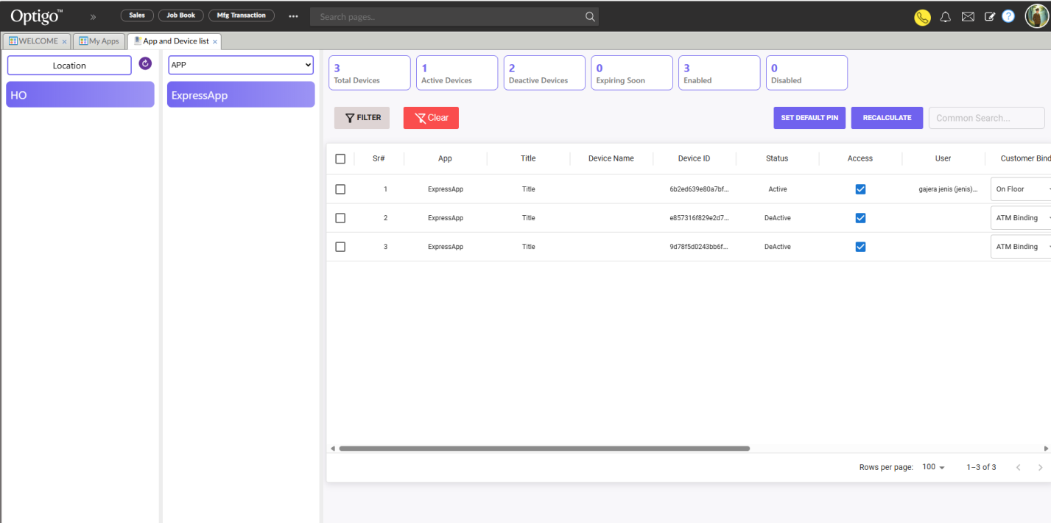
Customer add from app,
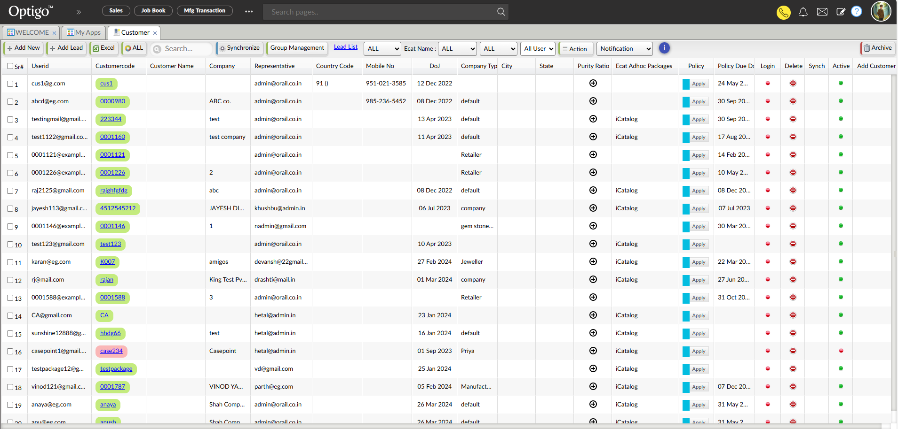
New created customer will directly add in to customer table accessible from bill option
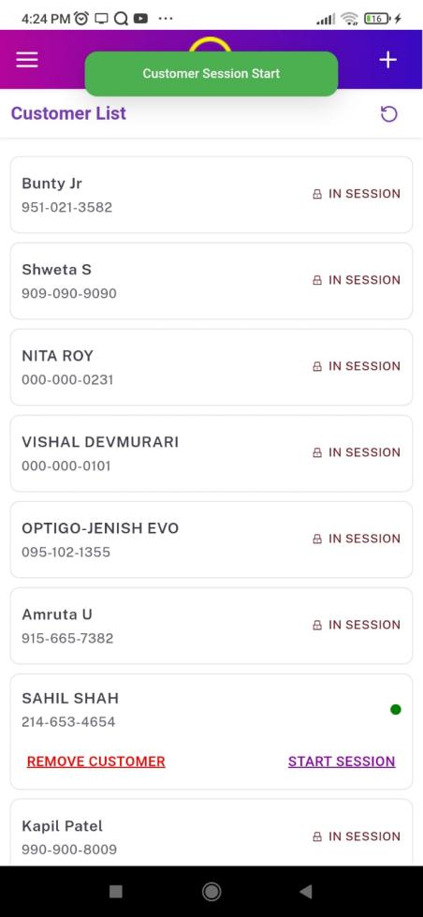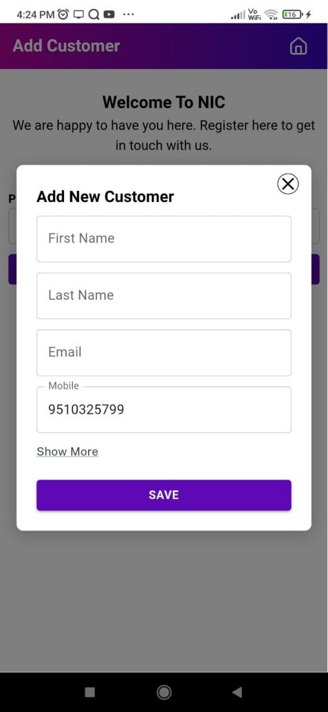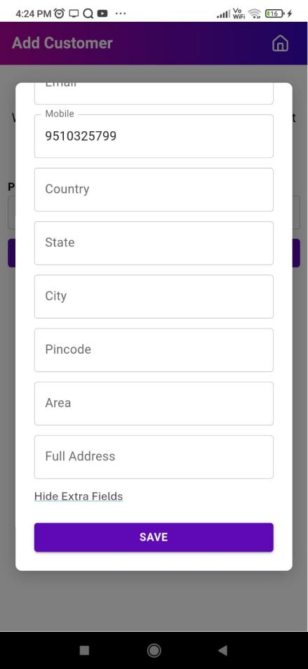
new added customer directly added to customers list in optigo

