Purpose:support team want to add call coming reason in call log
Step:1 add call reasons column in grid
Step:2 add static master of call reasons with following data

1.Support Call
2.Cloud side
3.Testing side
4.Release bug
5.Developer side
6.Document side
Step:3 selected master are shown in call reasons column
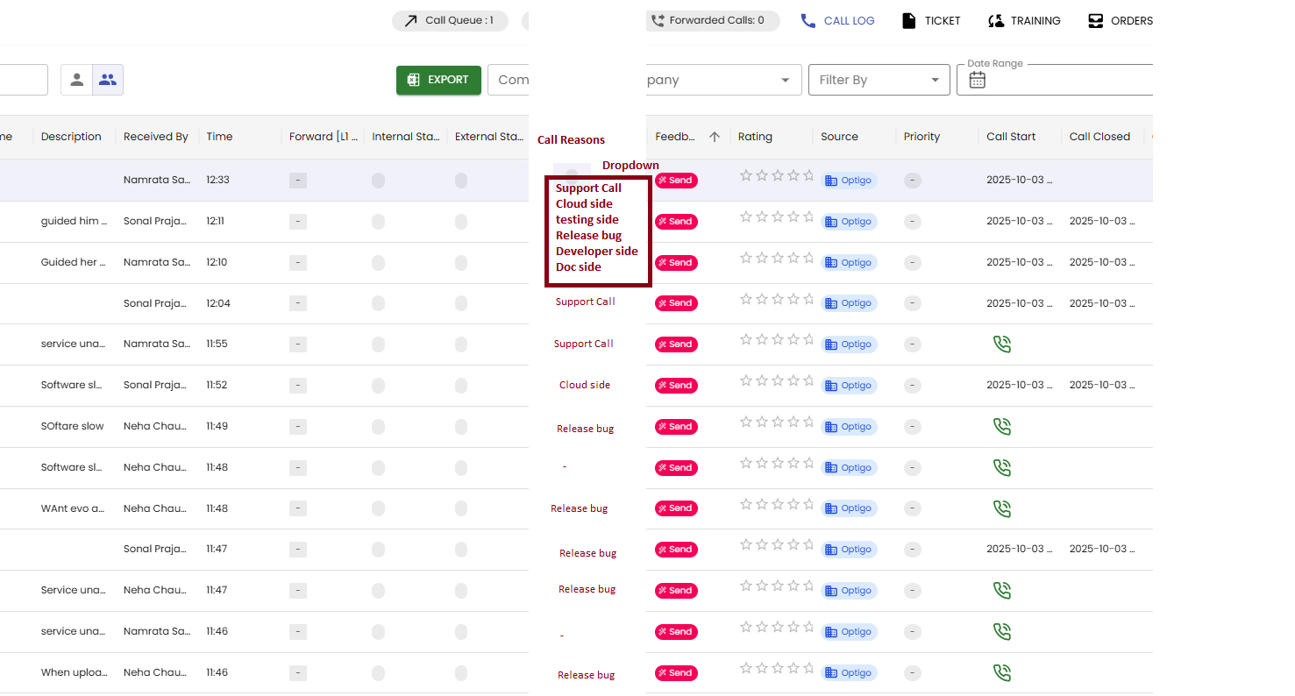
Example
- Company code:test74

Desctiption
Slowness

Call reason
Cloud side

2)Company code:test73

Description
you can refer invoice wise sale / sale tally excel no any other option

Call reason
Support side

3)Company code:test72

Description
When splitting the main job message is coming no enough material to delete

Call reason
Tester side

