Purpose:Add forgot pw option on help.optigoapps.com

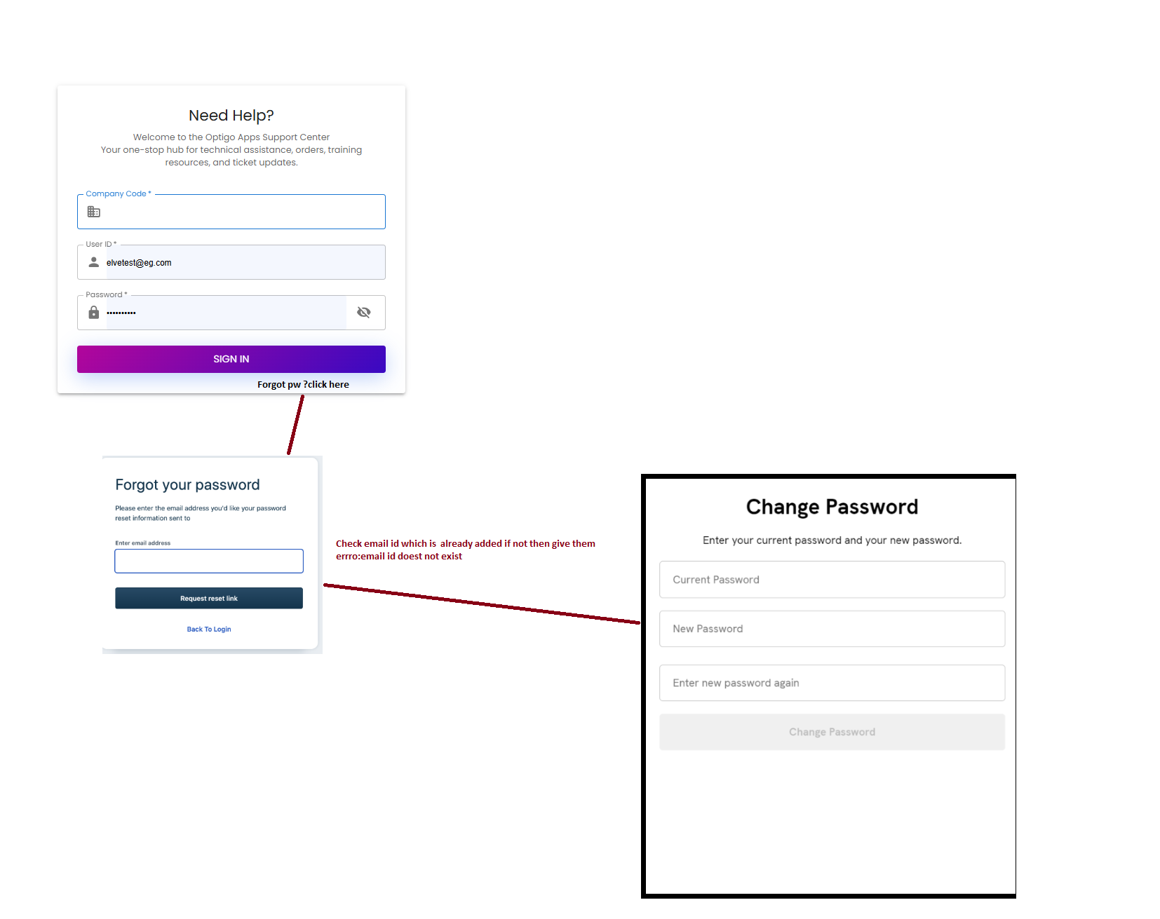
Storeline
Step:1 add Forgote pw link on login page (user id fill is compulsory)
Step:2 when click on that open ui as per image
Step:Enter email
Stpe:4 sent mail in following formate

Mail formate
Subject: Reset Your Password
Hi First name lastname ,
Welcome to optigohub.
We recommend that you reset your password using the link below:
{url}
https://help.optigoapps.com/change-password/?dGVzdDc0$@#dGVzdDc0OUBlZy5jb20=$@#MzA2+/
This link will expire in [48 hours] for security reasons.
If you did not request this account or have any concerns, please contact our support team at:
support@orail.in

Best regards,
optigohub
www.optigoapps.com

Step:5 when click on link oprn reset pw ui
Step:6 once pw is update go on login link
Step:7 login with new pw

